Investigating Matter and Energy in Organisms

Introduction:
Earlier in the unit, you reviewed common requirements for all living things. This included matter (food) and energy to grow, move and function. In this investigation, mealworms will serve as a model organism to learn more about how organisms actually use matter and energy to stay alive. You will use data from the investigation to construct an argument about the movement of atoms through organisms as they grow, move and function.

About the mealworm:
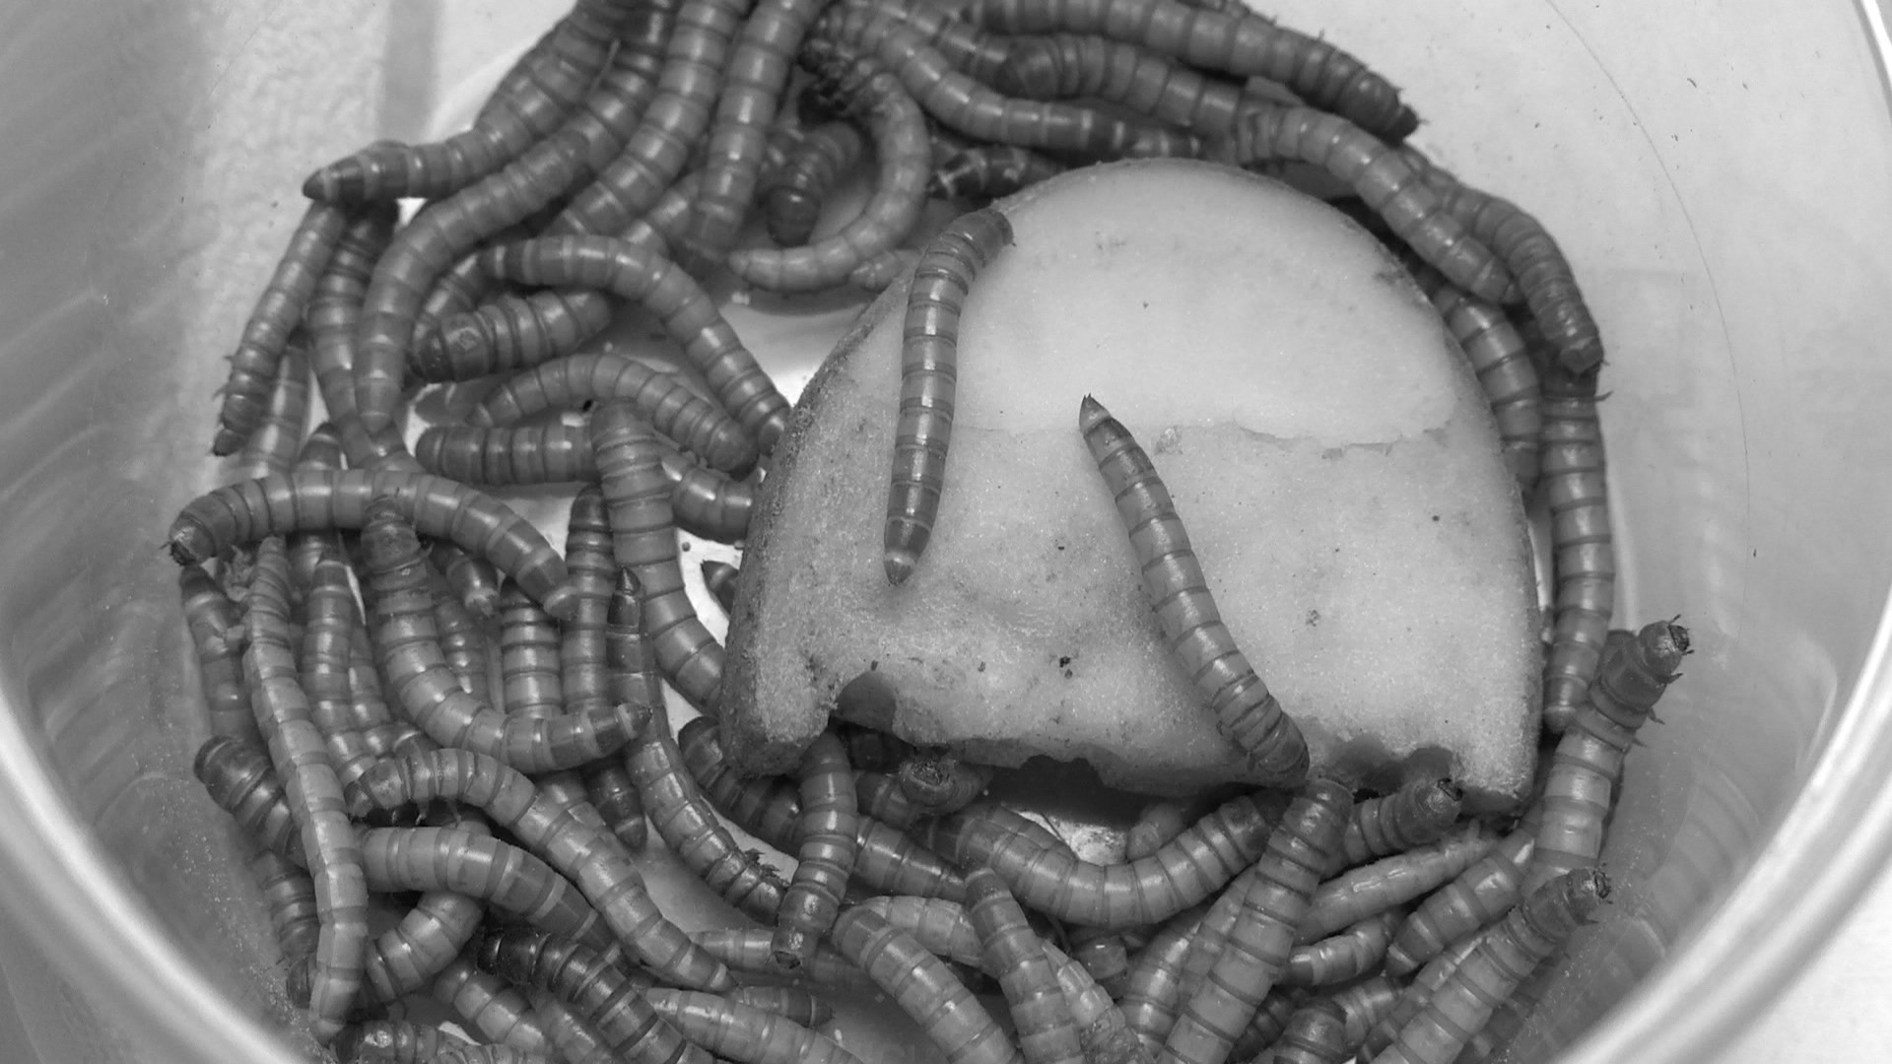
Mealworms are not actually worms! They are the larval stage of an insect called the darkling beetle (Tenebrio molitor). Even though mealworms look like worms, they have six jointed legs like adult beetles (worms don’t have legs). Mealworm larvae are yellow and have 13 body segments—a head, three thoracic segments, and nine abdominal segments.

Mealworms eat decaying leaves, sticks, grasses, plants, grains, and the waste of other animals. Although they prefer to live in barns and farms where lots of grains are stored, you can also find mealworms in pet stores. This is because mealworms make good food for other animals, like birds and lizards. In the wild, mealworms are also prey to a variety of animals, like other insects, birds, rodents, spiders, and lizards.

The mealworm is the larval stage of the mealworm beetle life cycle. The mealworm life cycle is similar to the caterpillar and butterfly life cycle. Mealworms begin as tiny eggs. After a few weeks, the eggs hatch. The creatures that come out of the eggs are called larvae. During the larval stage, mealworms have two goals: eat and grow. They grow so much that they have to molt their outer shell a few times to make space for their extra biomass. In the third stage, the pupal stage, the mealworm forms a shell around its body. Although it looks fairly inactive during this time, it is changing. This transformation, or metamorphosis, usually takes a few weeks, but can take up to nine months. At the end of this transformation, the adult darkling beetle emerges from the shell.

Because mealworms are used as a food source, there is nutrition information for mealworms available. The food label can be used to determine the molecules that the cells of mealworms are made up of. As you read, mealworms eat plant parts. In the investigation, you will see mealworms eat potatoes.

Use the food labels to answer these questions:

- What molecules are mealworms made of? _________________________________________________________________________________
- What molecules are potatoes made of? _________________________________________________________________________________
- How does the mealworms' food compare to what the mealworms' cells are made of? ________________________________________________________________________________________________________________________________________________________________________
- What do you wonder based on this comparison? ________________________________________________________________________________________________________________________________________________________________________

Composition of Mealworms and Potato:
Dried Mealworms | Potato
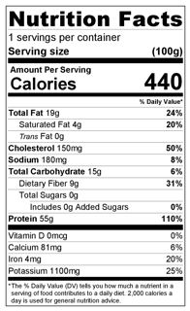 | 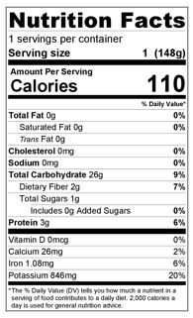

Tools of the Investigation - BTB:

One of the materials used in the investigation is bromothymol blue, or BTB. When BTB is dissolved in water, it can be used to detect the presence of the small inorganic molecule, carbon dioxide (CO₂). When CO₂ is added to BTB, the color will change, from blue to green to yellow.

BTB Color Key
Low CO₂ | Some CO₂ | High CO₂
Blue | Green | Yellow

Hypothesis:

Follow your Teacher’s instructions to complete the mealworm investigation Predictions Tool. This will serve as your hypothesis with explanation for what you expect the outcome of this investigation to be.

Materials:

Small container to hold mealworms | 25 mL blue BTB
Electronic balance | 15 g mealworms
Sealable 9.5 cup container | 10 g potato
Petri dish

Procedure:

Check the box as you complete each step.
- ☐ Get a small container for your mealworms during the investigation. Make sure the container is deep enough for mealworms to not crawl out, and has holes in the lid for ventilation so your mealworms have air.
- ☐ If your mealworms are already in their meal bedding and container, you will need to separate the mealworms from the bedding. Using the end of a pencil, separate all the worms from the meal. If your worms come already separated from bedding, skip this step.
- ☐ Place an empty small container onto the digital balance and “zero” out the scale. Then gently pour about 15 g of mealworms into this container. Record the “Mass of the mealworms before”.
- ☐ Cut a small piece off of the potato (about 10g) and place on the scale. Record on your worksheet the “Mass of the potato before” box in Part C.
- ☐ Place the piece of potato that you massed into the container with worms.
- ☐ Measure the mass of the entire container with all of its contents. Record on your worksheet the “Mass of whole container before” box in Part C.
- ☐ Place the small container with the worms and food into a larger sealable 9.5 cup container.
- ☐ Place a Petri dish with about 25 ml of blue BTB into the large sealable 9.5 cup container near the container with the mealworms. Record the color of the BTB in the “Color of BTB before” box. Seal the large sealable 9.5 cup container.
- ☐ Complete Part B below with your macroscopic observations.
- ☐ Final Mass: After 24 hours you will measure the mass of the whole container, the potato, and the mealworms. Use the same “zeroing” procedures as above. Record mass measurements in the “Measurements After” boxes. Observe the color of the BTB and record it in the “Changes in color of BTB” box.

Data:

Table 1: Measurements During The Investigation
 | Measurement BEFORE  (g) | Measurement AFTER  (g) | Change in Mass  (g)
Mass of mealworms
Mass of potato
Mass of whole container
Color of BTB |  |  | Change in color:

Table 2: Results for the Whole Class
Make notes about how the observations and measurements of other groups compared to yours. Describe patterns in the data.
Changes in mass of the mealworms | Changes in mass of the potato
Changes in mass of the whole container | Changes in color of BTB

Table 3: Class Data
Group # | Initial Mass Potato (g) | Initial Mass Worms  (g) | Final Mass Potato  (g) | Final Mass Worms  (g) | Change in Potato Mass (g) | Change in Worm Mass (g)
1
2
3
4
5
6
7
8
 | Average change in weight =

Graph: Average change in Mass for Mealworms and Potato

Analysis and Conclusions:

Revisiting your hypothesis
- Does the data support your predictions about mass? Explain.
  - Change in food mass: ___________________________________________________________
  - Change in mealworm mass: ______________________________________________________
  - Change in everything in the container: _____________________________________________________________________________
- Does the data support your prediction about changes in BTB? Explain. ________________________________________________________________________________________________________________________
- Does the data support your prediction about energy? Explain. ________________________________________________________________________________________________________________________

Patterns in the Class Data
- What patterns do you see in the mass data? ________________________________________________________________________________________________________________________
- What is a possible, science-based explanation for the patterns you observe? ________________________________________________________________________________________________________________________
- What patterns do you see in the BTB change data? ________________________________________________________________________________________________________________________
- What is a possible, science-based explanation for the patterns you observe? ________________________________________________________________________________________________________________________
Conclusion
The purpose of this investigation was to collect evidence, using the mealworm as a model organism, to answer the question “How do living things use matter and energy to stay alive?” The investigation guided you to examine three supporting questions:
- Where are molecules moving?
- How are atoms in molecules being rearranged into different molecules?
- What is happening to energy?
Complete the CER organizers to construct your conclusions about these questions based on the data.

Where are molecules moving?
Claim:
Evidence | Reasoning

How are atoms in molecules being rearranged into different molecules?
Claim:
Evidence | Reasoning

What is happening to energy?
Claim:
Evidence | Reasoning

