Water, Ethanol and Wood and Energy Capture Sheet
Exploring Organic vs Inorganic

Food is considered fuel for our bodies because it gives us energy; but what does food have in common with fuel like gasoline, ethanol and wood? To answer this question, we must first review basic chemistry terms and then look at the difference between organic and inorganic molecules.

Chemistry basics Review:
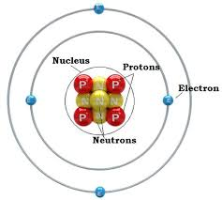
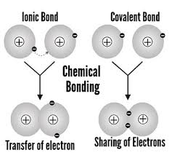
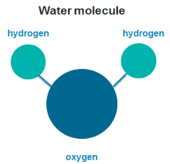
Molecule is the general term used to describe any atoms that are connected by chemical bonds. Every combination of atoms is a molecule.

A compound is a molecule made of atoms from different elements. All compounds are molecules, but not all molecules are compounds.
Hydrogen gas (H₂) is a molecule, but not a compound because it is made of only one element.

Water (H₂O) can be called a molecule or a compound because it is made of hydrogen (H) and oxygen (O) atoms.
There are two main types of chemical bonds that hold atoms together: covalent and ionic/electrovalent bonds. Atoms that share electrons in a chemical bond have covalent bonds. An oxygen molecule (O₂) is a good example of a molecule with a covalent bond. Ionic bonds occur when electrons are donated from one atom to another. Table salt (NaCl) is a common example of a compound with an ionic bond. (Source: http://www.chem4kids.com/files/atom_compounds.html)

What makes something “fuel”?

Why can some things burn while other things cannot burn?

We will begin to understand the answer to this question by starting at the macroscopic scale and then studying the molecular scale.

Macroscopic Scale:
Describe the macroscopic-scale (visible) features of each material below.

Ethanol | Water | Wood
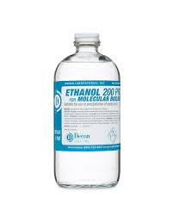 | 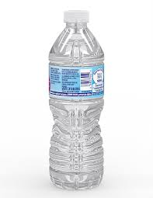 | 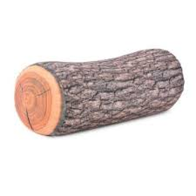
Description

- Which materials appear to be most alike? Why?
- Which of the materials can burn? Why?

Microscopic Scale:
Why does ethanol behave more like wood than like water?
Examine the molecular scale of each material and describe what you see.

Ethanol | Water | Wood
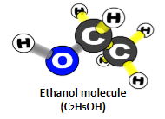 | 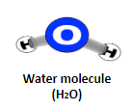 | 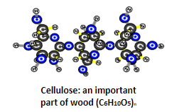
Observations:
What ATOMS are found in these materials?
What BONDS are found in these materials? (C-O; C-C; C-H, O-H)

- What is similar among all of the materials?
- What do you see in ethanol and wood that you do not see in water?

Understanding Chemical Energy

Energy can be found in many forms - light, heat, motion and chemical. The energy needed to keep living things living is found in the food we eat. To understand how, we must learn more about chemical energy.
What is chemical energy? Every atom has a small nucleus, made of protons and neutrons, and electrons that circulate outside the nucleus. Electrons are like other particles because they move naturally toward low-energy places or states close to the nucleus, like balls that roll downhill.
Molecules and chemical energy exist because many atoms have either too many or too few electrons. Carbon and hydrogen have extra electrons; they could be more stable if they could get rid of or share some of their extra electrons. Oxygen, on the other hand, does not have enough electrons; oxygen atoms would be more stable if they could add some electrons.
Summarize the main idea of this section of the reading (pictures or diagrams are encouraged):

Chemical bonds and molecules. Molecules exist because electrons can move to other atoms. When carbon and hydrogen share electrons, the shared extra electrons can move to lower-energy states. Oxygen atoms can also become more stable by gaining electrons to “fill their gaps.” Atoms that share electrons stay close together, so those shared electrons are the chemical bonds that keep atoms together in molecules.
Summarize the main idea of this section of the reading (pictures or diagrams are encouraged):

High-energy and low-energy bonds. Carbon and hydrogen atoms can lose a little energy (like a ball rolling a little way downhill) if they share electrons with other carbon and hydrogen atoms. But they still have their basic problem—extra electrons— so we say that C-C and C-H bonds are relatively weak high-energy bonds.
BUT if carbon and hydrogen atoms can give their extra electrons to oxygen atoms (remember oxygen atoms have too few electrons), then they can lose a lot more energy (like a ball rolling farther downhill). So we say that C-O and H-O bonds are stronger low energy bonds.
Summarize the main idea of this section of the reading (pictures or diagrams are encouraged):

Based on the analysis of ethanol, water and wood at the molecular scale and the information in the reading, which materials have available chemical energy?

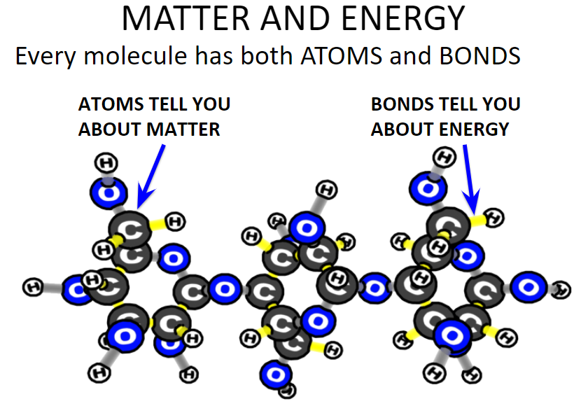
Photo Credit: Craig Douglas, Michigan State University
Contrasting organic and inorganic materials

When comparing materials that burn or do not burn, it is the bonds, not the atoms that make the difference. In general, it is organic materials, or those that have C-C and C-H bonds, that provide the chemical energy to sustain living things.

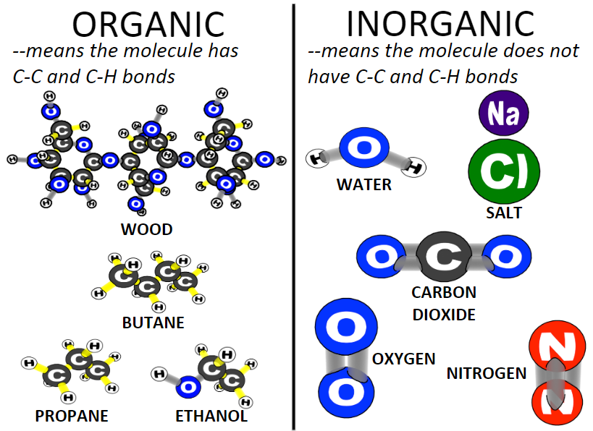
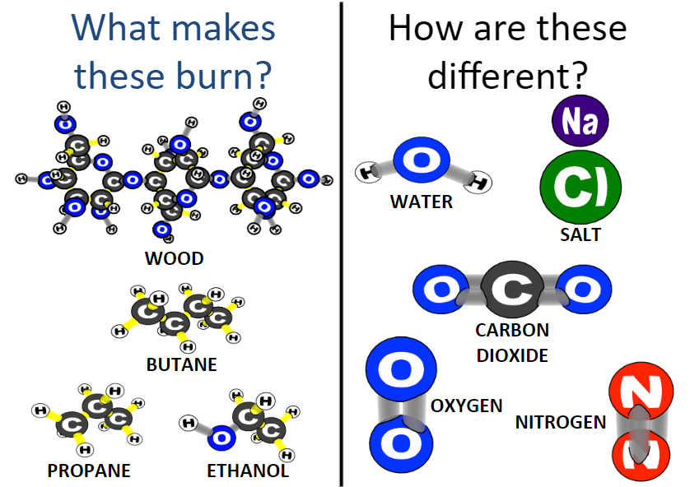
Photo Credit: Craig Douglas, Michigan State University
Photo Credit: Craig Douglas, Michigan State University

Using this new information, the the CER organizer to construct an explanation for why ethanol and wood will burn, but water will not. Be sure to use the terms organic, inorganic, chemical bonds, molecule and atoms in your explanation.

Claim:
Evidence
(which molecules are organic/inorganic?)
Reasoning
(Describe the difference in bonding between atoms in the molecule)

Connecting back to the Food Label analysis

Review the data you collected about the six different food types in the Food Label analysis activity. Based on what you have learned, what are possible explanations for why the beef and peanuts had significantly higher amounts on chemical energy (Calories) than the foods based on plant parts even though they all had the same mass?

Possible Explanations:

What questions are you left with?

