Homer-ostasis

Question: Can you keep Homer alive by maintaining his Homeostasis?
Lab Challenge-
You need to maintain a constant temperature, keep the water level constant at Homer’s eyebrows, and maintain a constant concentration of "body fluid" in a leaky plastic cup for over 5 minutes.

Materials for each group
1 Homer plastic cup with a hole punched in the bottom. Place tape over the hole to keep liquid inside.
1 control cup (Cup #1)
1 cup of “Homer Fluid” (Cup #2)
1 cup with concentrated liquid (orange color)
1 cup of hot water
1 cup of cold water
1 thermometer
1 ring stand
1 plastic beaker to catch fluid

Student responsibilities in the group:
- The group leader watches the temperature, level and compares the yellowness and directs the other three students.
- One student to add hot water as directed by the leader
- One student adds cold water
- One student adds concentrated dye (electrolytes and sugar)
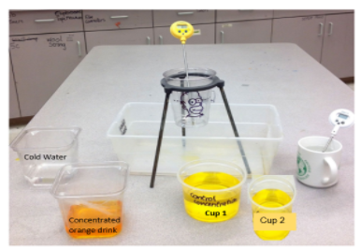

Pre-lab planning
What will you need to maintain to keep Homer from dying (vocab word)?

What is a “set point” ?
What is the set point for the temperature?
-Should the thermometer be set for F or C?
What is the set point for the water level?

What is the set point for the color?

What lab materials will you need to use to keep Homer from dying and maintain homeostasis? Explain what you would use each for.

Who is the group leader?

Who will control the Hot water?

Who will control the cold water?
Who will control the orange drink (used instead of concentrated dye)?

Who should tell people when to add water?

Homer fluid will be yellow. A control is used as a comparison. The yellow is the normal “healthy” color for Homer.
· If you add water but no orange his color will turn clear.
· If you add too much orange he will become sickly orange.
· If you add just the right amount of orange to the water he will stay yellow!!!
· You can’t add Homer juice after we begin timing!

What will you look at to know if homer is staying the correct color?

The ________________________ cup.

Directions (Lab Procedure): Let's get started!
- Gather all materials and place the Homer cup into the ring on the ring stand.

- Empty the cup of “Homer Fluid” (Cup #2) into the Homer Plastic Cup up to Homer’s eyebrow line

- Determine the temperature of Homer (Temperature of Homer Cup).
  - If the temperature is too high, put cold water into the cup until Homer’s temperature is exactly 25 degrees celsius.
  - If the temperature is too low, put hot water into the cup until Homer’s temperature is exactly 25 degrees celsius.
  - Record the number of times you have to either increase the temperature or decrease the temperature until Homer’s temperature is exactly 25 degrees centigrade. ____________ Times
- Once you have Homer’s temperature at 25 degrees celsius please stop and wait for all other groups in the class to get Homer’s temperature steady.

- When the teacher says “GO” remove the tape covering the hole in the Homer cup on the ring stand.

- Continue to add hot or cold water as Homer’s water level and temperature continues to change.
  - You must keep Homer’s water level at his eyebrows
  - You must keep Homer’s Temp at 25 degrees celsius.

- Add more concentrated orange or water to keep the concentration the same color as your "control" cup.

- Maintain a temperature and color balance (homeostasis) of Homer for at least 5 minutes.

- Did Homer live? (If anything got way off, he won't have made it!)
Dead Alive

Post Lab Analysis-

Each of you was part of “Homer’s Body” helping him maintain homeostasis.

What was the stimulus? Stimuli?

What was/were the receptor (s) /
sensor (s)? Explain.

Who was the control center? Explain.
Who were the effectors? Explain.

What was the response? Explain.

Think about the parts of a feedback mechanism (use page 2-3 of your notes).

There is a ____________________ that creates a change that is detected by a ____________________ (sensor), that sends a signal to the ___________________, which coordinates a response and sends a signal (communication through hormones or nerves) to the ____________________ which then responds (does something) to return the body to ____________________ .

Word Bank:
Homeostasis | Effector | Stimulus
Control center | Receptor

Name: _______________________________________ Date: ___________ Period: ________

Directions: Label (Annotate) the diagram by including the following items:
- Create a title that best represents the diagram.
- Circle on the diagram the functions of the hypothalamus.
- Put a star beside the setpoints (setpoint = level you are trying to maintain/ normal level)
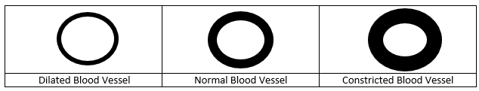
- Draw the pictures of the blood vessels “dilated” next to the box saying “blood vessel dilate”.
- Draw the pictures of the blood vessels “constricted” next to the box that says “blood vessel constrict”

Title: ___________________________________________
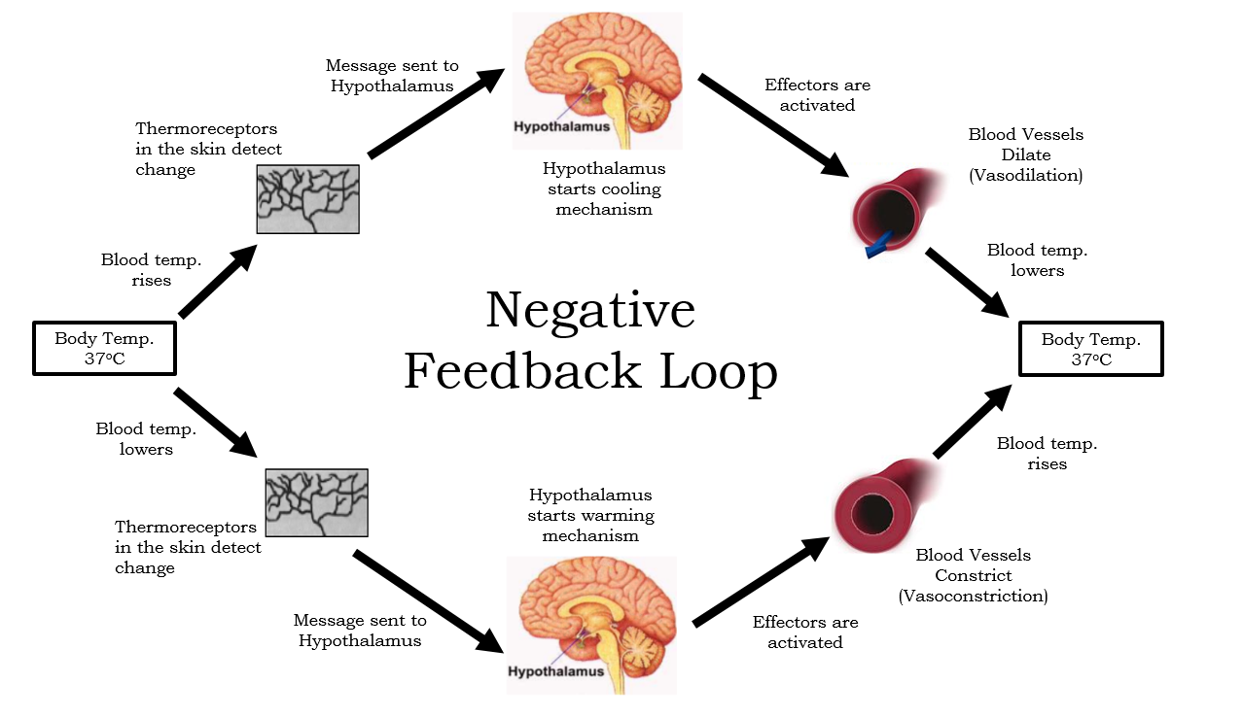

Answer: Predict what would happen to the organism if the hypothalamus is removed.

