Comparing the Needs of Living Things

Consider the three groups of living things below.

Three Kinds of Organisms
Animals  - Humans  - Cows  - Mealworms  - Fish  - Sponges | Plants  - Radishes  - Potato Plants  - Oak Trees  - Algae  - Grass | Decomposers  - Bread mold  - Mushrooms  - Yeast  - Soil Bacteria

Create a list of how these three types of organisms are alike and how they are different.
At your teacher’s signal, share your list with a partner.
- Star any characteristics you have both written.
- Add any new ideas your partner had in the Partner’s Ideas space.

My Ideas | My Partner’s Ideas
Characteristics they have in common: | Characteristics they have in common:
Characteristics that are different: | Characteristics that are different:

Your teacher will share three animations that examine characteristics of each of these types of organisms. Use the information from the animations to edit your lists.

Venn Diagram Directions
- Summarize: Use the word bank below to summarize your ideas about what characteristics different organisms share.
- Circle the characteristics that relate to the structure of organisms (what they are made of).
- Underline the characteristics that relate to the functions of organisms (what they do).
- Made of molecules
- Uses energy from other organisms
- Needs energy
- Recycles nutrients to soil
- Eats other organisms
Word Bank
- Consumer/heterotroph
- Producer/autotroph
- Made of cells
- Made of atoms
- Uses energy from light to make food
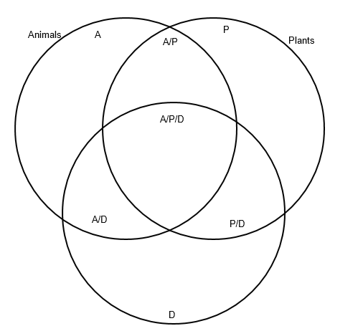
Decomposers

