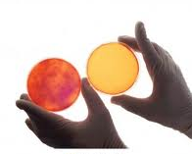
Damascus General Hospital
Request for Proposal
Cancer Center Campaign

What is cancer?
Cancer is the general name for a group of more than 100 diseases. Although there are many kinds of cancer, all cancers start because abnormal cells grow out of control.

The human body is made up of trillions of living cells. Normal body cells grow, divide, and die in well-organized, controlled process. During the early years of a person’s life, normal cells divide faster to allow the person to grow. After the person becomes an adult, most cells divide only to replace worn-out or dying cells, or to repair injuries.
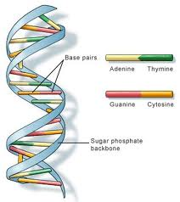
Cancer starts when cells in a part of the body start to grow out of control. Cancer cell growth is different from normal cell growth. Instead of dying, cancer cells continue to grow and form new, abnormal cells. Cancer cells can also invade (grow into) other tissues, something that normal cells cannot do. Growing out of control and invading other tissues are what makes a cell a cancer cell.
Cells become cancer cells when DNA (deoxyribonucleic acid) is damaged. DNA is in every cell, and directs all the cell’s actions. In a normal cell, when DNA gets damaged, the cell either repairs the damage or the cell dies. In cancer cells, the damaged DNA is not repaired, and the cell doesn’t die. Instead, the cell goes on making new cells that the body doesn’t need. These new cells all have the same abnormal DNA as the first cell does. People can inherit abnormal DNA, but most DNA damage is caused by mistakes that happen while the normal cell is reproducing or by something in the environment.

With the completion of the Human Genome Project in 2001, scientists have been able to study the connection between DNA and cancer, and create new tests and treatments that are available today. This has encouraged an increase in the number of specialized centers that focus on cancer detection and treatment.
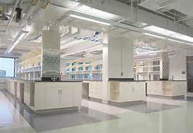
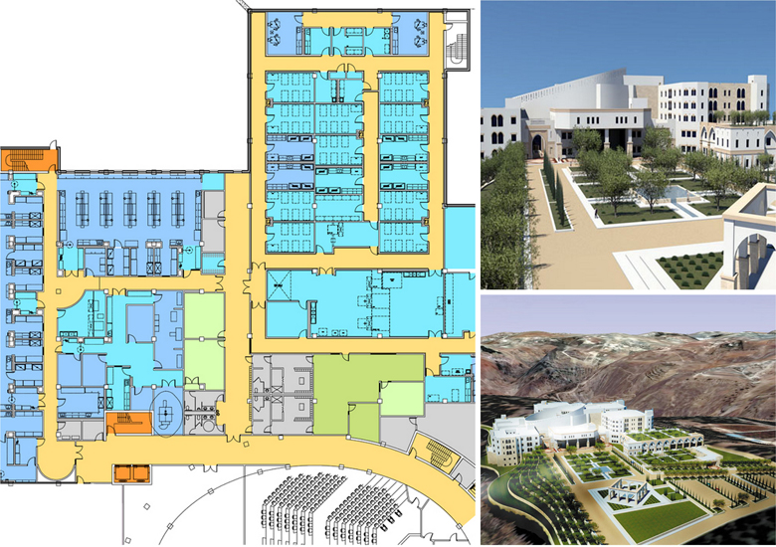

Request for Proposal

Across the United States, there are many cancer centers funded by the National Cancer Institute. These centers focus on research and training of medical staff, as well as patient care and education. Hospitals and other private medical organizations have also created cancer centers to provide care for their patients in one setting. Often people diagnosed with cancer must see many medical professionals during the course of their diagnosis, treatment and recovery; housing all of these services in one location can be very helpful.

Damascus General Hospital wants to lead a new educational campaign to raise awareness about the prevalence of cancer in the local community, the United States and in the world.

As your team develops an educational campaign for the Damascus General Hospital cancer center, you will work together to gain expertise in cytology (the study of cells), oncology (the study of cancer), genetics (the study of genes and DNA), medicine (the study of the human body), and statistics. The cancer center will focus on many different types of cancer. You will work in a team of 2 to become a specialist on one type of cancer. Patient education and support through genetic counseling, cancer education, and traditional therapies will be evaluated for inclusion in the cancer center services.

Part I. Survey the facts and determine need (completed during project connection lesson)
- You will research the most prevalent cancers per ethnic group in your geographical region, and compare with the five most prevalent cancers in the USA and worldwide.
- You will identify what is known about causes and treatments for the most prevalent cancers.
- You will provide statistical evidence to support the need for a comprehensive educational campaign about various types of cancer.
Part II. Explain the connection between our DNA and disease
You will compare and contrast the cell cycle of a normal cell and one that has lost control.
- You will study how changes in genes vital to cell cycle control can cause loss of control.
- You will contrast a cancer with a strong inherited risk with another associated with environmental risk factors.
- You will use existing microarray technology to learn how genetic risks can be identified.

Part III: Putting it all together & proposal preparation
You and a partner will create 2 posters about a specific type of cancer.
Poster 1 will about the causes of the cancer (genetic and/or environment) and the symptoms
Poster 2 will be about the treatment options and population distributions

.

Introduction to Cancer Center Education Campaign Unit

Name: Period:

Video Capture Sheet: https://www.youtube.com/watch?v=3qv8DTrRAoQ

- What are two characteristics of a cancer cell?

- What is the difference between benign and malignant tumors?

- What is metastasis?

- Name 3 risk factors for getting cancer?

Notes from 1st part of RFP
- What causes cancer?

- What do normal body cells do over the lifetime of a person?

- What is the purpose of cell division in a healthy person?

- How is cancer cell growth different than normal cell growth?

- How do cells become cancer cells?

- What happens in a normal cell when DNA is damaged?

- What happens in a cancer cell when DNA is damaged?

- What are the two ways that people can get abnormal DNA?

- What is a genome? (look it up)

- What was the Human Genome Project? (look it up)

- What has the Human Genome Project allowed us to do? (from text)

