Comparing a Growing Tree and a Growing Child
Consider what you have learned about cellular respiration, photosynthesis and biosynthesis. Think about the Key Questions for Matter and Energy for Systems. Use that information to compare the pathways that carbon atoms take through a growing tree and a growing child.
Word Bank: Biosynthesis
Carbon Dioxide
C-C bond
Cellular Respiration
C-H bond
Chemical energy
Circulatory system
digestion
Fat
Glucose
input
Light Energy
Monomer
output
Oxygen
Photosynthesis
Polymer
product
Protein
reactant
roots
stomata
transpiration
Water

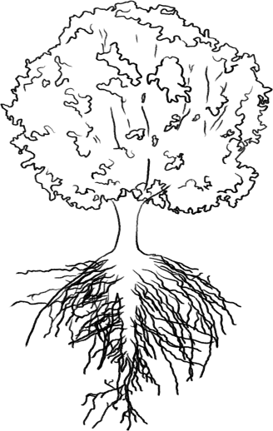  Draw and label arrows to show where carbon atoms enter and exit the tree and the pathway through the tree that they take to reach its growing root. | 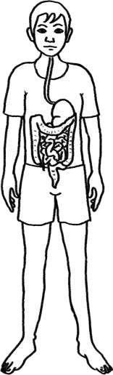  Draw and label arrows to show where the carbon atoms enter and exit the child and the pathway through the child that they take to reach a growing leg muscle.
Draw arrows connecting the Plant model to the Animal model

Word bank: These terms have been used as we studied matter and energy in living things. Select terms that are best suited for completing your task. You can add terms you believe are necessary that are not present.

Biosynthesis
Carbon Dioxide
C-C bond
Cellular Respiration
C-H bond
Chemical energy
circulate or circulation
digestion
Fat
Glucose
input
Light Energy
Monomer (small macromolecule)
output
Oxygen
Photosynthesis
Polymer (large macromolecule)
product
Protein
reactant
roots
stomata
transpiration
Water

