Name: ___________________________ Pd: ___
Carbon Cycle Reading
Background:
Nutrient cycles move and transfer important chemical elements like carbon, hydrogen, nitrogen, and oxygen throughout an ecosystem. These elements are a part of many important nutrients needed for living things. The cycling of these elements throughout an ecosystem is called biogeochemical cycles (bio: living, geo: earth, chemical: matter).
In biogeochemical cycles, matter is conserved (maintained) through many transformations and passes through the four spheres: atmosphere, hydrosphere, biosphere, and geosphere. We will be looking at the movement of carbon.
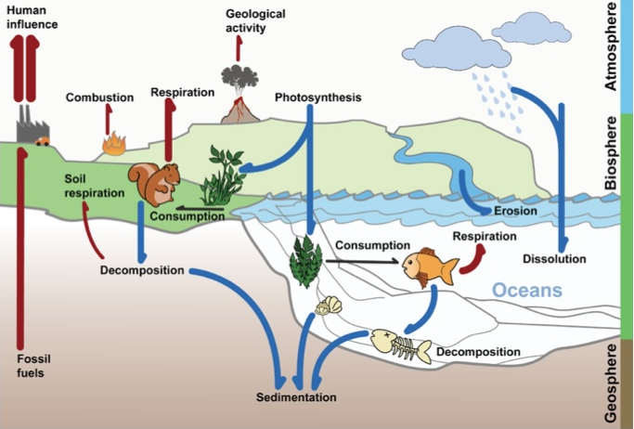
Air (Atmosphere):
Today, the amount of carbon in our atmosphere (air) increasing because more carbon is spending time stored as a gas. Carbon enters the atmosphere when carbon is released as a gas (CO₂) through respiration from the biosphere (living things), or when volcanoes erupt or gasses burn from the geosphere.
Carbon leaves the atmosphere and enters the biosphere through the process of photosynthesis when carbon is taken out of the air by plants to make food (glucose). It also enters the hydrosphere (water) through dissolution.

Water (Hydrosphere):
After rocks in the geosphere, water and more specifically the ocean (hydrosphere) is the next biggest storage site of carbon (with 38,000 billion tons of dissolved CO₂).
Plants (biosphere) and the ocean (hydrosphere) store half of the carbon we release into the atmosphere every year because they absorb slightly more CO₂ than they release.
Because CO₂ is soluble, it’s constantly dissolving into the ocean surface (dissolution) and being released from the ocean surface back to the atmosphere. This keeps the CO₂ levels in both the sea and the sky in reasonable balance.

Aquatic Plants (Biosphere):
After some carbon is dissolved from the atmosphere (air) into the water as CO₂, some plants can use the carbon to make food (glucose). The carbon leaves the hydrosphere (water) and enters the biosphere (living things) through the process of photosynthesis. When is a plant is eaten by animals, the carbon in the plant moves into the animal as glucose. The carbon moves up the food chain as animals eat other animals.
When plants and animals die and decompose the carbon can get stored in the geosphere (ground). Some carbon can become fossil fuel over millions of years and eventually released into the atmosphere through human influence.
Aquatic Animals (Biosphere):
When is a plant is eaten by animals, the carbon in the plant moves into the animal as glucose. The carbon moves up the food chain as animals eat other animals. Aquatic animals can release carbon back into the ocean (hydrosphere) through respiration.
When plants and animals die and decompose the carbon can get stored in the geosphere (ground). Some carbon can become fossil fuel over millions of years and eventually released into the atmosphere through human influence.
Land Plants (Biosphere):
Carbon leaves the atmosphere (air) and enters the biosphere (living things) through the process of photosynthesis when carbon is taken out of the air by plants to make food (glucose). When is a plant is eaten by animals, the carbon in plants moves into the animal as glucose. The carbon moves up the food chain as animals eat other animals.
When plants and animals die and decompose the carbon can get stored in the geosphere (ground). Some carbon can become fossil fuel over millions of years and eventually released into the atmosphere through human influence.
Land Animals (Biosphere):
When is a plant is eaten by animals, the carbon in the plant moves into the animal. The carbon moves up the food chain as animals eat other animals. Land animals can release carbon back into the air (atmosphere) through respiration.
When plants and animals die and decompose the carbon can get stored in the geosphere (ground). Some carbon can become fossil fuel over millions of years and eventually released into the atmosphere through human influence.
Sediment and Rock (Geosphere):
Carbon can moves through our planet over long time scales. For example, over millions of years weathering and erosion of rocks on land (geosphere) can add carbon to surface water which eventually runs off to the ocean (hydrosphere).
The geosphere always has the largest amount of carbon storage. 99.9% of carbon is stored in rock, mostly as limestone. Soil itself stores three times as much carbon as all the world’s plants. Parts of plant and animal remains (biosphere) can stay in the soil for hundred of year, making it another large carbon storage site. Soil holds about 1550 billion tons of carbon this way—about three times as much as the total carbon stored in all the plants (550 billion tons) and animals (2 billion tons) alive today.

Name: __________________________________________________ Date: ________ Period: _____
Carbon Cycle and Spheres Interactions

List what makes up each system below:
- Biosphere: _____________________________________________________________________
- Geosphere: ____________________________________________________________________
- Atmosphere: ___________________________________________________________________
- Hydrosphere:___________________________________________________________________
Describe how each of the systems interact with one another in the Carbon Cycle.

- How do the Biosphere and Geosphere interact? __________________________________
______________________________________________________________________________
- How do the Geosphere and Hydrosphere interact? ________________________________
______________________________________________________________________________
- How do the Hydrosphere and Atmosphere interact? _____________________________
______________________________________________________________________________
- How do the Biosphere and Atmosphere interact? ______________________________
______________________________________________________________________________
- How do the Biosphere and Hydrosphere interact? ________________________________
______________________________________________________________________________
- How do the Atmosphere and Geosphere interact? ______________________________
___________________________________________________________________________

