Name: ____________________________________________________ Date: ________ Period: _____

ECOLOGICAL SUCCESSION SIMULATION

Directions: Follow along with the Succession Animation and answer the following questions. https://sites.google.com/site/successionanimation/

SUCCESSION
Choose the tab labeled “Succession.”
- Define Succession: ____________________________________________________________________
____________________________________________________________________________________

PRIMARY SUCCESSION
Choose the tab labeled “Primary Succession.” Using the “Temperature and Rainfall” slider control, select “LOW” temperature and then watch the animation.

- What creates the island at the very beginning? ______________________________________________

- What happens with TOPSOIL and NUTRIENTS as time passes? _______________________________
- IN ORDER OF SUCCESSION, describe the sequence of ecological changes that take place:
  - _________________________________________________________________________________
  - _________________________________________________________________________________
  - _________________________________________________________________________________
  - _________________________________________________________________________________
  - _________________________________________________________________________________

Now set the “Temperature and Rainfall” slider to MEDIUM and then watch the animation. Repeat on HIGH.
- How much TIME does PRIMARY SUCCESSION take when temperature and rainfall are…
  - Low? ___________________________________________________________________________
  - Medium? ________________________________________________________________________
  - High? ___________________________________________________________________________
- Why do you think the length of time varies based on temperature and rainfall? ________________________________________________________________________________________________________________________________________________________________________

- The volcanic island is solid rock. Where does “brown soil” come from? __________________________
____________________________________________________________________________________
SECONDARY SUCCESSION
(Choose the tab labeled “Secondary Succession” Click the arrow to start the fire in the forest.)

- How are the TOP SOIL and NUTRIENTS changing during this secondary succession?
________________________________________________________________________________________________________________________________________________________________________
- Is the ORDER OF SUCCESSION the same as with Primary Succession? _________________________
- Explain how PRIMARY and SECONDARY succession compare when it comes to the amount of TIME it takes and the development of TOPSOIL and NUTRIENTS in the ecosystem. Give reasons why they are the same or different.
________________________________________________________________________________________________________________________________________________________________________
________________________________________________________________________________________________________________________________________________________________________

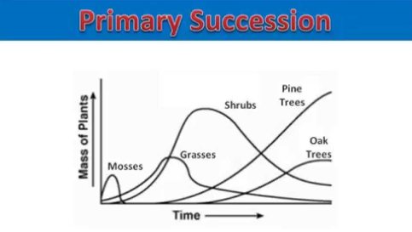
Source: https://www.youtube.com/watch?v=BihEmMEg0KU
Apply your knowledge and write an explanation for this graph. How would the graph look different if it was Secondary Succession instead of Primary? Why?

Primary Succession Graph Explanation
If it was Secondary Succession, it would…..

Test yourself by playing the Succession Game at:

https://biomanbio.com/HTML5GamesandLabs/EcoGames/succession_interactive.html

