Anaerobic Respiration Notes
Name:
Anaerobic Respiration
- Does _____________require __________________
- Occurs in the ____________________________
- Much less efficient than aerobic (cellular) respiration because only __________molecules of ATP are formed (instead of 38).
- Two main types of Anaerobic Respiration:
  - ______________________Fermentation
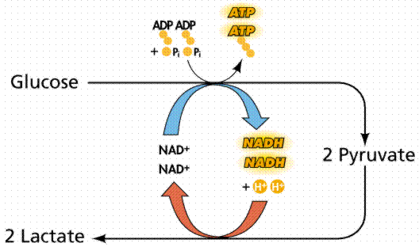
  - _______________________Fermentation
Lactic Acid Fermentation
- Used by ________________ cells when oxygen has run out
- Pyruvate (from glycolysis) is converted to lactic acid.
- Occurs in muscle cells, as well as in some bacteria and fungi.
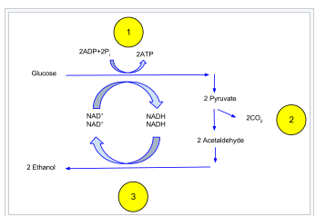
- The liver converts lactic acid back to pyruvate once oxygen is available.
Alcoholic Fermentation
- Used by many _______________________(ex. yeast)
- Pyruvate is converted to _______ and ethyl alcohol

Yeast Demonstration:
Yeast (single-celled eukaryotic organisms) perform alcoholic fermentation. The products of alcoholic fermentation are ethyl alcohol (drinking alcohol) and carbon dioxide. This process is used to make common food and drinks. For example, alcoholic fermentation is used to bake bread. The carbon dioxide bubbles allow the bread to rise and become fluffy. Meanwhile, the alcohol evaporates. In wine making, the sugars of grapes are fermented to produce wine.
- Are yeast biotic or abiotic?

- What is added to the yeast for them to do cellular respiration?

- What is the chemical equation that is happening in the yeast?
- What gas is being produced? What is the evidence that a gas is being produced?

Muscle Fatigue activity:
Animals and some bacteria and fungi carry out lactic acid fermentation. Lactic acid is a waste product of this process. Our muscles perform lactic acid fermentation during strenuous exercise, since oxygen cannot be delivered to the muscles quickly enough. The buildup of lactic acid is believed to make your muscles sore after exercise. Bacteria that produce lactic acid are used to make cheese and yogurt. The lactic acid causes the proteins in milk to thicken. Lactic acid also causes tooth decay, because bacteria use the sugars in your mouth for energy.
Muscle Fatigue Procedures

- Partner A holds the binder clip in their hand and squeezes as many times as possible in 2 minutes. Record the number of squeezes in each 30 sec interval.
- Partner B holds the binder clip in their hand and squeezes as many times as possible in 2 minutes. Record the number of squeezes in each 30 sec interval.

# of Squeezes/ 30 sec
2 min total
Partner A
Partner B

- Did your rate of squeezing increase or decrease as time went on?

- How did your forearm feel as you continued to squeeze?

- What process is taking place in the muscle cells in your forearm as those cells use up the oxygen?

- What is the product of this type of respiration?

- Why can’t you do this type of respiration forever?

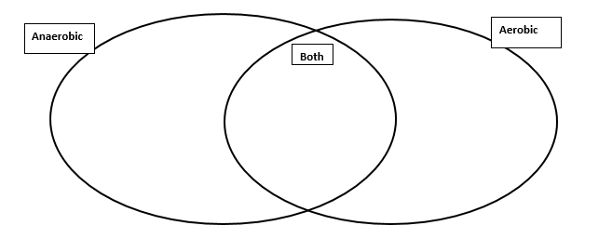
Aerobic vs. Anaerobic Respiration
Name:

Word Bank:
No O₂ Energy is released With Oxygen Fermentation Energy is needed
Occurs in mitochondria Lactic Acid is produced Glucose is used 36-38 ATP
Alcohol is produced 2 ATP CO₂ produced (in one type) H₂O is produced
Occurs ONLY in the cytoplasm Does Glycolysis Does Kreb Cycle and ETC

