Name: Period: _________________
Endangered Species Test Review Packet
*In order to get points for this packet, it must be turned in before you take your test.

- Define:
  - Population= Group of same species in the same area at the same time that interact w/ each other.
  - Community= All of the different living organisms in an ecosystem (just biotic factors)
  - Ecosystem= Biotic + Abiotic (All of the living organisms + physical features of an area)
  - Biome= An area with a similar temperature, altitude, rainfall, latitude (ex: savannah, boreal forest)

- Identify the following examples using the vocab words from question #1.
  - The Boreal Forrest is defined by its temperature, altitude, rainfall, and latitude. Biome
  - At a water hole in Africa there are often Giraffes, zebras, gazelles and elephants Community
  - A salt water marsh has soil that is water logged. That causes the decomposers to break down the dead plants much more slowly. Certain types of plants develop adaptations to live in salty water and animals use those plants as habitat and food. Ecosystem
  - All of the Grizzly Bears in Yellowstone park that have the ability to interact with each other. Population

- Classify the following as Abiotic or Biotic
  - Temperature- Abiotic
  - Producers- Biotic
  - Intensity of Light- Abiotic
  - Rainfall- Abiotic
  - Decomposers- Biotic
  - Disease-Biotic
  - Keystone Species- Biotic

- Define a limiting factor= Something that causes a population to not increase in size forever (stops exponential growth)
- Identify 3 density dependent limiting factors= Competition, Disease, Predation, Amount of producers
- Identify 3 density independent limiting factors= Amount of rainfall, Fire, Natural Disasters, Pollution

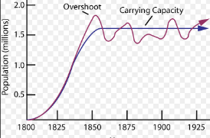
- What is “carrying capacity”? What will affect carrying capacity? Carrying capacity is the maximum population size that an ecosystem can support. It is affected by abiotic and biotic limiting factors such as space, competition, amount of water and # of predators. On a population graph the carrying capacity is shown as the average once the population has stopped increasing exponentially and started to level out. This happens when birth rate +immigration = death rate + emigration

- A. Identify which graph shows Logistic growth and which shows Exponential Growth: First Graph

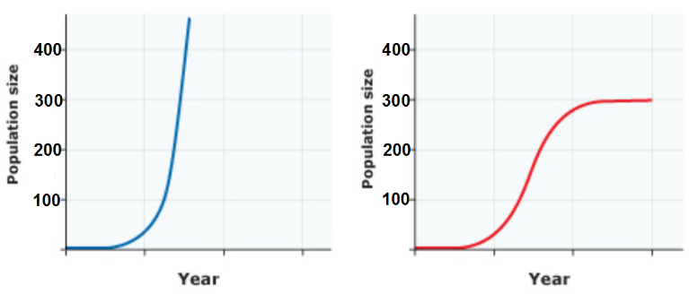
B. On the logistic growth population graph, what is the carrying capacity for that population?__300_______ Draw in a dotted line to show carrying capacity.

- What type of growth would you expect to see if a species moves into a new ecosystem and has very few limiting factors? Exponential Growth

- What type of growth would you expect to see if the birth rate equals the death rate?
Logistic Growth…Carrying Capacity
- What will happen to the carrying capacity of a system if the number of producers decreases?
The carrying capacity of the ecosystem will decrease
- What will happen to the biodiversity of an ecosystem if the number of producers decreases?
The biodiversity of the ecosystem will decrease as the number of producers decreases.
- How do you measure biodiversity?
Biodiversity is measured by determining the species abundance and species richness. Also determining the genetic diversity and ecosystem complexity.
- A community has 8 robins, 10 blackbirds, 12 sparrows, 4 oak trees and 3 pine trees.
  - What is the species richness? 5 species
  - What is the species abundance? 37 organisms

- A niche is the role an organism plays in its ecosystem. The more complex an ecosystem the more niches that are filled. If a species becomes endangered, how does that affect the interactions of the species in the ecosystem?
If a species is endangered then there are less roles in the ecosystem that are filled. If the endangered species is a producer there may be less herbivores. If the endangered species is a keystone species it may affect many organisms in the ecosystem.

- Identify the type of ecosystem service: (Regulating, Supporting, Cultural, Provisioning)
- Yellowstone is a beautiful environment with amazing views of mountains and incredible wildlife. Many people enjoy spending time at Yellowstone and feeling close to nature. Cultural
- The area around Yellowstone is drilled to obtain natural gas reserves. Trees are cut down to provide timber for construction. Provisioning
- The insects in Yellowstone pollinate the flowers which produce fruits useful to animals. Regulating
- Carbon is stored in the trees, soil, and underground the Yellowstone ecosystem. Supporting

- Identify whether each of the following is a characteristic of a high density population or a low density population.
- High reproduction rate high density population
- Apex Predator (top predator) low density population
- Territorial Animal low density population
- Social Insects high density population

- Identify the type of population distribution (clumped, random, or uniform)
- Herds of zebras, flocks of geese, murders of crows Clumped
- Emperor Penguins aggressively defend the territory around their family. Uniform
- Plant that have seeds that are dispersed by the wind and can grow in a variety of areas. Random

- What method would you use to measure a population of sea otters? Mark and Recapture

- What method would you use to measure the number of star fish on the bottom of the ocean floor?
Quadrats
- Identify the major abiotic differences in the 2 biomes below. Rainfall and temperature
Biome A Biome B
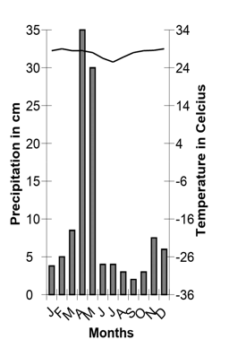
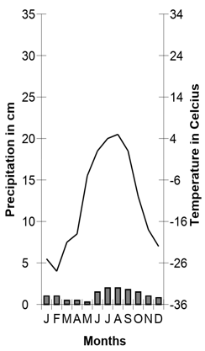

- Explain which biome above you believe would have a greater biodiversity and how the abiotic factors shown in the climatogram would affect the carrying capacity of ecosystems within that biome.
Biome B probably has a greater biodiversity because it has warmer temperatures and more rainfall. This would lead to a greater carrying capacity for the ecosystem and most likely more biodiversity.

- How do autotrophs get their energy?
Autotrophs get their energy from the sun.
- What is another name for a producer?
Autotrophs are producers
- What is another term for an herbivore? How do they get their energy?
Herbivores are primary consumers and heterotrophs. They get their energy from eating plants.
- What is another term for a secondary, tertiary, or quaternary consumer? How do they get their energy?
Secondary consumers, tertiary consumers and quaternary consumers are all carnivores. They get their energy from eating animals.

- What is a trophic level?
A trophic level is the feeding level of a group of organisms (ex: producer, primary consumer…etc)
Match the following words to the descriptions below: Omnivore, Carnivore, Herbivore

- ________Herbivore_______________ are organisms that feed exclusively on photosynthetic producers (photosynthetic producer means plants).
- _________Carnivore_______________________ are organisms that feed on other consumers.
- ____________Omnivore_______________ are organisms that can feed on both producers and consumers.
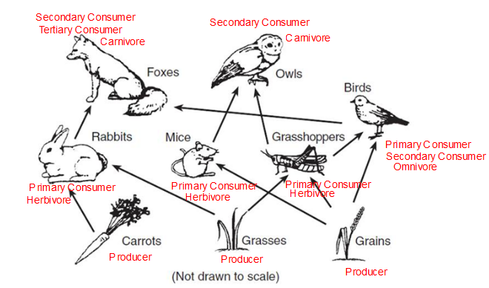
Label the energy pyramid with the correct trophic levels.
Use the food web below to answer the following questions.
- What is the species richness of the food web above? 9 species

- List the trophic level(s) owls occupy in this food web: Secondary Consumer/Carnivore
- List the trophic level(s) birds occupy in this food web: Primary Consumer/Secondary Consumer/Omnivore

- Foxes and owls will be much rarer than grasses, grains, and carrots. Why is this? There is less every on the top of the food web than at the bottom. Most energy found in producers.

- All food webs end with decomposers returning raw materials back to the producers.

- How will the food web be affected if a farmer uses insecticide to kill the grasshoppers?
The number of birds will decrease. The number of foxes may also decrease. The number of grasses will increase.

- What might happen to the biodiversity of the ecosystem if one of the top predators was removed?
The biodiversity will decrease. This happens because the herbivore population gets too big and they eat too many of the producers. The most efficient herbivore may outcompete the others and the biodiversity of the system decreases.

- Grasses Grasshoppers Birds Foxes
What is the trophic level of the fox?
Tertiary Consumer
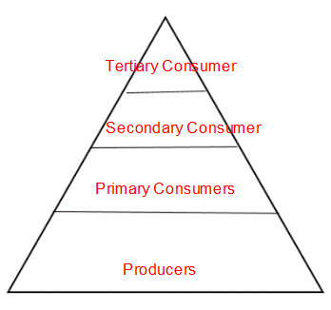
- What happens to the amount of available energy as you go up the food chain?
The amount of available energy decreases
- Label the energy pyramid on the right with the following:
Secondary Consumers
Producers
Tertiary Consumers
Primary Consumers

- Wolves help to regulate the deer population. Deer feed on young trees. When the wolves in Yellowstone National park were all gone the young trees were destroyed by the large deer population. When the wolves were reintroduced into Yellowstone the tree population was much healthier. What term describes the wolves in the Yellowstone ecosystem?
The Wolves are a keystone species because they have an impact on many different types of species.
- In a meerkat colony, one meerkat will be the sentry watching for danger while the others forage. If the sentry meerkat sees danger, it will sound an alarm call, warning the others to retreat to their burrows. How does this cooperative behavior impact the individual meerkat? How does this behavior impact the group?
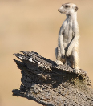
This behavior helps to keep the individual meerkats alive and helps to keep the numbers in the colony up.

- In many areas farms that grow only one species of plant will replace natural forests. Describe how this change affects the food webs of that area, the species richness and diversity and the carrying capacity. How might this affect endangered species in this area?

Food webs will be changed because the species richness will be decreased and the herbivores that feed on the native plants that have been replaced will no longer have a food source. This will cause the biodiversity of the ecosystem to decrease. The carrying capacity of the ecosystem will also decrease because there are less varieties of biotic resources for herbivores and carnivores. An endangered species may rely on one or a few types of producers to obtain their food. When these producers are replaced with crops the endangered species may lose its food source and habitat and its population may decline even more. Crops may also affect the abiotic resources of the ecosystem. Crops often need more water than native plants. They may cause native plants not to be able to grow because of their water usage.

Succession:
- Put the following in order for primary succession:
Trees – Grasses – Bushes—Lichens/Mosses – Bare Rock
Bare Rock- Lichens/Mosses- Grasses- Bushes- Trees
- What is a pioneer species?
The first species to come back after a disaster. Often Lichen/Mosses (or grasses for secondary succession)

- How does the biodiversity change during succession?
Biodiversity increases A LOT during succession. The climax community has a much greater species richness and abundance than the pioneer community.

- What is a climax community?
A stable community after many years of succession with all of the niches filled.

