Name: Period: _________________
Endangered Species Test Review Packet
*In order to get points for this packet, it must be turned in before you take your test.

- Define:
  - Population______________________________________________________________________
  - Community_____________________________________________________________________
  - Ecosystem______________________________________________________________________
  - Biome

- Identify the following examples using the vocab words from question #1.
  - The Boreal Forrest is defined by its temperature, altitude, rainfall, and latitude.
  - At a water hole in Africa there are often Giraffes, zebras, gazelles and elephants
  - A salt water marsh has soil that is water logged. That causes the decomposers to break down the dead plants much more slowly. Certain types of plants develop adaptations to live in salty water and animals use those plants as habitat and food.
  - All of the Grizzly Bears in Yellowstone park that have the ability to interact with each other.

- Classify the following as Abiotic or Biotic (Circle your choice)
  - Temperature Abiotic or Biotic
  - Producers Abiotic or Biotic
  - Intensity of Light Abiotic or Biotic
  - Rainfall Abiotic or Biotic
  - Decomposers Abiotic or Biotic
  - Disease Abiotic or Biotic
  - Keystone Species Abiotic or Biotic

- Define a limiting factor
- Identify 3 density dependent limiting factors
- Identify 3 density independent limiting factors

- What is “carrying capacity”? What will affect carrying capacity?

- A. Identify which graph shows Logistic growth and which shows Exponential Growth:

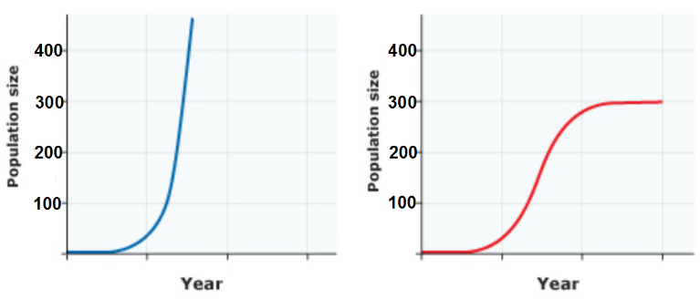
B. On the logistic growth population graph, what is the carrying capacity for that population? _________

C. Draw in a dotted line to show carrying capacity.

- What type of growth would you expect to see if a species moves into a new ecosystem and has very few limiting factors?

- What type of growth would you expect to see if the birth rate equals the death rate?

- What will happen to the carrying capacity of a system if the number of producers decreases?

- What will happen to the biodiversity of an ecosystem if the number of producers decreases?

- How do you measure biodiversity?

- A community has 8 robins, 10 blackbirds, 12 sparrows, 4 oak trees and 3 pine trees.
  - What is the species richness?
  - What is the species abundance?

- A niche is the role an organism plays in its ecosystem. The more complex an ecosystem the more niches that are filled. If a species becomes endangered, how does that affect the interactions of the species in the ecosystem?

- Identify the type of ecosystem service: (Regulating, Supporting, Cultural, Provisioning)
- Yellowstone is a beautiful environment with amazing views of mountains and incredible wildlife. Many people enjoy spending time at Yellowstone and feeling close to nature.
- The area around Yellowstone is drilled to obtain natural gas reserves. Trees are cut down to provide timber for construction.
- The insects in Yellowstone pollinate the flowers which produce fruits useful to animals.
- Carbon is stored in the trees, soil, and underground the Yellowstone ecosystem.

- Identify whether each of the following is a characteristic of a high density population or a low density population.
  - High reproduction rate high density population or a low density population.
  - Apex Predator (top predator) high density population or a low density population.
  - Territorial Animal high density population or a low density population.
  - Social Insects high density population or a low density population.

- Identify the type of population distribution (clumped, random, or uniform)
- Herds of zebras, flocks of geese, murders of crows
- Emperor Penguins aggressively defend the territory around their family.
- Plant that have seeds that are dispersed by the wind and can grow in a variety of areas.

- What method would you use to measure a population of sea otters? (Quadrat or Mark and Recapture)

- What method would you use to measure the number of star fish on the bottom of the ocean floor?
(Quadrat or Mark and Recapture)

- Identify the major abiotic differences in the 2 biomes below. ___________________________________________________________________________
Biome A Biome B
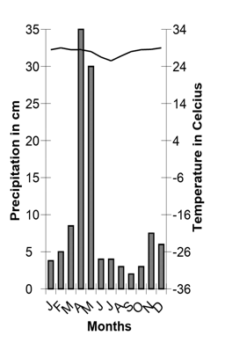
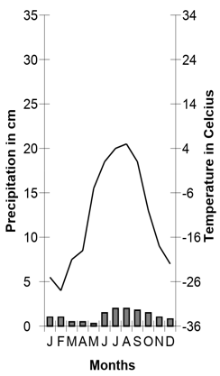

- Explain which biome above you believe would have a greater biodiversity and how the abiotic factors shown in the climatogram would affect the carrying capacity of ecosystems within that biome.

- How do autotrophs get their energy?

- What is another name for a producer?

- What is another term for an herbivore? How do they get their energy?

- What is another term for a secondary, tertiary, or quaternary consumer? How do they get their energy?

- What is a trophic level?

Match the following words to the descriptions below: Omnivore, Carnivore, Herbivore

- ________________________________ are organisms that feed exclusively on photosynthetic producers.
- ________________________________ are organisms that feed on other consumers.
- ________________________________ are organisms that can feed on both producers and consumers.

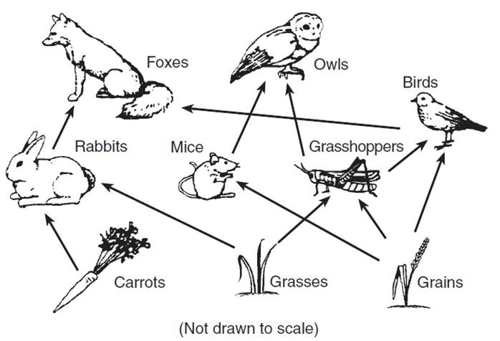
Use the food web to answer the following questions.
- What is the species richness of the food web?

- List the trophic level(s) owls occupy in this food web:
- List the trophic level(s) birds occupy in this food web:

- Foxes and owls will be much rarer than grasses, grains, and carrots. Why is this?

- All food webs end with __________________________ returning raw materials back to the producers.

- How will the food web be affected if a farmer uses insecticide to kill the grasshoppers?

- What might happen to the biodiversity of the ecosystem if one of the top predators was removed?

- Grasses Grasshoppers Birds Foxes
What is the trophic level of the fox?

- What happens to the amount of available energy as you go up the food chain?

- Label the energy pyramid on the right with the following:
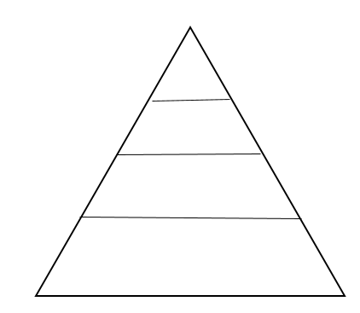
Secondary Consumers
Producers
Tertiary Consumers
Primary Consumers

- Wolves help to regulate the deer population. Deer feed on young trees. When the wolves in Yellowstone National park were all gone the young trees were destroyed by the large deer population. When the wolves were reintroduced into Yellowstone the tree population was much healthier. What term describes the wolves in the Yellowstone ecosystem?

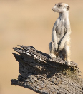
- In a meerkat colony, one meerkat will be the sentry watching for danger while the others forage. If the sentry meerkat sees danger, it will sound an alarm call, warning the others to retreat to their burrows. How does this cooperative behavior impact the individual meerkat? How does this behavior impact the group?

- In many areas farms that grow only one species of plant will replace natural forests. Describe how this change affects the food webs of that area, the species richness and diversity and the carrying capacity. How might this affect endangered species in this area?

Succession:
- Put the following in order for primary succession:
Trees – Grasses – Bushes—Lichens/Mosses – Bare Rock

- What is a pioneer species?

- How does the biodiversity change during succession?

- What is a climax community?

