Name: ___________________________ Period: _____

**Study Guide for Cell Cycle, DNA and Protein Synthesis Test- Due Monday March 9**

Label each part of the cell cycle picture on the right with the name of the phase:

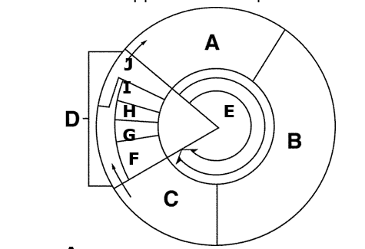

A: ______________________________________

B: _______________________________________

C: ______________________________________

D: (F-I) _________________________________

E: (A, B, and C) :___________________________

F: ________________________________________

G: ________________________________________

H:_________________________________________

I:__________________________________________

J:________________________________________

Identify the phases in the picture to the right:

1:____________________

2:____________________

3: ___________________

4: ___________________

5:____________________

1. What occurs in the cell during interphase? Is the DNA coiled or uncoiled? _______________________________

_____________________________________________________________________________________________

2. What is the purpose of mitosis? ________________________________________________________________

3. What molecules act as checkpoints? ____________________________________________

4. What molecules are made to express a trait? ______________________________________________________

5. What happens when an oncogene is active in a cell?__________________________________________________

6. What is the function of a tumor suppressor gene in a healthy cell? ______________________________________

7. What is the function of DNA repair genes? ________________________________________________________

8. What does a microarray measure? ____________________________________________________________

9. If genes are ONLY active in cancer cells they will appear what color on a microarray? __________________

10. If genes are ONLY active in healthy cells they will appear what color on a microarray? __________________

11. If gene are active in both types of cells they will appear what color on a microarray? ____________________

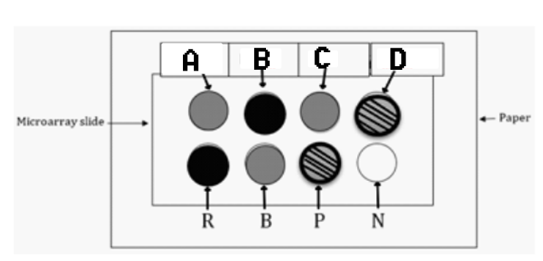

12. A, B, C and D are unknown genes. R, B, P and N are the controls. Which gene is active in a cancer cell? _____

13. Which gene or genes are found in healthy cells? ____________________________

14. Do all cells in the body have the same chromosomes, DNA, and genes? _________________________

15. Do all cells express all of the genes? ___________________________________

16. What type of molecule is made as a result of a gene being “expressed”? ___________________________

17. What happens to the ability of a cell to perform its functions if there is a mutation in the DNA and the gene cannot be expressed? __________________________________________________________________

18. What happens in the cell if an activator is added to a gene? _____________________________________

19. Identify each of the pictures below:



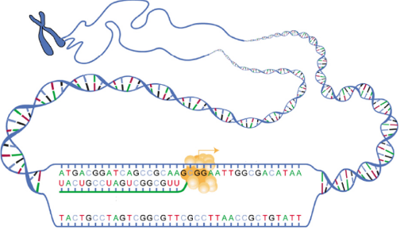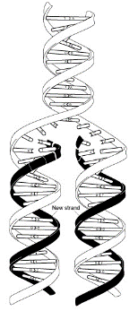



**Nucleic Acid Structure and Function:**

19. Place the following vocab into the Venn diagram below.

|  |  |  |
| --- | --- | --- |
| Deoxyribose  Phosphate  nucleotides  ribose  Contains information | Thymine  Guanine  Cytosine  Uracil  Adenine | Single-stranded  Double-stranded  Involved in Transcription  Involved in Translation  Found in Nucleus  Found in Cytoplasm |

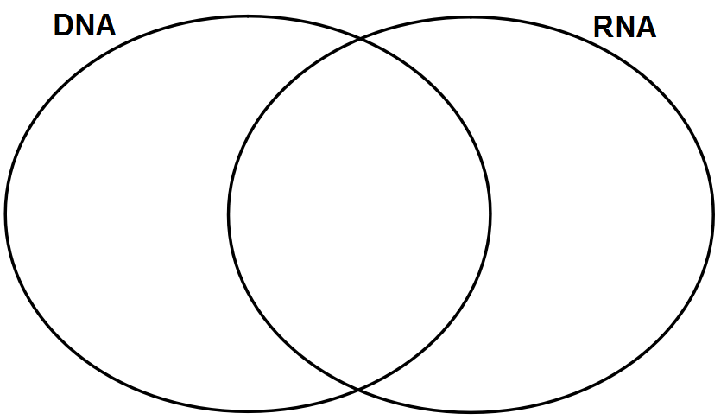

1. **A DNA molecule contains 100 base pairs of nucleotides. 40 of the nucleotides are paired with Adenine. How many of the nucleotides are paired with guanine?**
2. **a. What is the purpose of DNA Replication? ____________________________________________**
3. **When does it occur? _____________________________________________________________**
4. A. What is the purpose of protein synthesis? ______________________________________________

**B. When does it occur? ______________________________________________________________**

1. What are the 2 parts of protein synthesis? _______________________ and ___________________
2. **What is transcription? ____________________________________________________________**
3. **What is translation? ______________________________________________________________**
4. **Fill in the blanks with the appropriate information:**

**DNA: 5’ A T C C T A G G T A A G G G C 3’**

**Complementary DNA: 3’ _______________________________5’**

**mRNA: 5’ _______________________________ 3’**

**Amino acid chain: _________________________________**

**DNA: 5’ C G G C A T C A C A G C A G G G 3’**

**Complementary DNA: 3’ _______________________________ 5’**

**mRNA: 5’ _______________________________ 3’**

**Amino acid chain: _________________________________**

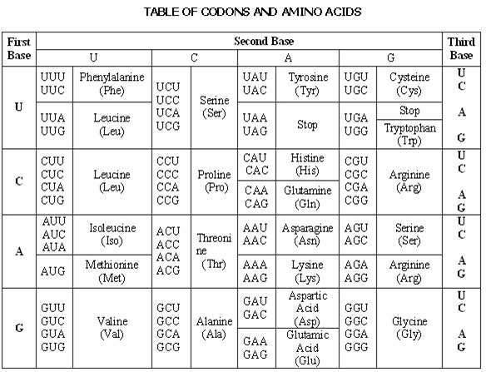

1. What is a random change in DNA called? ___________________
2. If the DNA in a gene is changed, what molecule will most likely be altered? _________________________
3. In one type of mutated gene, AAA replaced the normal ATA in the DNA code. What amino acid substitution has taken place in the mutated hemoglobin?
   1. Arg has replaced Tyr
   2. Lys has replaced Arg
   3. Phe has replaced Tyr
   4. Lys has replaced Asp
4. **Match the following words to the appropriate numbers:**

**Word bank:** Ribosome, DNA, Amino acid chain, Amino Acid, anticodon, codon, mRNA, tRNA

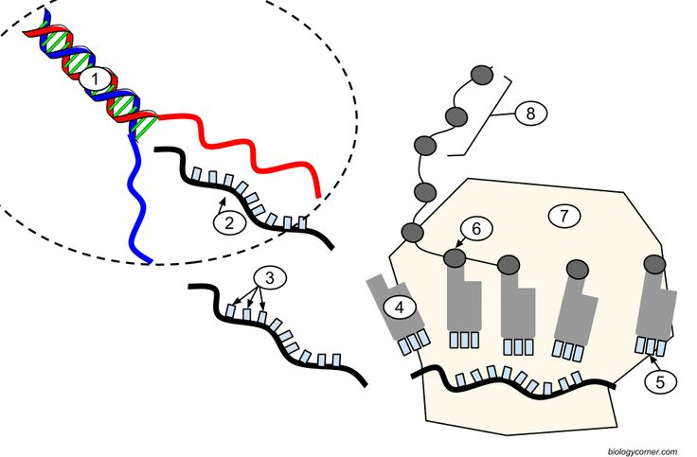

1. ________________
2. ________________
3. ________________
4. ________________
5. ________________
6. ________________
7. ________________
8. ________________

31. **Label the following on this diagram:**

**DNA, hydrogen bond, sugar phosphate backbone, nucleotide, base pair**

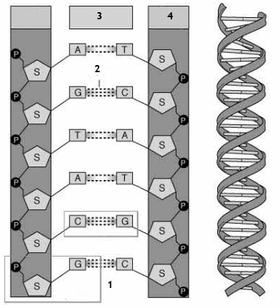

**Meiosis:**

1. What is Meiosis? What is the final result? ____________________________________________
2. Define “Diploid”. _______________________________________________________________
3. Define “Haploid”. _______________________________________________________________
4. What kind(s) of cells are diploid in the human body? ____________________________________
5. What kinds(s) of cells are haploid in the human body? ___________________________________
6. How many times does the cell divide in meiosis? _______________________
7. What is crossing over? What is the result? What process is it a part of?
8. Which of the following leads to greater variation? (Crossing Over, Independent Assortment, Random Fertilization, DNA Replication) (can be more than one answer)
9. *The following diagram shows Meiosis. On this diagram, label:*
   * 1. all cells as haploid or diploid
     2. Gametes
     3. Where crossing over takes place

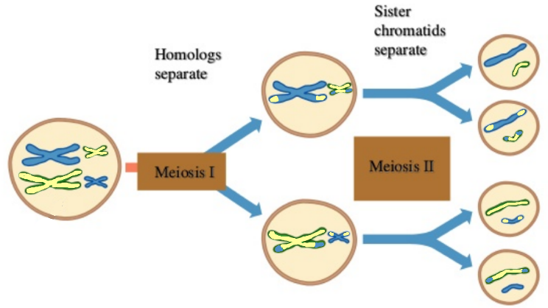

1. What is fertilization? ___________________________________
2. What is the end result of fertilization? ____________________________
3. Label cells as haploid or diploid, and label zygote, male gamete, female gamete. Write in chromosome number for humans.

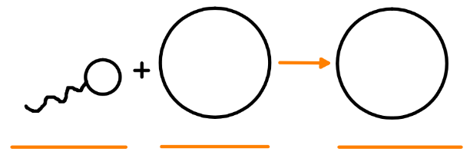

1. If an organism’s skin cells have 40 chromosomes, how many chromosomes are in its:
   1. Sperm cells: ___________ d. Zygote: ___________
   2. Gamete: ___________ e. Brain cells: ___________
   3. Egg cells: ___________

**Mitosis vs Meiosis**

1. How is the purpose of meiosis different from the purpose of mitosis?
2. Mitosis, meiosis or both:
   * 1. Creates skin cells: ________________ Includes two cell divisions: _________________
     2. Creates sperm cells: _______________ Creates variation in offspring: _______________
     3. Creates cancer cells: _______________ Type of cell division: ________________
     4. Creates gametes: _______________