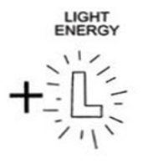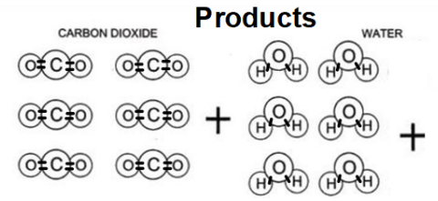

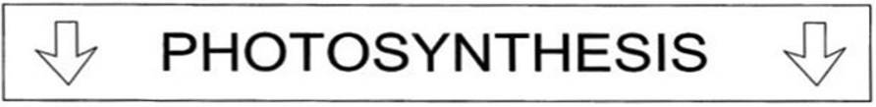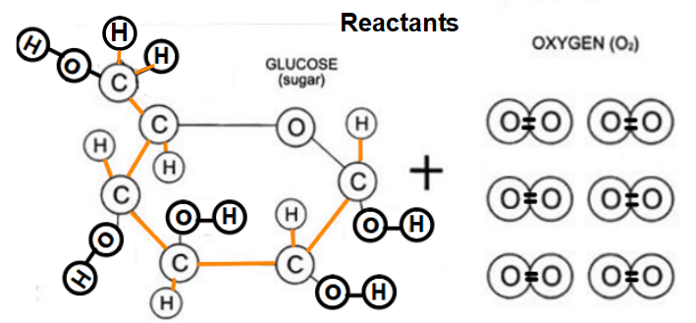

**1 Glucose Molecule**

Where in the plant is glucose made?

During which stage of photosynthesis is it made?

Which part of the chloroplast makes glucose?

What type of energy is glucose?

What part of the glucose holds the energy?

What type of tissue in the plant transports the sugar?

**6 Water Molecules**

Where does it enter the plant?

What type of tissue does it travel in to get to the leaves?

During which stage of photosynthesis is it used?

Which part of the chloroplast uses H2O?

**6 Oxygen Molecules**

Where does it exit the plant?

During which stage of photosynthesis is it made?

Which part of the chloroplast makes O2?

**Chloroplast**

What process takes place in the chloroplast?

What takes place in the grana? What is made?

What takes place in the stroma? What is made?

**Light**

Where does it enter the plant?

During which stage of photosynthesis is it used?

Which part of the chloroplast uses Light?

What form of energy is light?

**6 Carbon Dioxide Molecules**

Where does it enter the plant?

During which stage of photosynthesis is it used?

Which part of the chloroplast uses CO2?