NAME: ____________________________________ Period: _________
How Humans Disrupt Ecosystems

An ecosystem is comprised of communities of plants, animals and other organisms in a particular area that interact with each other and their surrounding environment. Both biotic (living) and abiotic (non-living) things are considered part of an ecosystem. Humans threaten ecosystems by producing waste, damaging habitats and removing too many species without giving the ecosystem time to naturally regenerate.

Pollution
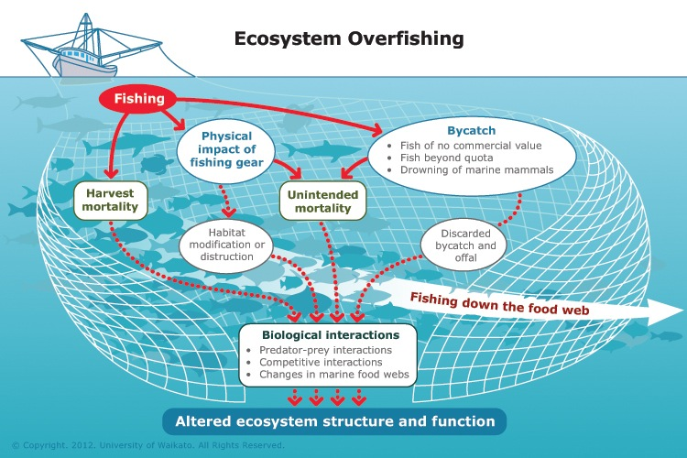
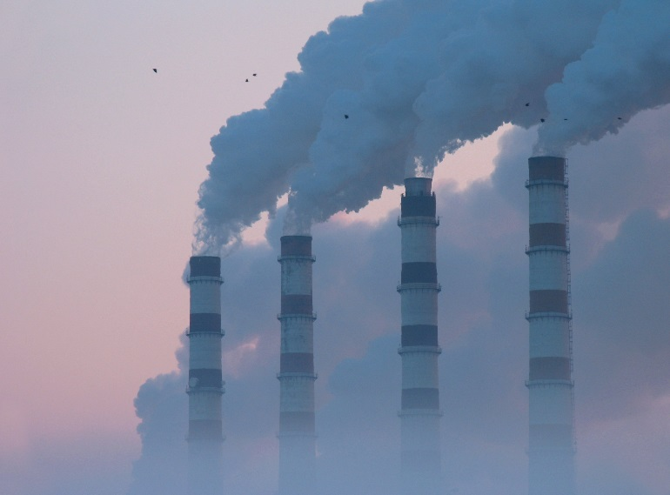
Since the Industrial Revolution, humans have relied heavily on the combustion of fossil fuels, which has led to an increase in the amount of carbon dioxide in the atmosphere. Vehicles, trains, and planes emit toxic gases that include carcinogenic (cancer causing) particles and irritants, creating air pollution. In farming the use of pesticides and fertilizers containing nitrogen migrate into groundwater and bodies of water, poisoning ecosystems. Plants and animals die from exposure to pollutants such as excess nutrients from chemical fertilizers and other harmful chemicals.

Overhunting
When humans over-hunt key predators such as lions, tigers and bears, they remove the very animals that keep plant consumers in balance and prevent overgrazing. A healthy ecosystem has a balance of predators and prey that naturally cycle through life and death sequences. Over-hunting often results in ecosystem species imbalance and environmental stress. Humans also practice commercial overfishing, where massive fishing nets result in “bycatch,” in which unwanted fish are caught in nets and then thrown away. Bycatch results in the death of one million sharks annually. Large weights and heavy metal rollers that are used with the commercial fishing nets also drag along the bottom of the ocean, destroying anything in their path including fragile coral reefs.

Deforestation
Humans have always cut down trees throughout history. However, they now have the resources of multimillion-dollar equipment that drastically increases the rate of tree removal. The world’s rainforests are being destroyed at a rate of 78 million acres per year, resulting in vegetation degradation, nutrient imbalance, flooding and animal displacement. Trees also act as a natural air filter in the carbon cycle by taking in carbon dioxide and releasing oxygen, so deforestation contributes to global warming. Some estimates indicate that canopy forest species will be reduced by 35 percent by 2040 if deforestation continues at the same rate.
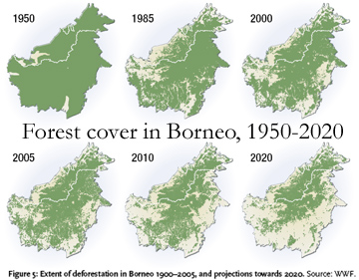

Urbanization
Through urban development, the continued rapid construction of road systems and buildings has changed the Earth's natural surface, removing soil nutrients, surface vegetation and trees that filter the air and equalize the carbon cycle. Urbanization also displaces animals and increases environmental pollution from vehicles and factories. A system of highways also causes serious migratory obstacles for animals and replaces native plants with impermeable concrete, resulting in habitat destruction. Since the concrete is impermeable, it doesn’t allow water to seep
Human Activities that Affect the Ecosystem by Ben Alonzo, Demand Media
http://classroom.synonym.com/human-activities-affect-ecosystem-9189.htm

How Humans Disrupt the Ecosystem by Jonas Martonas, Demand Media
http://classroom.synonym.com/humans-disrupt-ecosystem-5968.html

References
- U.S. Fish and Wildlife Service: Endangered Species- Gray Wolf Recovery
- Hypoxia in the Northern Gulf of Mexico: What is Hypoxia?
- Earth System Research Laboratory, Global Monitoring Division: Trends in Atmospheric Carbon Dioxide
- Earth Policy Institute: Eco-Economy Indicators - Carbon Emissions

through, resulting in increased vulnerability to flooding. This practice of human construction continues at a rapid pace, leading to urban sprawl, where cities are essentially forever expanding outside the traditional inner-city limits.
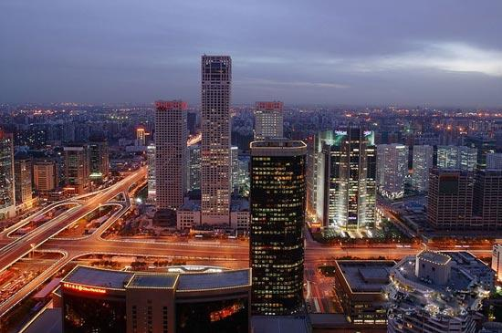

Solutions
While not all impacts on ecosystems are reversible, there are several ways to minimize and reverse human-induced adverse effects. Green technologies that reduce reliance on fossil fuels, decrease waste and have low carbon footprints can make measurable differences on the quality of multiple ecosystems. For example, utilizing public transportation and car-pooling can reduce gaseous carbon emissions, alternative energy sources produce fewer atmospheric contaminants and reducing the reliance on large-scale agriculture can help reduce soil and water pollution by minimizing excessive use of synthetic fertilizers.

How Humans Disrupt Ecosystems
HUMAN IMPACT | EFFECT ON ENVIRONMENT | Possible Solutions
POLLUTION

- Combustion of Fossil Fuels

- Pesticides & Fertilizers
OVERHUNTING

&

OVERFISHING
DEFORESTATION
URBANIZATION

Invasive Species Notes
What is an invasive species? ___________________________________________________ __________________________________________________________________________
What are characteristics of an invasive species?
- ________________________________________________________________________
- ________________________________________________________________________
- ________________________________________________________________________
- ________________________________________________________________________
- ________________________________________________________________________
- ________________________________________________________________________
What is a non-native species?
______________________________________________________________________________
______________________________________________________________________________
What are the differences and similarities between Invasive and Non-Native Species?
Invasive Species | Both | Non-Native Species

