Exploring Trophic Cascades and Keystone Species

What determines how many species live in a given place? What determines how large each population can grow?
My answer | My partner’s answer
Our final answer

Vocabulary Check: Put these terms in order of size:
Organism ecosystem community species population biosphere biome

Smallest Largest

Concept Check:
What is the relationship between sea otters, sea urchins and kelp? Use words and pictures to complete the model below. Be sure to show how energy flows, population size and which would be more abundant in a balanced ecosystem:
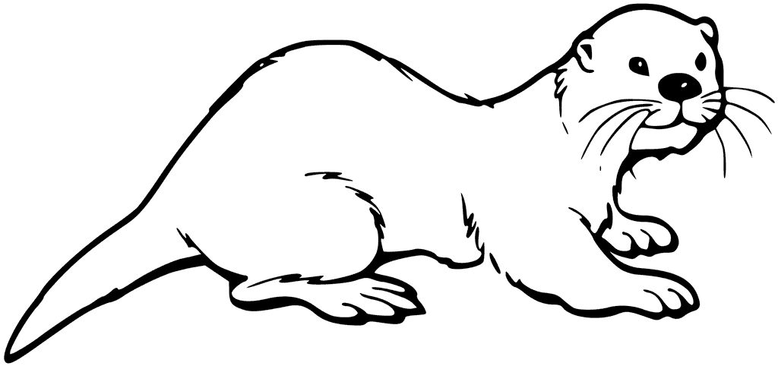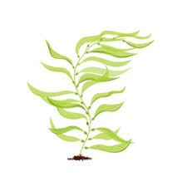
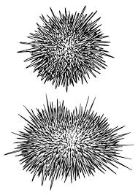
Some Animals Are More Equal Than Others - video

Watch the HHMI video. Listen for information on the four big ideas below and take notes from the video.
Green World Hypothesis | Keystone Species
Trophic Cascades | Hypothesis and Experimentation

Based on this information - do you think there is a Keystone Species in the Otter story? Which one would it be? What is your evidence?
My answer | My partner’s answer
Our final answer
Trophic Cascades in the Spotlight - HHMI Click & Learn

Watch the introduction video and review the three Introduction Slides, then construct the following models:

- Trophic Pyramid showing direct effects with explanation
- Trophic Pyramid showing indirect effects with explanation
- Otter, Urchin, Kelp food chain showing the direct (solid line arrows) and indirect (dashed line arrows) effects. Include the + or - to show if the effect is positive or negative.

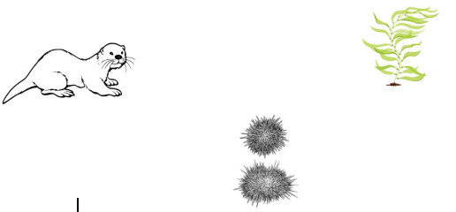

Explain how it can be possible that any trophic level can be responsible for limiting population sizes of the other trophic levels, not just the producers or top/apex predator:

Select either the seagull or the bald eagle to identify and explain how the loss of the kelp affected other members of the community.
Species | Effect | Explanation

A trophic cascade can be described as: ________________________________________________
___________________________________________________________________________
___________________________________________________________________________

Case Studies
Make a model of each trophic cascade using the lines and arrows as you did in the sea otter mode. Be sure to add notes about the +/- effects. Answer the question associated with each ecosystem.

Arctic Tundra: | Midwestern Lake
Foxes have a (Positive or Negative; Direct or Indirect) effect on grass population. | How do changes in the bass effect carbon dioxide levels?
African Savannah | Venezuelan Jungle
What is the relationship between rinderpest virus and percentage of vegetation burned? | Do large predators have a positive or negative effect on herbivores?

Think about it: Describe the effect trophic cascades had on the biodiversity of the ecosystems ___________________________________________________________________________

