Questions About Plants

In the previous lesson on animals, we learned these basic facts:
- All organisms are made of cells
- All the functions of organisms are done by their cells
- All cells are made of molecules, including large organic molecules (fats, carbohydrates, and proteins)
- All functions of cells involve moving and changing molecules.

Plants are clearly different from animals - what do we need to know about them to understand how they use matter and energy to live?

Question: Do plants move?
Observe these three video clips and record what you observe. See clips on weebly or myMCPS
Germination | Phototropism | Gravitropism
Observation | Observation | Observation
Explanation | Explanation | Explanation

Skim these short articles on Plant Growth and Plant Tropisms and add to your explanation for how the plants are able to move.

Summarize:
Describe and explain the plant’s movements in each case presented. In your explanation, compare it to how animals move and explain if matter and energy are necessary for plant movement.
______________________________________________________________________________________________________________________________________________________________________________________________________________________________________________________________________________________________________________________________________________________________________________________________________________________________

Question: What are common features of plants?
Review the pictures below and summarize the similarities and differences between the different plants and within a single plant..
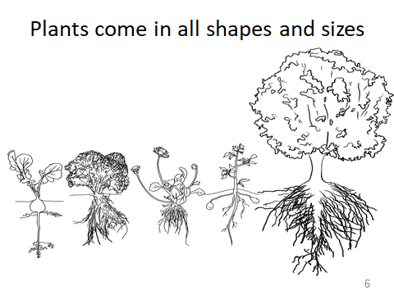 | 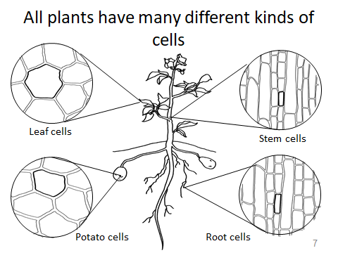
Similarities among the plants. | Similarities within the plant (what is the same with all cells)
Differences among the plants. | Differences within the plant (what is difference among the different cells)

Question: How do materials get into and out of plants?
Humans take materials in through eating and breathing. Plants have to have some way to get materials into and out of their structures as well.
Leaves:
Study the two images below. Each image provides information about the structure and function of leaves. Pay close attention to the structures called stomata (or stoma).

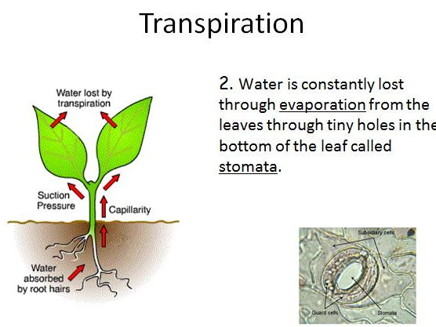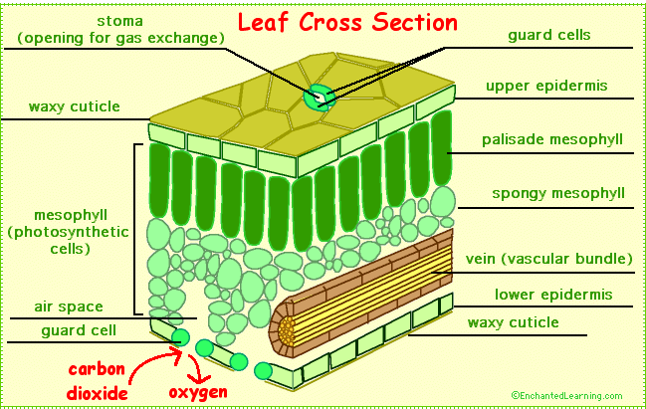

- What three materials enter and exit leaves through the stomata? List them below. Write the word EXIT or ENTER next to each molecule to identify the primary action. (Look at the arrows in the pictures to see what is coming in and where it enters).
- ___________________________
- ___________________________
- ___________________________

Roots:
Study the two images below. Each image provides information about the structure and function of roots. 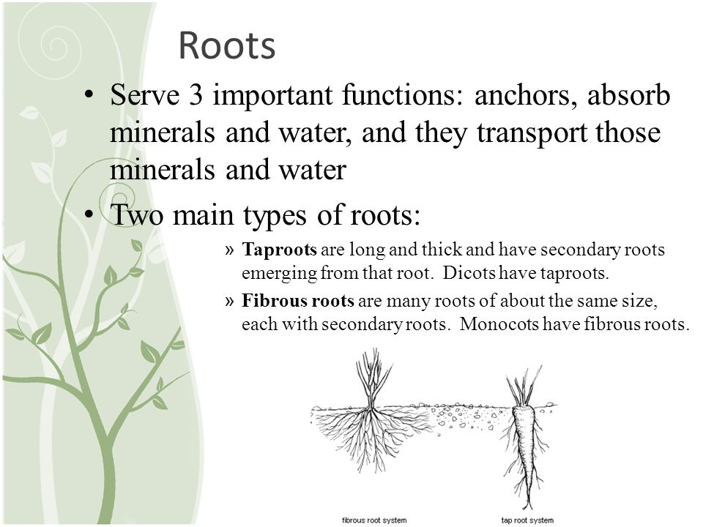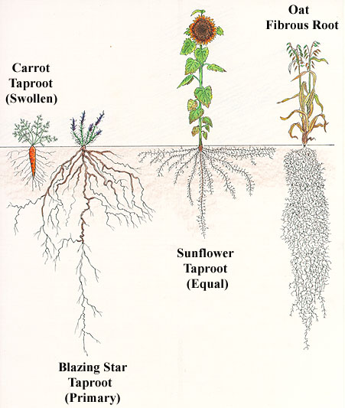

- What do you notice about the root systems of the four plants above?

Root Functions: Roots form a major part of a plant body, in terms of bulk and function. The major functions of the roots are as following:

Anchor and Support
The root system of the plant provides physical support by anchoring the plant body to the soil. Many plants can stand erect for hundreds of years because their roots grow deep into the soil and hold the plants strongly in place.

Absorption and Conduction
Roots have root hairs through which roots absorb water and nutrients from the soil which are essential for the plant growth. Roots have a capability of absorbing inorganic nutrients against the concentration gradient. After the water and nutrients are absorbed, they are moved upwards to stem and leaves.
In deserts, roots grow deep into the permanent water reserves. Desert areas where plants are found to be growing are considered to have underground water reserves. This greatly helps in deciding where to dig a well.

Transport
Roots have specially designed channels for the transport of absorbed nutrients and water to stem and leaves. Moreover, they also have channels through which organic food can be transported from aerial parts of the plant to the roots.

Storage
Some roots like carrots and sweet potatoes serve the purpose of a storage organ. They store carbohydrates and water. Roots of some plants found in desserts can store up to 70kg of water.

Photosynthesis (only in special cases…most roots do not have this function)
Photosynthesis is the process by which plants prepare their food. Some roots are capable of photosynthesis as is the case with aerial roots of mangrove plants and epiphytic orchids.

Aeration
Plants that grow on the surface of stagnant water have specialized roots that are called pneumatophores which diffuses the oxygen from the air.

Movement
Contractile roots of many bulb-forming plants pull the plant downwards into the soil. Environment under the soil is more favorable for bulb-forming plants.

Reproduction
Some special roots are capable of reproduction. They serve as a means of perpetuating a species. In some plants like the mature Agoho, offshoots are seen growing around the trunk profusely from roots that are growing horizontally.

2. Based on the important functions that roots serve, propose reasons for the differences in the root systems for each plant.

Question: How do materials move around inside plants?
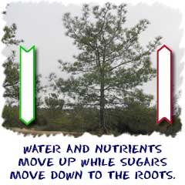
Read about the way plants transport materials inside their structures. Use the information to complete the Venn Diagram comparing Xylem and Phloem.

Xylem and phloem make up the big transportation system of vascular plants. As you get bigger, it is more difficult to transport nutrients, water, and sugars around your body. You have a circulatory system if you want to keep growing. As plants evolved to be larger, they also developed their own kind of circulatory systems. The main parts you will hear a lot about are called xylem and phloem.

It all starts with a top and a bottom. Logically, it makes sense. Trees and other vascular plants have a top and a bottom. The top has a trunk, branches, leaves, or needles. The bottom is a system of roots. Each needs the other to survive. The roots hold the plant steady and grab moisture and nutrients from the soil. The top is in the light, conducting photosynthesis and helping the plant reproduce. You have to connect the two parts. That's where xylem and phloem come in.
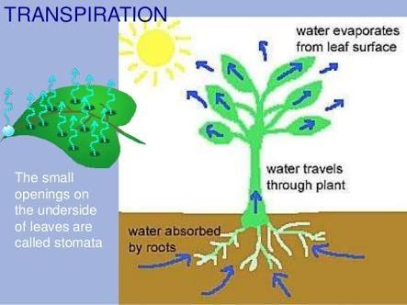

Zippy Xylem
The xylem of a plant is the system of tubes and transport cells that circulates water and dissolved minerals. As a plant, you have roots to help you absorb water. If your leaves need water and they are 100 feet above the ground, it is time to put the xylem into action! Xylem is made of vessels that are connected end to end for the maximum speed to move water around. They also have a secondary function of support. When someone cuts an old tree down, they reveal a set of rings. Those rings are the remains of old xylem tissue, one ring for every year the tree was alive.

Phloem Fun
The fun never stops in the plant's circulatory system. Most plants have green leaves, where the photosynthesis happens. When those sugars are made, they need to be given to every cell in the plant for energy. Enter phloem. The phloem cells are laid out end-to-end throughout the entire plant, transporting the sugars and other molecules created by the plant. Phloem is always alive. Xylem tissue dies after one year and then develops anew (rings in the tree trunk). What is the best way to think about phloem? Think about sap coming out of a tree. That dripping sap usually comes from the phloem. (From Biology4Kids.com)

Xylem

Xylem
Phloem

Word/phrase Bank:
Transport Tissue Transports Sugar Transports against gravity from roots to leaves Sap
Transports Water and dissolved minerals Living tissue
Tissue dies each year- forms rings on trees Transpiration
Transports from the leaves to the roots

Question: What molecules are in plants?
Examine the information below. On the left is the list of plant nutrients added to an artificial “soil” for growing plants called Ionic Grow. The nutrients simulate what a plant would receive in a natural setting. On the right is the nutrition label for a plant-based food, radishes. Use the information to answer the questions.
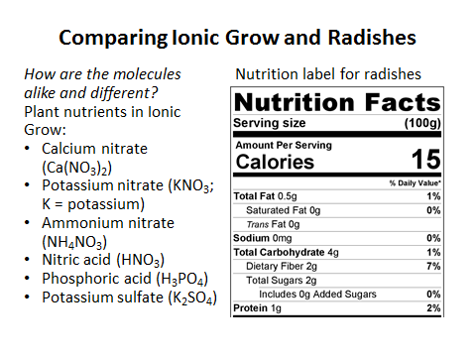
Hint about molecule size: Glucose (C₆H₁₂O₆) is considered a small organic molecule. It has 24 atoms in it. Starch has 300-1000 rings of glucose. Dietary Fiber (Cellulose) has about 1500 rings of glucose. The largest molecule listed above (Ca(NO₃)₂) has 9 atoms in it. Organic molecules are considered macromolecules because they have a LOT of atoms in them.

- Are the molecules in Ionic Grow organic or inorganic? How do you know?
- Are the molecules very large or small? How do you know?
- Are the molecules in the Radish organic or inorganic? How do you know?
- Are the molecules very large or small? How do you know?
- How do the nutrients in Ionic Grow enter the plant?
- What do the plant cells do with the nutrients once they have entered the plant? (read over the next page to see how nutrients are used)
Plants can absorb inorganic nutrients and water through their root system, and carbon dioxide from the environment. The combination of organic compounds, along with water, carbon dioxide, and sunlight, produce the energy that allows plants to grow. Inorganic compounds form the majority of the soil solution. Plants access water though the soil. Water is absorbed by the plant root, transports nutrients throughout the plant, and maintains the structure of the plant. Essential elements are indispensable elements for plant growth. They are divided into macronutrients and micronutrients. The macronutrients plants require are carbon, nitrogen, hydrogen, oxygen, phosphorus, potassium, calcium, magnesium, and sulfur. Important micronutrients include iron, manganese, boron, molybdenum, copper, zinc, chlorine, nickel, cobalt, silicon and sodium.

Macronutrients and Micronutrients
The essential elements can be divided into two groups: macronutrients and micronutrients. Nutrients that plants require in larger amounts are called macronutrients. About half of the essential elements are considered macronutrients: carbon, hydrogen, oxygen, nitrogen, phosphorus, potassium, calcium, magnesium and sulfur. The first of these macronutrients, carbon (C), is required to form carbohydrates, proteins, nucleic acids, and many other compounds; it is therefore present in all macromolecules. On average, the dry weight (excluding water) of a cell is 50 percent carbon. As shown in Figure 31.1.231.1.2, carbon is a key part of plant biomolecules.
The next most abundant element in plant cells is nitrogen (N); it is part of proteins and nucleic acids. Nitrogen is also used in the synthesis of some vitamins. Hydrogen and oxygen are macronutrients that are part of many organic compounds, and also form water. Oxygen is necessary for cellular respiration; plants use oxygen to store energy in the form of ATP. Phosphorus (P), another macromolecule, is necessary to synthesize nucleic acids and phospholipids. As part of ATP, phosphorus enables food energy to be converted into chemical energy through oxidative phosphorylation. Likewise, light energy is converted into chemical energy during photophosphorylation in photosynthesis, and into chemical energy to be extracted during respiration. Sulfur is part of certain amino acids, such as cysteine and methionine, and is present in several coenzymes. Sulfur also plays a role in photosynthesis as part of the electron transport chain, where hydrogen gradients play a key role in the conversion of light energy into ATP. Potassium (K) is important because of its role in regulating stomatal opening and closing. As the openings for gas exchange, stomata help maintain a healthy water balance; a potassium ion pump supports this process.
Magnesium (Mg) and calcium (Ca) are also important macronutrients. The role of calcium is twofold: to regulate nutrient transport, and to support many enzyme functions. Magnesium is important to the photosynthetic process. These minerals, along with the micronutrients, which are described below, also contribute to the plant’s ionic balance.
In addition to macronutrients, organisms require various elements in small amounts. These micronutrients, or trace elements, are present in very small quantities. They include boron (B), chlorine (Cl), manganese (Mn), iron (Fe), zinc (Zn), copper (Cu), molybdenum (Mo), nickel (Ni), silicon (Si), and sodium (Na).
Deficiencies in any of these nutrients—particularly the macronutrients—can adversely affect plant growth (Figure 31.1.331.1.3). Depending on the specific nutrient, a lack can cause stunted growth, slow growth, or chlorosis (yellowing of the leaves). Extreme deficiencies may result in leaves showing signs of cell death.

