Photosynthesis Notes Name: Period:
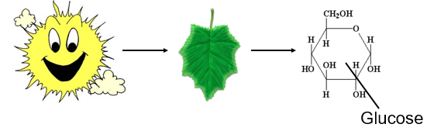
Overview: The Process That Feeds All Living Things
Photosynthesis (photo = light, synthesis = to make, put together)
- Overall Definition: the process that converts ______________ (photons) into _________________ (glucose)
- Plants are ______________________.
- They are the ___________________ of an ecosystem.
    - Plants use energy from the sun to produce the food that feeds the ecosystem
    - Some bacteria (ex. blue-green algae) and some protists are also photosynthetic
Chemosynthesis
- Certain types of bacteria and fungi use energy from _______________________ (such as hydrogen sulfide) instead of light energy to produce food.
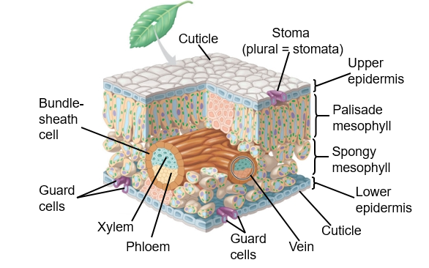
- This process is called ___________________________.
Leaf Anatomy
Photosynthesis Occurs Within the Cells of Plant Leaves
- Nutrients and water, can get into and out of leaves:
  - ____________: Carries _________ and dissolved ____________ upward from roots into the stems and leaves
  - __________: Transports ____________________ (ex. sugars) from where they are made to where they are needed
  - __________ (singular): allows ________, ________, and ____________(transpiration) to enter and leave the leaves. Plural = ____________
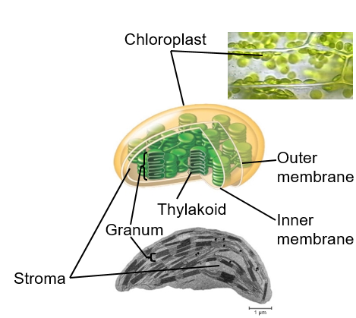
- Photosynthesis converts light energy to the chemical energy of food
  - The leaves of plants are the sites of photosynthesis
Chloroplasts: The Sites of Photosynthesis
- The organelles in which photosynthesis occurs
- Contain _________________, grana, and _______________
    - ______________= disk-shaped sac in the stroma of a chloroplast
    - __________ = layers or stacks of thylakoids
    - __________ = the thick fluid contained in the inner membrane of a chloroplast; made of water and enzymes
- ___________________: The Green Pigment Inside Chloroplasts
    - Chlorophyll is a pigment.
    - A pigment is any substance that absorbs light.
    - The color of the pigment comes from the _________________________________ (in other words, those not absorbed).
    - Chlorophyll is green because it reflects green light.
The Chemical Reaction of Photosynthesis
- Photosynthesis is summarized by the following chemical reaction:
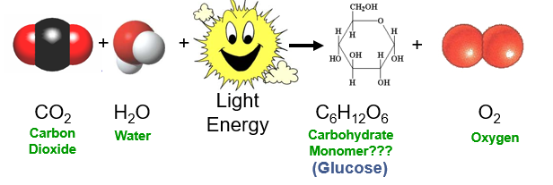

The Balanced Chemical Equation:
__CO₂ + __H₂O + Light Energy → C₆H₁₂O₆ + __O₂

- Chloroplasts split carbon dioxide and water
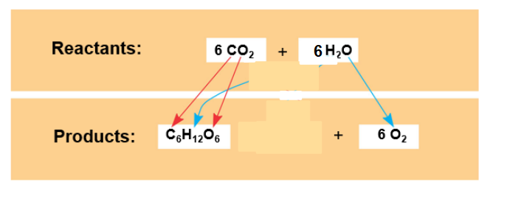
  - To make sugar molecules, oxygen, and water
  - The_____________ we breath comes from _____________
  - The ___________in our food, comes from _______________

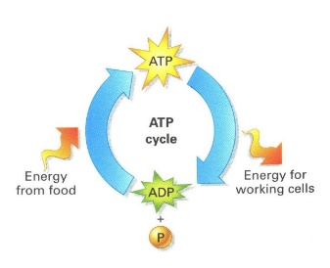
Adenosine Triphosphate (ATP)
- ATP is the _______________ source for cell processes
- Energy is __________________ when ATP is converted to ADP (Adenosine Diphosphate)
  - Tri = ______ Di = ___________
- ADP can be converted into ATP again using energy from food to reform bonds.
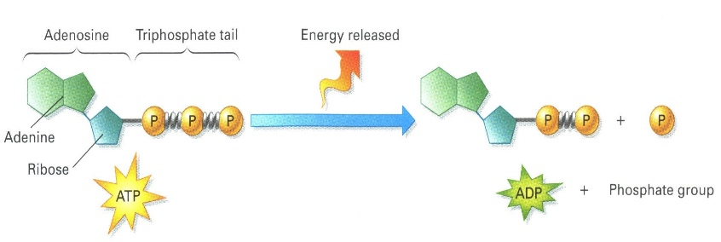
- ATP is made of three components
  - ______________
  - ______________
  - ______________

The Two Stages of Photosynthesis
- Photosynthesis consists of two processes
  - The light (dependent) reactions
  - The dark (light-independent) reactions; also called the _______________ cycle
The Light Reactions
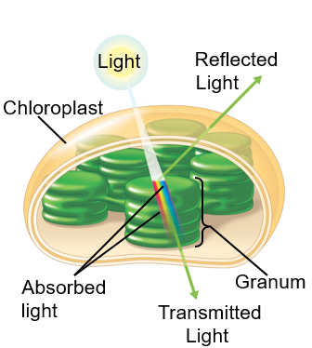
- Occur in the _________
  - Split _________
  - Release ____________
  - Produces _________ (energy)
  - Produces _______________(carries H⁺ from the light reactions to the Calvin cycle)
The Calvin Cycle (Light Independent Reactions)
- Occurs in the _____________
  - Forms _____________ from carbon dioxide
  - Uses ___________ for energy
  - Also uses ____________
Putting the two reactions together

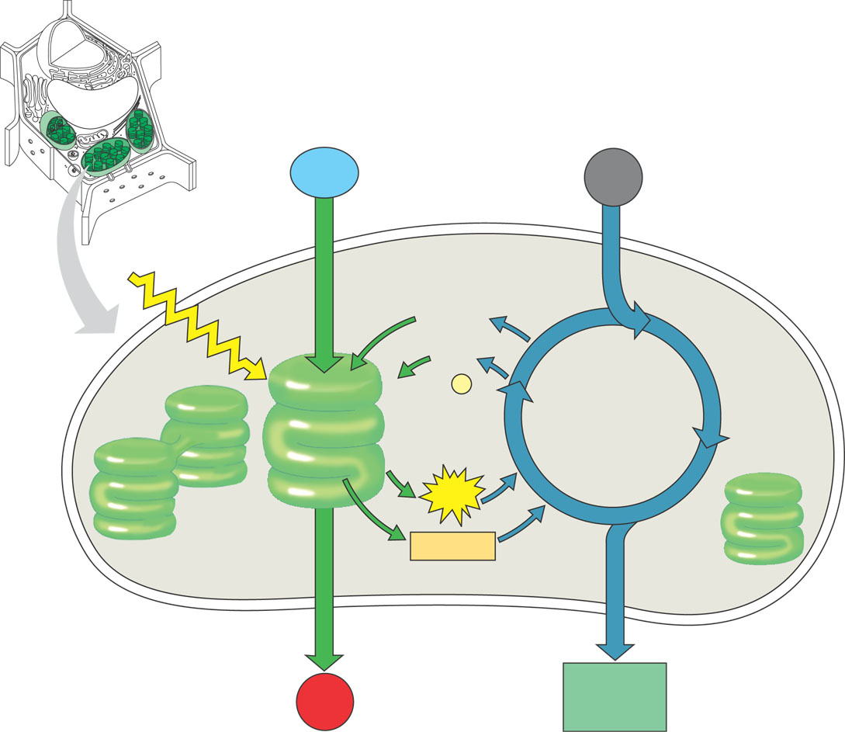

Summary of Photosynthesis
- The overall chemical equation:
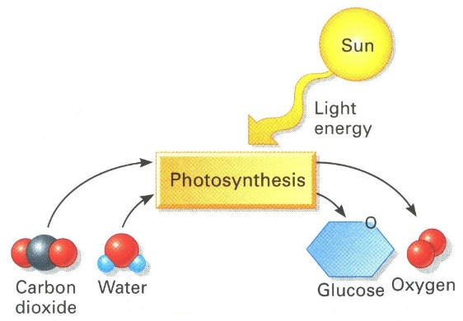
__CO₂ + __H₂O + Light Energy → C₆H₁₂O₆ + __O₂
 | Light Reactions | Calvin Cycle
Takes place in the….
Reactants are….
Products are….
The Nature of Sunlight
- Light reactions convert ___________ energy to the ____________energy stored in the ________ of glucose molecules.
- Sunlight is a form of electromagnetic energy, which travels in waves
The visible light spectrum
- Includes the colors of light we can see
- Includes the wavelengths (colors of light) that power photosynthesis
Pigments
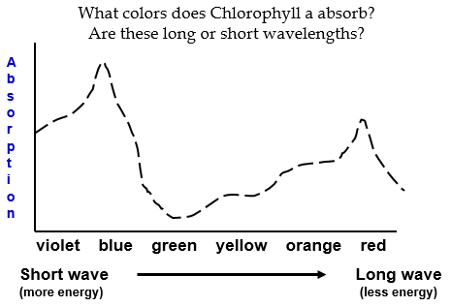
- Substances that _____________ visible light AND _________ light, which include the colors we see_____________________ is the most abundant pigment in plants.
The absorption spectra of chloroplast pigments
- Provide clues to the relative effectiveness of different wavelengths for driving photosynthesis
- Green has the ______________ absorption and the most _______________ making plants appear green

