Name: ________________________________ Pd: ____
Chesapeake Bay Food Web Capture Sheet
Analyzing the Phenomena:
Inspect the two food webs for the Chesapeake Bay. The web titled “Before Large Scale Fishing” represents the time period before the arrival of European settlers and large-scale fishing, approximately 300 years ago. The web titled “After Large Scale Fishing” represents today’s conditions.
“Before Large Scale Fishing” |  | “After Large Scale Fishing”
Unique Features “Before” | Common Features |  | Unique Features “After”
Questions about “Before” |  | Questions about “After”

Vocabulary:
Write the definitions for the following terms:

Term | Definition
Food Web
Producer
Consumer
Primary Consumer
Secondary Consumer
Tertiary Consumer
Decomposers
Detritus
Digging Deeper - Chesapeake Bay Food Web BEFORE Large-scale Fishing

- Examine the food web before humans lived in the Chesapeake. Notice which species groups are abundant (dark circles) and which species groups are rare (light circles). Color or check the squares on the chart below to indicate which species groups were rare or abundant.
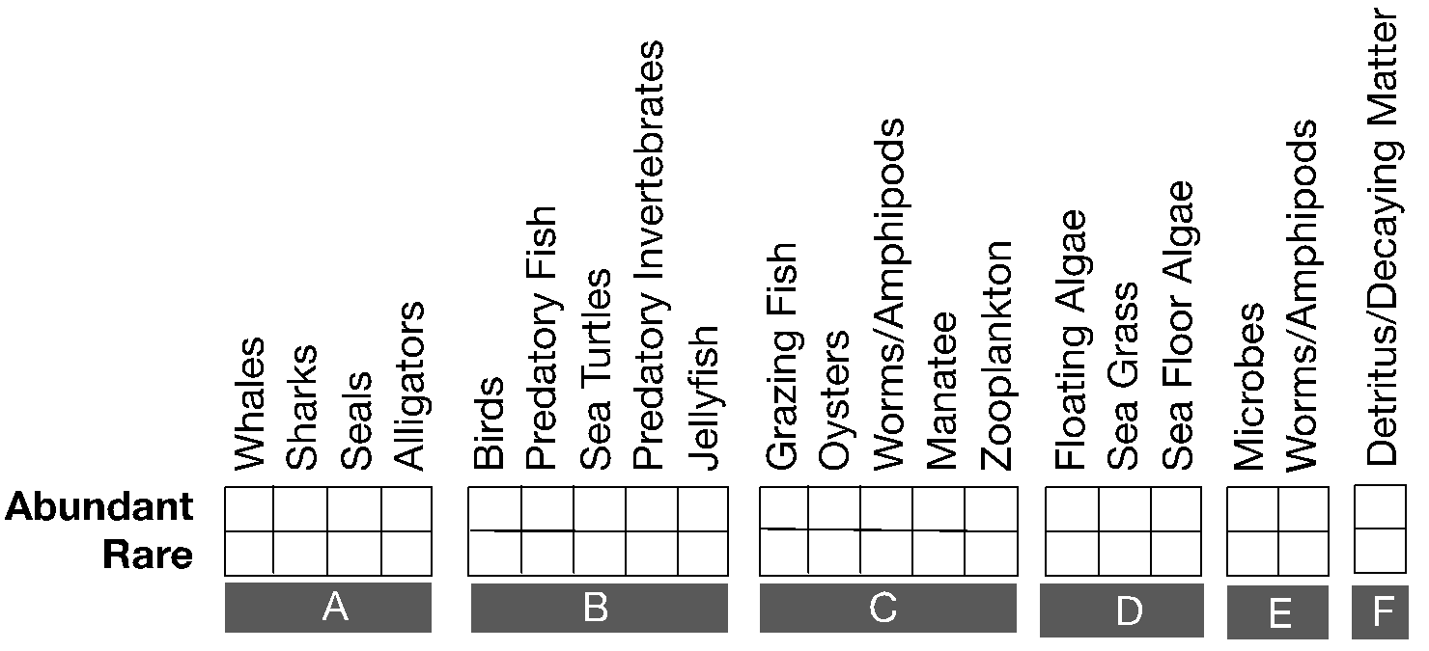

2. Are most species abundant or rare? Which species groups are rare?
______________________________________________________________________________
3. The species groups in the chart above are organized by trophic level. Write the name of the trophic group for groups A, B, C, D, and E. The trophic groups found in this ecosystem are decomposers, producers, consumers, secondary consumers, and top predators. Include a brief explanation of how each group interacts with other trophic levels.
Group | Trophic Level | Explanation of interaction with other trophic levels (Who do they eat? Who eats them?)
A
B
C
D
E

4. A. How is it possible that the worms/amphipods are considered part of two groups? ________________________________________________________________________________________________________________________________________________________________________________
B. In which group are they more appropriately placed? Hint: Worms and amphipods cause rot on the plants that they eat.
________________________________________________________________________________________________________________________________________________________________________________
5. What is group F? What is the role of detritus in the food web?
________________________________________________________________________________________________________________________________________________________________________________
6. List the number of strong and weak interactions (arrows) for each of the species groups listed at the top of this chart. Count the number of strong and weak connections (arrows going to or from a species group) to complete the chart below:
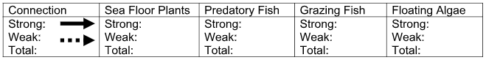
7. The producers can be organized based on where they are found in the water. Some float and some grow from the seabed. Which producers float and which producers grow from the sea bottom?
Floating | Sea Bottom/Floor
1) | 1)  2)
8. In this ecosystem (BEFORE), which type of producers are more abundant, the producers that float or the producers that grow from the sea bottom?

More abundant producers:
9. Find and write out a six -step food chain (start with a producer in the left-most box):
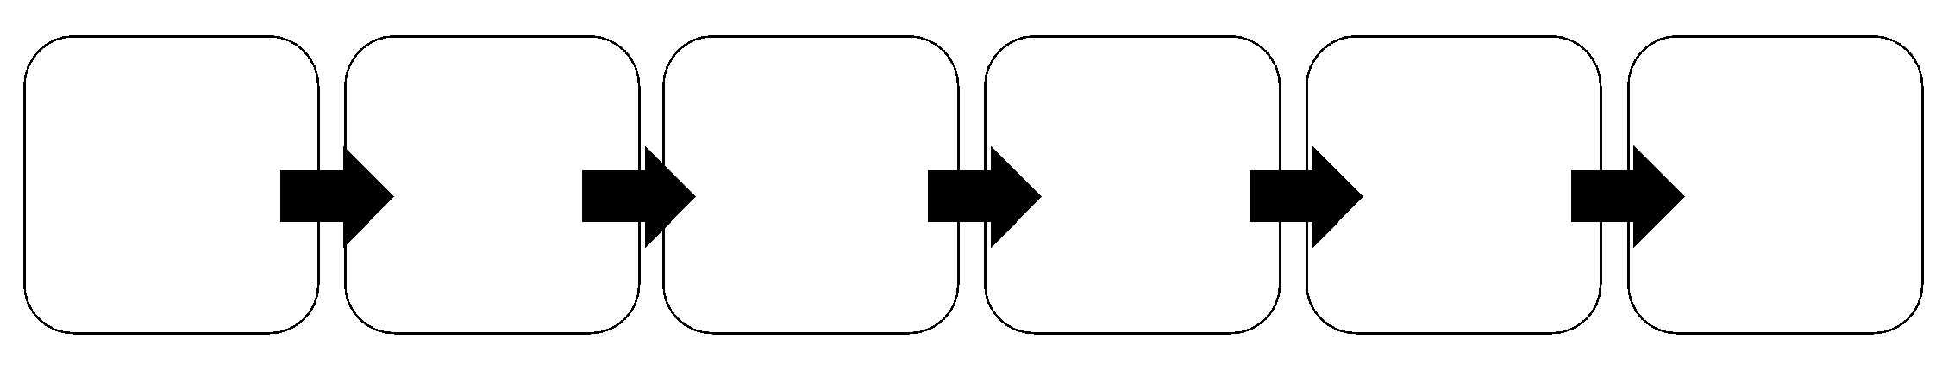
10. What do the microbes eat? Are they producers, consumers or decomposers? __________________________________________________________________________________

11. If the oyster population was reduced, what would you expect to happen to the population sizes of the microbes, floating algae and detritus?

 | Predicted change | Reasoning
Microbes
Floating algae
Detritus
Digging Deeper - Chesapeake Bay Food Web AFTER Large-scale Fishing
- Now examine the food web after humans became part of the Chesapeake Bay ecosystem through fishing. Complete the same chart that you completed for the previous food web, and color or check which species groups are now rare or abundant. If a species group has gone extinct, then cross out both boxes with an X.

2. Which organisms went locally extinct?
__________________________________________________________________________________________

3. Are more organisms rare or abundant after large-scale fishing? Which organisms are abundant?
________________________________________________________________________________________________________________________________
4. Are these the same organisms that were abundant in the pre-human food web? Explain.
_______________________________________________________________________________________________________________________________________________________________________________________________________________

5. What happened to the top predators? Were they more or less affected than other trophic groups?
__________________________________________________________________________________________________________________________________________

6. List how many species groups depend on each of the species groups listed at the top of this table. Count the number of strong and weak connections (arrows going to or from a species group) to complete the table below:
7. In general, do these species groups have more connections or less after fishing?
_____________________________________________________________________

8. How does the strength of the interactions compare between this food web and the one before fishing?
__________________________________________________________________________________________________________________________________________
9. What does it mean for the ecosystem when most of the interactions are weak?
_____________________________________________________________________
10. Redraw the food web including only the abundant species? What do you notice? (Note: some species may not have any connections at all)

11. How is this food web similar/different to the food web without people?
_______________________________________________________________________________________________________________________________________________________________________________________________________________
12. Why do you think jellyfish are now abundant?
________________________________________________________________________________________________________________________________________________________________________________________________

13. Why are there fewer predatory fish if there are fewer whales, sharks, seals and alligators?
________________________________________________________________________________________________________________________________________________________________________________________________

14. Which producers are now more common in this ecosystem, the floating algae or the sea floor algae and plants and seagrass?
__________________________________________________________________________________________________________________________________________

Adding to the story - Human Impact

Your teacher will share information about the changes humans made to the Bay ecosystem. Take notes to help you understand the problem.

Effect on Ecosystem (Result) | Cause
Increased Nutrients in the Bay
Algae Blooms
Dead Zones

15. From what you know about the relationship between high levels of nutrients and algae growth, why have the floating algae increased?
________________________________________________________________
________________________________________________________________
16. What happened to the sea floor algae and plants? If fewer organisms are eating them, shouldn’t their numbers have increased? Why are they rare now? Hint: Like all plants, what do the sea floor algae and plants need to grow? How do more floating algae limit this important resource that sea floor algae and plants need? Explain.
________________________________________________________________
________________________________________________________________
17. How does this food web connect to the present-day problem of high nutrient levels in the water? (Hint: Oysters filter the nutrients, microbes and floating algae from the water.) Use the food web to explain what happened to their numbers and why. ________________________________________________________________
________________________________________________________________
18. Based on your answer to question seventeen make a hypothesis for how catching oysters affects floating algae levels?
________________________________________________________________
________________________________________________________________
19. What type of data would you need to collect in order to test your hypothesis? Hint: You would need to compare historic and present day data on two elements of the Bay. What are those elements? ________________________________________________________________
________________________________________________________________

