Name: _______________________________________________________ Period: _________

Microarray Background Information
Capture Sheet

Use the video clip to fill in the flowchart below.
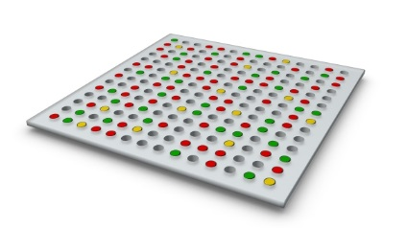
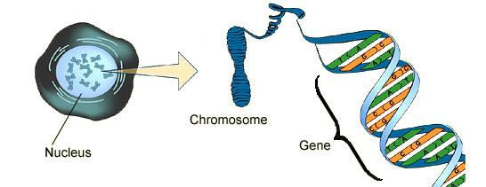
Uninfected Cell
Infected Cell
Reversed transcribed into
Color?
Color?
- What do genes do?

- Where is DNA located?

cDNA then hybridizes (creates complimentary pairs) to DNA probes on Microarray

A Review of Protein Synthesis
DNA is contained in the nucleus and coiled into chromosomes. In humans, each chromosome contains about 1000 genes. Genes code for proteins which give organisms their characteristics or traits.

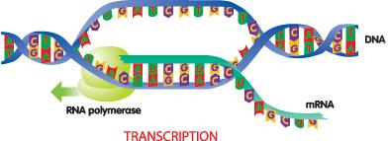
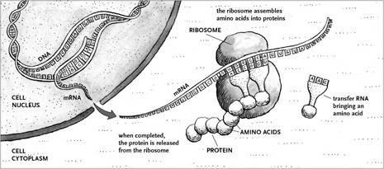
During gene expression, a segment (part) of DNA called a gene, separates and is copied by mRNA. This process is called transcription. The amount of mRNA copied indicates how much of the protein is needed by the cell. Only the proteins required for a particular cell to function will be transcribed. A heart cell will only make the proteins necessary for a heart cell to function, even though every cell holds the information to make all the genes for every protein in its’ genome.
3. What is transcription?

4. Why don’t all cells make all proteins?
5. Where are proteins made?

6. What processes make up protein synthesis?

After the mRNA is made it leaves the nucleus and goes to the ribosome where the mRNA matches up with tRNA to construct the polypeptide chain or protein. This process is called translation. Transcription and translation are the two processes of protein synthesis.

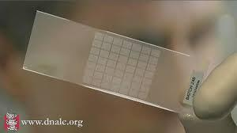
How Microarrays are Made
If a cell is expressing a gene to make a protein then it has to make mRNA. Scientists use this cellular information to study which genes are being expressed by measuring the amount of mRNA present in a cell. This tool is known as a microarray, which allows a scientist to measure the gene activity in a cell all at one time.

A microarray slide can hold an organisms’ entire genome with small sections of DNA from every gene attached to a section or circle on the slide. These attached sections of genes are called probes. They are single-stranded DNA, so they are ready to pair up with their complimentary strands.
- What must a cell make in order to make a protein?

- What does a microarray measure?

- What is a DNA probe? What is unique about a DNA probe?
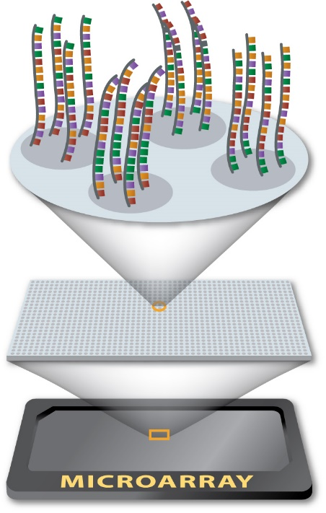
If a person has cancer, a doctor can take mRNA from both their cancer cells and healthy cells in their body. The mRNA taken from both the healthy and cancerous cells is converted to cDNA (complimentary DNA) and tagged with a fluorescent dye. The healthy cells’ cDNA is tagged with a green dye and will fluoresce a bright green spot if a gene is being expressed. The cancerous cells cDNA is tagged with a red dye and will show a red spot if a gene from the cancer cell is expressed.

The microarray with the DNA probes is then “washed” with the tagged cDNA and the probes may pair up with the cDNA. If the same gene is expressed in both cells, the spot will glow yellow. If the gene is not expressed in either cell, the spot will appear black. Therefore a microarray slide will show green, red, yellow and black spots, based on what genes are making mRNA, in order to create a protein.
- Why is mRNA extracted from both healthy and cancerous cells?

- Microarrays will show green, red, yellow and black spots. What does each color represent?

- Green:
- Red:
- Yellow:
- Black:

