DNA vs. RNA and Protein Synthesis Notes
Name: Period:
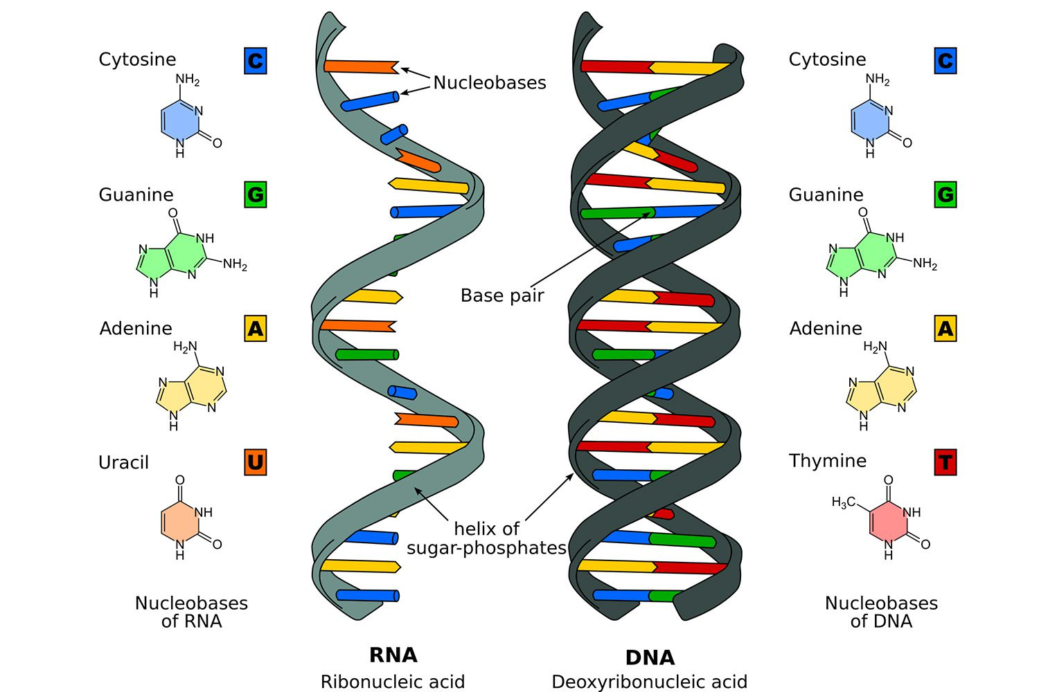
RNA is composed of 3 parts:
- __________________-smaller sugar than deoxyribose
- __________________
- 4 Nitrogenous bases
  - A
  - G
  - C
  - U
  - RNA is ____________ stranded and thus smaller so it is able to leave the nucleus through ____________.

3 Types of RNA
- mRNA: __________________RNA
-Carries the gene code from the ___________ to the ______________
- tRNA: ___________________RNA
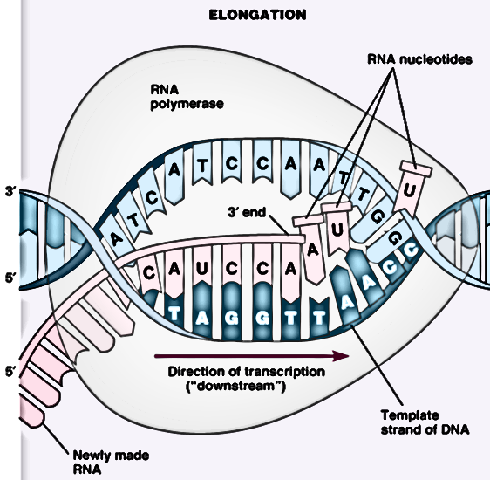
-Delivers ________________ _______________ to the ribosome
- rRNA: __________________RNA
-Makes up the ______________________
Transcription: Writing the DNA message to mRNA
- Takes place in the ______________________ of the cell
- Code for a gene gets transferred to mRNA.
Step 1: DNA uncoils and unzips
Step 2: The exposed DNA bases match up with RNA ___________________ in the nucleus to form RNA.
DNA nucleotide matches with | RNA Nucleotide
Adenine (A)
Thymine (T)
Cytosine (C)
Guanine (G)
Transcribe: T A C G A G C C A T A T A A A
_________________________
Step 3: The mRNA will detach from the DNA
Step 4: The mRNA will move out of the nucleus into the _______________ and attach to a _______________________.
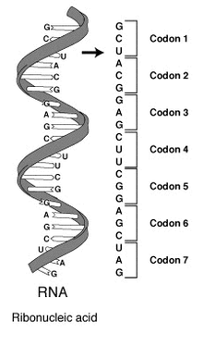
Translation: Reading the mRNA to make protein
- Occurs on the ________________________ which may be free floating or attached to the rough __________________________.
- The mRNA strand is pulled through the ribosome ______ bases at a time, in triplets.
- Each of these triplets on the mRNA strand is called a _________________.
- Each codon will code for ____________ amino acid

•These amino acids, when put together, form polypeptides, or proteins
•The genetic code is _____________, meaning that there are 64 codons, but only 20 amino acids
-Each codon codes for one amino acid, but some amino acids are coded for by more than one codon
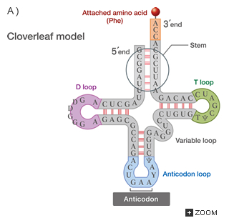
- Transfer RNA (tRNA) reads mRNA and delivers the appropriate _________ _________.

- At one end of a tRNA molecule is a set of 3 bases that will complement the mRNA strand. This is called the ______________.

- At the other end is a specific amino acid

- If the 3 base anti-codon complements the 3 base codon of the mRNA, the will combine briefly the tRNA will drop off the amino acid

- As each codon is read, the next tRNA brings in a new amino acid, and the protein chain grows
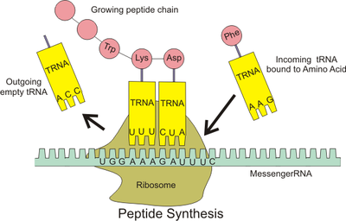
Transcribe and the Translate the following DNA Code
DNA: T A C A A T G T C A C G A G A T G A G T T
mRNA:

Amino acid _____ - ______ - ______ - _______ - ________ - ______- _______

