Name _______________________________ Teacher _________________ Date __________

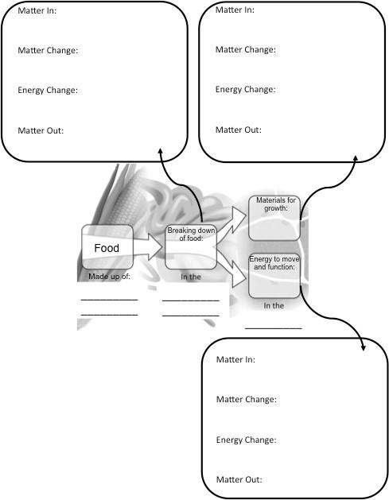
Matter and Energy in Animals Graphic Organizer

Word Bank

This list represents the key vocabulary for the concepts in the graphic organizer and are intended to help point out key ideas that fit. Terms may be used once, multiple times or not at all.

Biosynthesis
C-C bond
C-H bond
Carbon Dioxide
Cells
Cellular Respiration
Chemical Energy
Digestion
Digestive System
Food
Glucose
Heat Energy
Inorganic molecules
Kinetic (Motion) Energy
Large Molecules or Polymers
Organic Molecules
Oxygen
Small Molecules or Monomers
Waste
Water

