Name__________________________________ Period______ Date________________

Cell Differentiation and Gene Expression
In most human cells, the nucleus contains a full set of 23 pairs of chromosomes, which carry 20,000-25,000 genes. These genes are identical from cell to cell. Through the process of protein synthesis with transcription and translation is how genes are transcribed to produce Ribonucleic acid (RNA). This RNA is in then translated to produce proteins. If all cells in the same organism have the same genes, why don’t they all make the same proteins?
Some proteins are made by almost every cell because they are needed for basic cell functions. Other proteins are made by only one type of cell or small groups of cells. Only white blood cells, for example, make antibodies, the proteins that help the body fight infections. Each of the more than 220 kinds of specialized cells in the human body makes a characteristic group of proteins.
Although the two human cells shown have the same genes in their nuclei, they are specialized to make different proteins.
Lung Cells
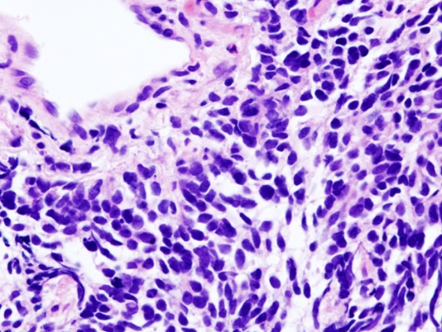
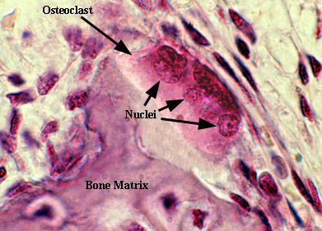
Bone Cells
The lung cells are specialized for surfactant protein B, a protein found in the lung which is vital for reducing surface tension in the lungs and allowing for the oxygen change in the alveoli to take place.
The bone cell is a cell that is responsible for the breakdown of bone tissue and makes large amounts of the protein integrin.
In each cell, only some of the genes are active, or expressed. The activity of genes in a cell is called gene expression. In this activity, you will explore how some genes are turned on and off by molecules called transcription factors. These molecules control the transcription of DNA into RNA.
Challenge
How does the same set of genes direct the activities of 220 different types of human cells?

Materials
For Each Group For Each Pair of Students
Set of 14 Cellular Event Cards 3 colored pencils (blue, black, and orange)

For Each Student
Model of human chromosome 2 Model of human chromosome 11
4 silver binder clips 7 red paper clips 7 green paper clips

Procedure
Part A: Gene Expression in Differentiated Cells

1. Each member of your group will look at gene activity in one of four kinds of specialized cells shown below. With your group, decide who will investigate each type of cell.

Location in body | Cell Type | Function | Student Name
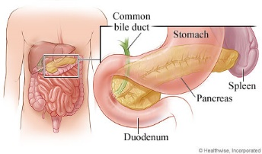 | 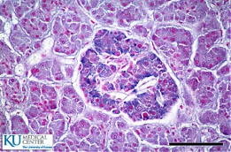  Beta cell in the pancreas | Beta cells in the pancreas which produce the protein hormone insulin, which regulates cellular uptake and metabolism of sugars and fats
 | Red blood cell  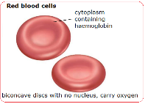  (circulatory system) | Red blood cells produce hemoglobin, a transport protein that carries oxygen to every other cell in the body.
 | 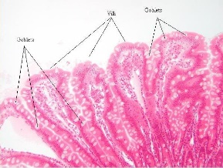  Intestinal lining cell | Intestinal lining cells produce enzymes that contribute to specific steps of digestion
 | Smooth muscle cell  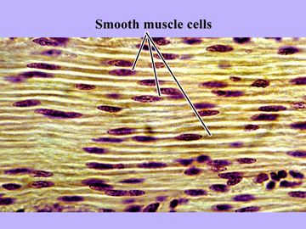  in the digestive system | Smooth muscle cells in the digestive system contract or relax in waves that move food through the digestive tract

2. You will look at a small number of genes on two human chromosomes: Chromosome 2 and 11.
Identify these chromosomes in the diagrams below and circle both pairs.
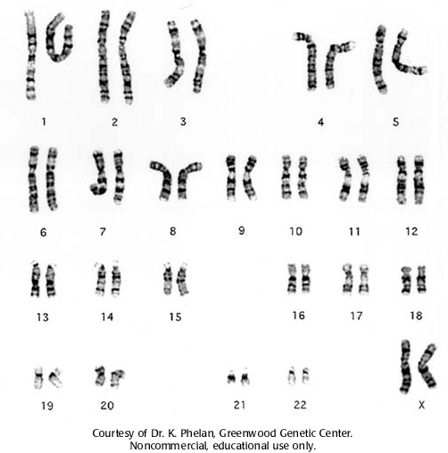
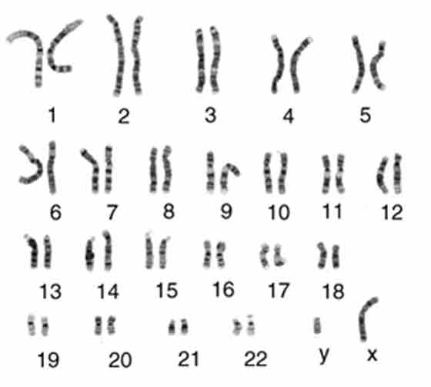

Human female karyotype
Human male karyotype
3) Read the chart that lists which genes are active in each cell. If a gene is activated (+) in all four cells circle the (+) in orange. Circle all genes that are repressed (-) in black. If a gene is only activated in one type of cell circle it in blue.

4) Based on the information in the table.

a. On Student Sheet “Chromosome Map,” find the chromosome for your cell. Draw a single, dark black line in the position of each gene that is NOT expressed in your cell type. These genes are still present, but they are never expressed in your cell type, and are permanently turned off, or repressed.

b. On Student Sheet “Chromosome Map,” draw a single, dark blue line in the position of a gene that is expressed ONLY in your cell type. This is one of a number of genes that produce specialized proteins that help your cell perform its role in the human body.

c. On student sheet “Chromosome Map” draw a single, dark orange line in the position of a gene that is expressed in all four cell types. This is a gene that produces proteins that nearly all cells need if they are to function.

d. Compare the chromosomes for your cell on Student Sheet “Chromosome Map,” with the others in your group. Copy the diagrams from their cells onto your Student Sheet

Part B: Differentiated Cells at Work

7. Shuffle the deck of Cellular Event Cards, and place it in the middle of your table. Put your models of chromosome 2 and chromosome 11 nearby.

8. Select one member of your group to start. That person will draw a card from the top of the deck and read it to the group.

9. Based on the information on the card, each member of the group determines which genes in their cells are activated to make proteins at this time, based on the event stated on the card, and which genes in their cell type are repressed during this event. Follow directions on the card to place transcription factors that determine whether the genes are expressed, or temporarily repressed. These transcription factors include both activators (green paper clips) and repressors (red paper
clips) that bind to portions of the DNA that regulate the gene. Place the paper clips on the appropriate gene on your model chromosomes.

10. Key: Green paper clip= Protein is needed- increasing the rate of transcription
Red paper clip= Protein is no longer needed- decreasing or turning off transcription
No paper clip= Only small amounts of the protein are needed
Binder clip= The protein is NEVER made in that type of cell

11. For your cell, in the data table below, record the cellular event, the affected gene, and the result.

12. The next person, clockwise, in your group selects the next card from the top of the deck. Repeat steps 10-11.

13. Continue selecting cards and determining which genes are affected until you finish going through the cards or your teacher instructs you to stop.

14. Compare your cell’s chromosome 2 to those of the other members of your group. Discuss and record in your data table any similarities and differences you observe in the genes that are expressed and repressed.

15. Compare your cell’s chromosome 11 to those of the other members of your group. Discuss and record in your data table any similarities and differences you observe in the genes that are expressed and repressed.

16. Discuss with your group.

- What patterns did you observe, related to genes turning on and off?

17. Complete analysis section.
Fill in the table with the cellular events and what happened

Genes Expressed in Four Types of Human Cells

Key: + = active gene, - = repressed gene
Chromosomes 2
Protein Produced by the Gene | Beta Cell in Pancreas | Developing Red Blood Cell | Intestinal Lining Cell | Smooth muscle Cell in the Digestive System | Function of the Protein
Ribosome protein S7 | + | + | + | + | Needed by ribosomes, which are essential for protein synthesis
Protein synthesis initiator | + | + | + | + | Controls the beginning of protein synthesis
Actin, smooth muscle type | _ | _ | _ | + | Most cells produce actin for cell movement and cell division, but muscle cells produce large amounts of specific types of actin
Cellular respiration enzyme | + | + | + | + | Catalyzes reactions for aerobic respiration in the mitochondria
Lactase | _ | _ | + | _ | Required for digestion of lactose, the sugar in milk
AGA enzyme | _ | _ | _ | _ | Breaks down fats and some toxic substances
Chromosome 11
Protein Produced by the Gene | Beta Cell in Pancreas | Developing Red Blood Cell | Intestinal Lining Cell | Smooth muscle Cell in the Digestive System | Function of the Protein
Cell growth controller | + | + | + | + | Prevents cells from dividing unless more cells are needed, helps prevent certain cancers
Hemoglobin B | _ | + | _ | _ | Carries oxygen to the cells throughout the body
Insulin | + | _ | _ | _ | A hormone that regulates the metabolism of sugars and fats
Fat and protein breakdown enzyme | + | + | + | + | Catalyzes one step in the breakdown of proteins and fats in the diet so they can be used for energy
DNA repair protein | + | + | + | + | Repairs damage to DNA

Name__________________________________ Period______ Date________________

Chromosome Map
Cell Type: beta cell in pancreas red blood cell intestinal lining cell smooth muscle cell

Gene
chromosome 2 chromosome 2 chromosome 2 chromosome 2
ribosome proteinS7 1
2
3
protein synthesis 4
initiator 5
6
7
actin, smooth 8
muscle type 9
cellular 10
respiration enzyme

11
12
13
14
15
16
lactase 17
18
20
21
22
23
24
AGA enzyme 25

chromosome 11 chromosome 11 chromosome 11 chromosome 11
cell growth
controller 1
2
hemoglobin B 3
insulin 4
5
6
7

8
fat and protein
breakdown 9
enzyme 10
11
12
13
DNA repair 14
Protein 15
16
17
18
19
Name:____________ Type of Cell ________________
Cellular event | Affected gene and result | How Does this affect my cell?

Name:____________________ Type of Cell___________________________
Analysis

- Compare the chromosomes in the four types of cells. Are chromosomes 2 and 11 in the muscle cells the same as chromosomes 2 and 11 in the other cells?

- Compare the genes that were on the DNA in the four types of cells. Did the chromosomes in the different cells have the same genes located on them?

- How was the expression of the genes different in the different cells?

- What kinds of genes were permanently inactivated in some of your cells? Why were they inactivated?

- Explain why some proteins are made by nearly all cells. Give 2 examples.

- What types of events caused short-term changes in some of the cells that you investigated?

- For your cell, explain how gene expression related to the cell’s ability to perform its functions in the body.

- For the human cell that you were the expert for, explain the connection between our DNA and disease. What would happen if a vital gene were repressed (turned off) on your chromosome?

This page contains the cards used in the activity which describes various cellular events, each student in the group must complete what is instructed by the action of each card.

14. The smooth muscle cell is mature and only needs to produce small amounts of actin to help with muscle contractions. Remove all activators or repressors from this gene, which will continue to direct production of small amounts of actin. | 13. The person’s last few meals were high in carbohydrates, but moderate in fat and protein. In all cells, remove any green activators from the gene for the fat and protein breakdown enzyme. The cell will continue to produce small amounts of the enzyme.
12. The developing red blood cell must make a large amount of hemoglobin. Attach two green activators to the gene for hemoglobin to indicate that this gene must be highly expressed. | 11. The smooth muscle cell is growing and must produce actin. Add a green activator to the actin gene of the smooth muscle cell.
10. The intestinal lining cell and the maturing red blood cell do not need to divide ever again. Add a green activator to the cell-cycle control gene, which will produce a protein that prevents the cell from dividing. | 9. The smooth muscle cell is about to start a new cell cycle, when it will replicate its DNA and divide. Add a green activator to the DNA repair protein gene and a red suppressor to the cell growth control gene.
8. The pancreatic beta cell currently has enough insulin. Remove any green activators, and add a red repressor to the insulin gene of the beta cell. | 7. The pancreatic beta cell has released its insulin, and more is needed. Remove any red repressors, and add a green activator to the insulin gene. This will turn on production of insulin.
6. Proteins are needed for a cell to function. The protein synthesis initiator gene is expressed in all cells. Add a green activator to this gene for all cell types. | 5. There is no milk in the small intestine. The lactase gene is repressed in the intestinal lining cells. Remove any green activators, and attach a red suppressor to the gene for lactase. This will decrease production of the lactase enzyme.
3. After a meal full of protein and fats, a person’s body needs more enzymes to break down the fat and protein. Add a green activator to the gene for the fat and protein breakdown enzyme in all the cells. | 2. Your cell has enough ribosomes for now. Attach a red repressor to the gene for the ribosomal protein. This will decrease production of the ribosome protein.
4.There is milk, which contains lactose, in the small intestines. The lactase gene is expressed in the intestinal lining cells. Remove any red suppressors, and attach a green activator to the lactase gene. This will increase production of the lactase enzyme. | 1. All cells require energy, which they obtain by cellular respiration. Attach a green activator to the gene for the cell respiration enzyme in all cell types. This will increase production of the cell respiration enzyme. For cell respiration in smooth muscle, which needs more energy than most cell types, add a second activator to the gene.

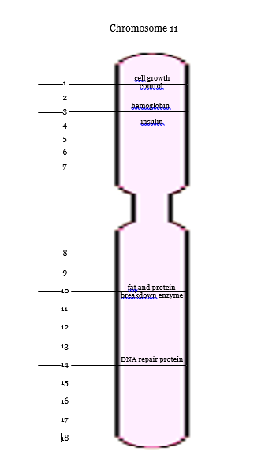
Chromosome 2

ribosome protein
1
2
3
protein synthesis
initiator
4
5
6
7
actin
8
9
cellular respiration
enzyme

10

11
12
13
14
15
16
lactase
17
18
19
20
21
22
23
24
AGA enzyme
25
Type of Cell:
Type of Cell:

