Digestion and Biosynthesis Exploration

Driving Question:
Every animal obtains food - Why? Is it only to satisfy their need for energy?

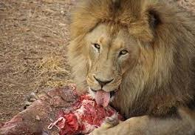

Part A: Carnivore Example

In a zoo, the lion is given beef to eat. When proteins are digested, chemical bonds between each amino acid are broken as shown in the model below
.
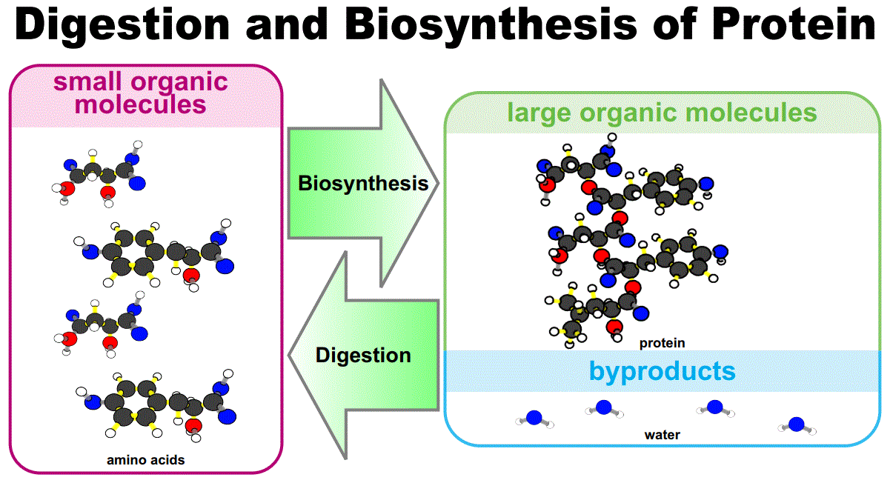

Procedure:
- Assign a beef protein to each member of the team.
  - Protein 1 ____________________
  - Protein 2 ____________________
  - Protein 3 ____________________
  - Protein 4 ____________________
- Each member simulates digestion by cutting their assigned protein into individual amino acids. In the digestive system, this action is done by a combination of stomach acid and enzymes like Pepsin and Trypsin. This ensures protein molecules are small enough to pass through the cell wall of the small intestine and into the bloodstream.
- Complete Data Table 1 recording how many bonds were broken during digestion and the amount of chemical energy that was released.
- Once you have completed Data Table 1, your team will simulate biosynthesis of new proteins that the lion needs to grow and survive. Assign one member to each protein below.
- Working together, rearrange your amino acids to make these proteins for the lion’s body. You may need to trade with your team members to get all the amino acids you need for your assigned new protein.
- When your team is done, answer the questions in Part A Data and Analysis

Proteins needed for lion survival:
Protein for muscle | Protein for collagen | Protein for fur | Protein for cell transport | Assignments
LYS | GLU | LYS | THR | Muscle Protein:
LYS | ALA | PHE | PRO
SER | ALA | GLU | GLU | Collagen Protein:
GLU | GLU | HIS | THR
VAL | LEU | VAL | PHE | Fur Protein:
VAL | SER | VAL | LYS
VAL | ARG | PHE | VAL | Transport Protein:
SER | VAL | VAL | LEU
ASN | PRO | VAL | PRO
ILE | LYS | LEU | LYS
CYS | PRO | PRO | LEU
HIS | GLY | ARG | VAL
PRO |  | LYS | LYS
ALA |  | SER | HIS
PRO |  | ASN
 |  | THR

Part A Data and Analysis

Data Table 1
Protein  (Original) | Number of Bonds Broken (cuts) | Amount of energy released (kcal)  A peptide bond releases 10 kcal when broken
1
2
3
4
Total:

Data Table 2
Protein (new) | Number of Bonds Formed | Amount of energy used (kcal)  It takes 10 kcal to form a peptide bond in the new protein.
muscle
collagen
fur
cell transport
Total:

- After completing the Biosynthesis step, are there amino acids left over from your original protein? (circle one)
YES NO
If yes, which ones? _______________________________________

- Were any of your original amino acids “swapped” with someone else in your group? Give specific evidence.
- Comparing your total amount of energy released and energy used (from Data Table 1 and 2), provide evidence to support that there was a net gain in energy (kcal).
__________________________________________________________________________________________________________________

4. Comparing your total number of bonds broken and number of bonds formed (from Data Table 1 and 2), provide evidence to support that there was a net gain in energy with respect to bonds. _________________________________________________________

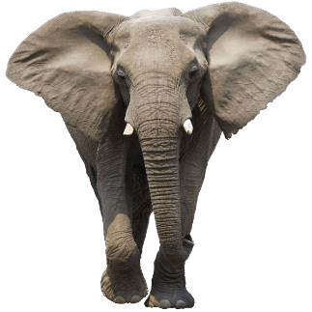
Part B: Herbivore Example

In a zoo, the elephant’s diet consists of plant material which is high in cellulose (fiber), a complex carbohydrate. When carbohydrates are digested, chemical bonds between each glucose monomer (small organic molecule) are broken as shown in the model below.

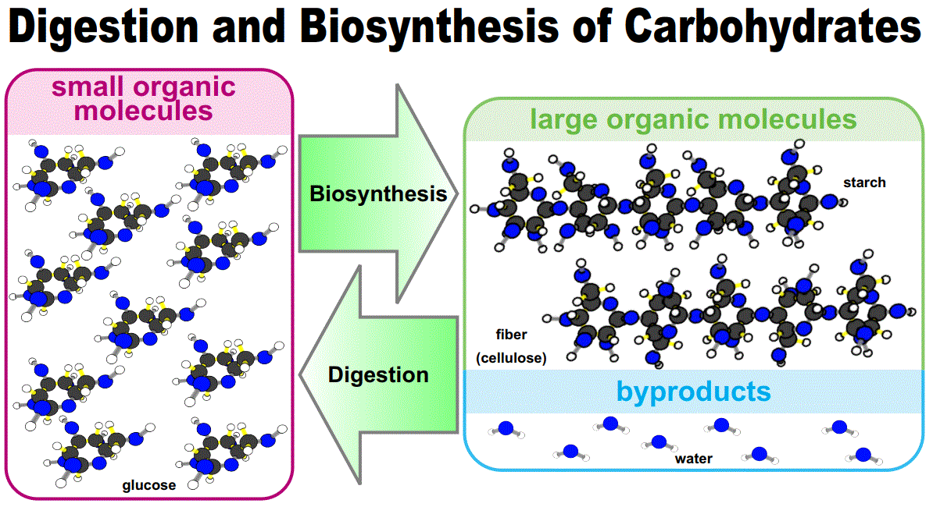

Collagen is a protein found in the skin of animals. Skin cells can be replaced every 2 weeks making it necessary for collagen to be produced often in cells. The elephant needs collagen to replace and/or repair these skin cells. You will be following and analyzing the process of creating a protein on a plant-based diet.

As a group, complete the following:

1. Complete Data Table 3 to analyze the number of each element in glutamine, glycine, lysine, and proline which are 4 amino acids in collagen.

Data Table 3

Amino Acid | Carbon | Hydrogen | Nitrogen | Oxygen | Total atoms:
Glutamine C5H10N2O3 |  |  |  |  | =
Glycine C2H5NO2 |  |  |  |  | =
Lysine C6H14N2O2 |  |  |  |  | =
Proline C5H9NO2 |  |  |  |  | =
Totals: |  |  |  |  | =

2. Analyze the cellulose molecule model (see the “Cellulose Molecule Model” sheet). Step 1 illustrates the elephant eating plant material and then magnifies it at the molecular level.

a. What element is missing from the cellulose molecule which is needed to make collagen? _________________________________________________

b. What overall process is occurring from step 1 to step 5? ______________________________________________

c. What happens between step 2 and step 3? _________________________________________________

d. What is released between step 2 and step 3 when bonds are broken? _________________________________________________

e. Between step 4 and step 5, there are now individual elements. What happened? __________________________________________________________________________________________________

f. fill out Data Table 4 with the number of bonds broken and calculate the amount of energy released.
Data Table 4

Steps | Number of Bonds Broken  (in section of cellulose shown) | Amount of Energy Released (kcal)  (# of bonds broken x 10 kcal)
Between 2 and 3
Between 3 and 4
Between 4 and 5 | 102
Totals:

Conclusion Questions:
- Compare your total amount of energy released from the proteins the lion digested (Data Table 1) and the carbohydrates the elephant digested (Data Table 4). Which species had a larger net gain of energy from their digested food? Provide evidence.
- Apply what you have learned about the structure of organic molecules to explain your answer for question 1.
- Since a complete cellulose molecule is 100 times longer than pictured in Step 2, how many total bonds would actually be broken through digestion? Show your calculation.
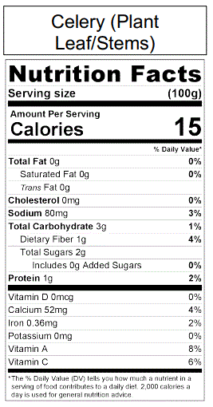
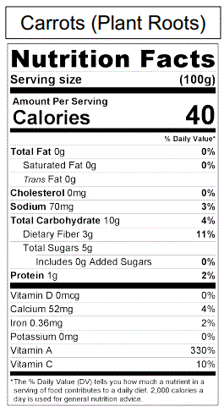
- What was the missing element (from Step 5) needed to make proteins like collagen? Since the elephant’s diet consists of plant material only, where would the elephant get the missing element needed to make collagen (or any protein)? To help answer this look at the food labels.

- Every animal obtains food? Why? Is it only to satisfy their need for energy?

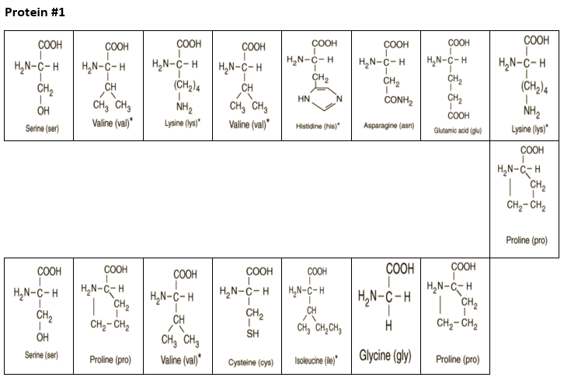
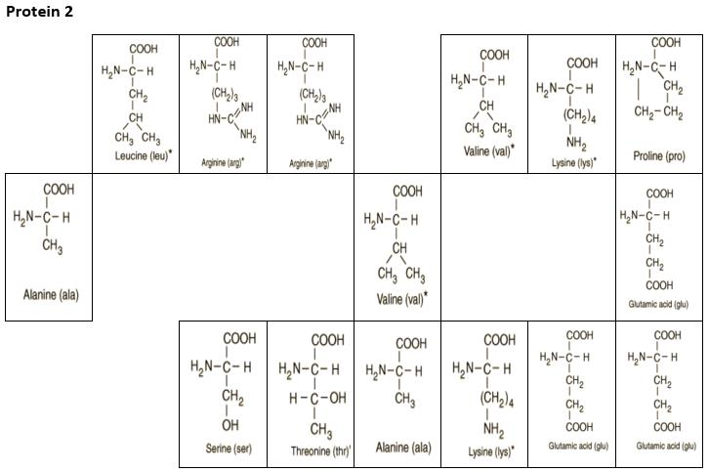

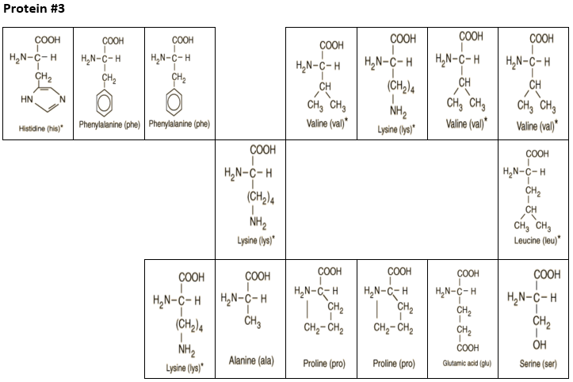
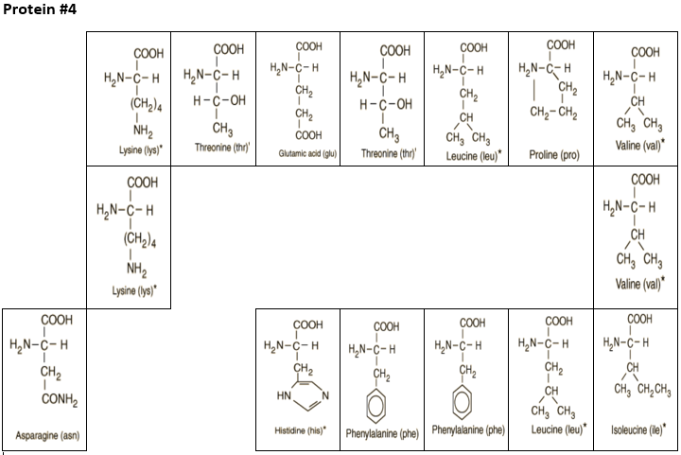

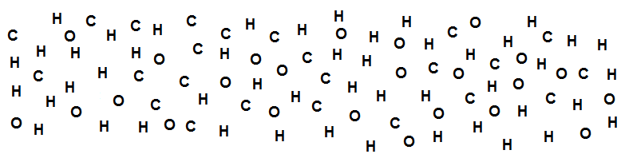
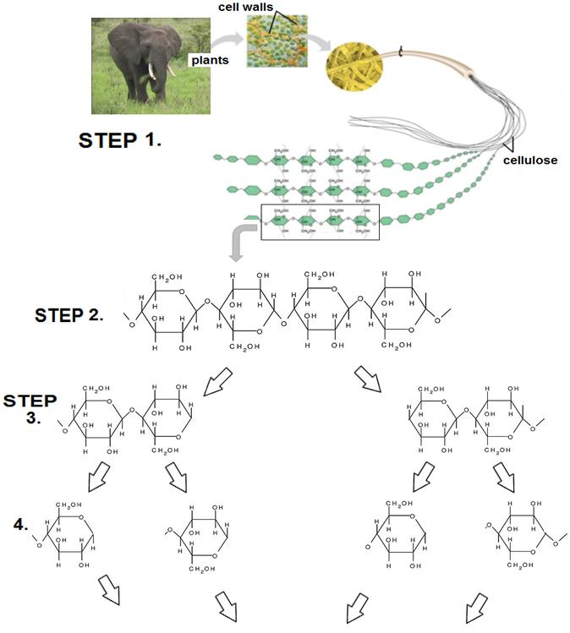
CELLULOSE MOLECULE MODEL

