Look at the ecosystem below. Identify 2 biotic and 2 abiotic factors.
Biotic Factors | 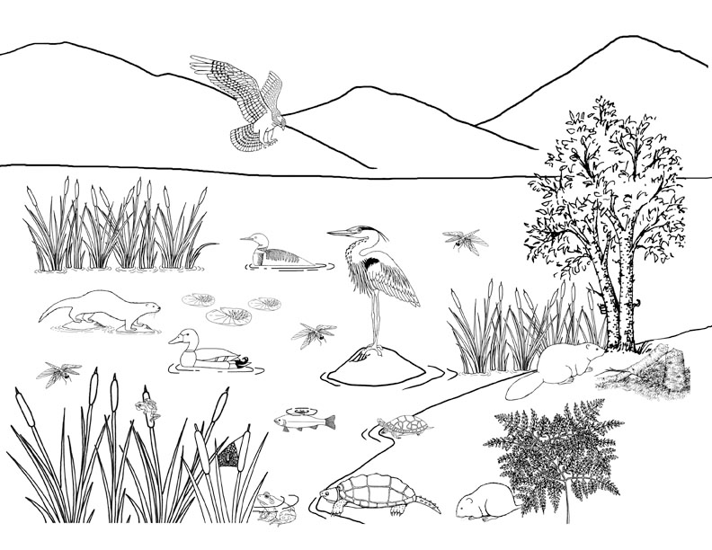 | Abiotic Factors
All biotic and abiotic factors are interrelated: a change in one factor will affect other factors.
Describe how a change in one abiotic factor that you identified may affect one of the biotic factors.
_____________________________________________________________________________________________________________________
______________________________________________________________________________

For more information on limiting factors, watch this video and take notes:
Video: Limiting Factors in an Ecosystem (2:08)
Definition of Density Dependent Limiting Factor  & example | Definition of Density Independent Limiting Factor & example | More examples of Abiotic & Biotic Limiting Factors
How does a population grow?
Take notes from this video:
Ecology - Lesson 2: Populations (2:34 min)
How populations increase
How populations decrease

With a partner, list factors that increase a population’s growth and factors that decrease a population’s growth, and fit them into the equation format provided below. 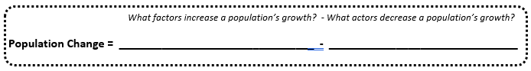
Exploring Bacteria Population Growth

The graph below contains data for the population growth of a hypothetical bacteria population.
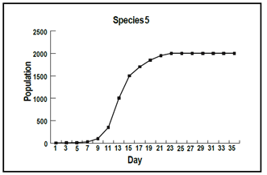
- Identify the trends (pattern) in the population size. You should note two observations.

- Based on the graph, what do you observe about bacteria growth?

- Construct an explanation for why bacteria don’t take over the world.

