DNA Structure and Replication Notes
Name:
- Nucleic acids store information in their sequences of chemical units
- There are two types of nucleic acids:
a. ( )
      - .
      - the “blueprint of life”
      - Stores all heritable genetic information
b. ( )
      - stranded
      - Stores genetic information in some organisms; transfers information in other organisms (humans)
      - Three types: (Messenger RNA), (Transfer RNA), and . (Ribosomal RNA)
      - Nucleic acids are polymers composed of long chains of monomers called nucleotides that are linked by dehydration synthesis.

- Nucleic acids dictate the amino acid sequence of proteins

. . .
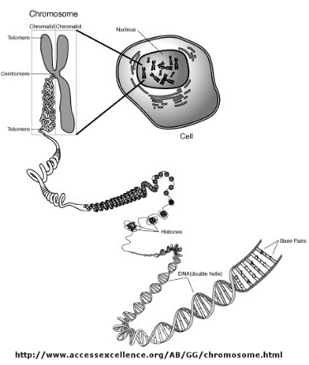
- Nucleic acids store genetic information in chromosomes, which are passed from parents to offspring during reproduction
Nucleotides are the building blocks of nucleic acids
Nucleotides have THREE parts:
a. (P)
b. pentose (ring-shaped, 5-carbon sugar)
Either deoxyribose (DNA) or ribose (RNA)
c. nitrogenous bases (made of C, H, N):
(A)
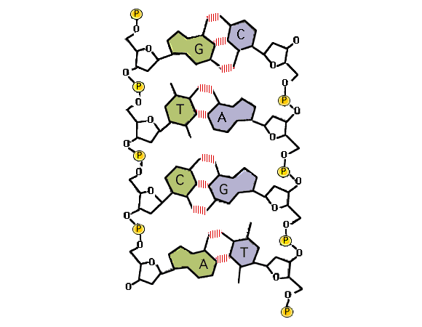
(T) – in DNA only
(C)
(G)
(U) – in RNA only
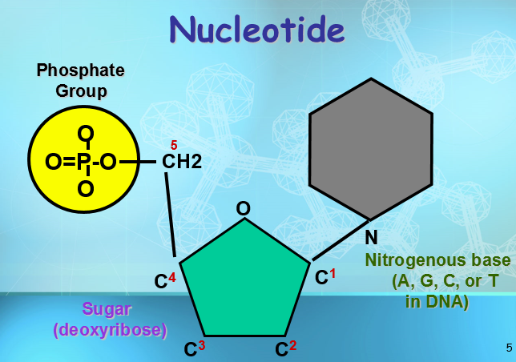

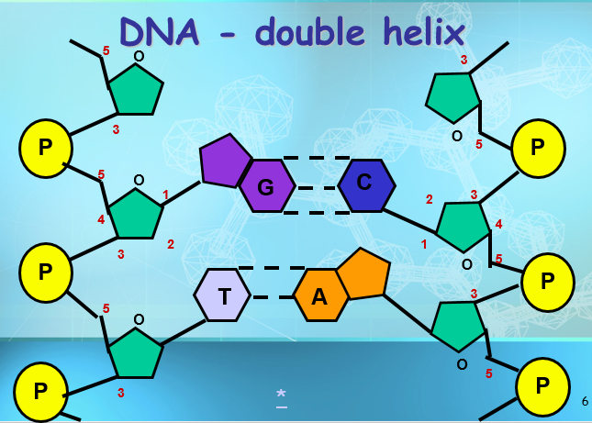
How Does DNA Work?
1. DNA stores genetic information in segments called .
2. The DNA code is in (short sequences of 3 nucleotides) ex. GCA
3. Each is translated by the cell into a specific .
4. The in DNA indicates the in a protein.
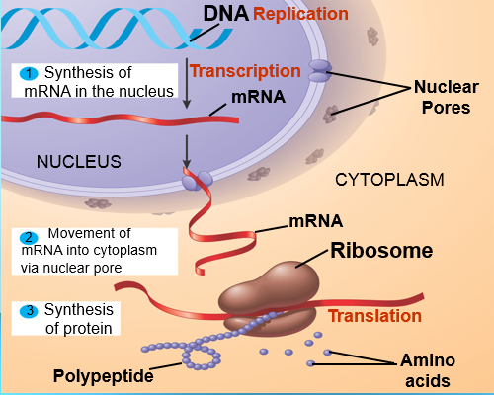
DNA is often called the blueprint of life – it stores an organism’s genetic information.

DNA contains the instructions for making proteins within the cell.

Chromosomes and DNA

are made up of compacted DNA.
are segments of DNA molecules located on our chromosomes.

DNA is a very long polymer made up of s .
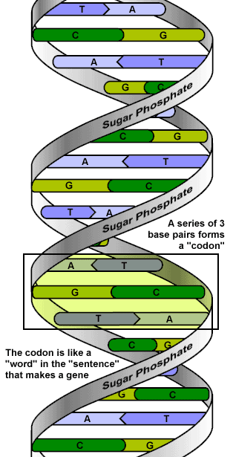
The basic shape is like a twisted ladder or zipper.
This is called a .
The of the DNA molecule is made of alternating groups and deoxyribose .
The “rungs of the DNA ladder” are the nitrogenous bases (either A, C, T, or G).
always pairs with and
always pairs with .
This is known as complimentary base pairing.
One strand of DNA is a polymer of nucleotides. One strand of DNA has millions of nucleotides.
The nucleotides are connected to each other by covalent bonds that join the sugar of one nucleotide to the phosphate group of the next nucleotide.
Pyrimidines are single-ringed bases.
Thymine (T) and Cytosine (C) are pyrimidines They each have one ring of carbon and nitrogen atoms.
Purines are large, double-ringed bases.
Adenine (A) and Guanine (G) are purines They each have two rings of carbon and nitrogen atoms

The bases attract each other because of bonds.
Hydrogen bonds are weak, but there are millions and millions of them in a single molecule of DNA.
The bonds between cytosine and guanine are shown here with lines
When making hydrogen bonds, cytosine always pairs with _______.
Adenine always pairs with ___________.

DNA Replication

- Occurs when ________________ duplicate during ____________________.
- An enzyme called ______________ “unzips” the DNA molecule breaks the ________________ ___________ between the bases.
- Nucleotides are added to the template strand by an enzyme called _____ _________________.
- The end product of DNA replication is two,_____________ molecules of ___________.
- Each old strand of nucleotides serves as a template for each new strand.
- This is called ____________________ replication.
Review:

What is the complementary strand:
A T C G G A T C G G G A T A
.

How does the structure of the DNA molecule allow genetic information to be transferred from one generation to the next (or from one cell to the next) without changing the sequences of bases each time it is replicated?

________________________________________________________________________________________________________________________________________________________________________________________________________________________________________________________________________________________________________________________________________________________________________________________________________________________________________________________________________________________________________________________________________________________________________________________________________________________________________________________________________________________________________________________________________________________________________________________

Comparing DNA to RNA
DNA (Deoxyribonucleic acid) is a huge double stranded molecule that is only found in the nucleus. It is made up of nucleotides. Each nucleotide has deoxyribose sugar, a phosphate, and one of the 4 DNA nitrogenous bases (Adenine, Thymine, Guanine, or Cytosine). Exact copies of DNA are made during replication because either strand can be used as a template. This works because of base pairing rules. Adenine can only be linked to thymine and cytosine can only be linked to guanine. Every cell contains 46 molecules of DNA. This information on the DNA contains the code for making all of the proteins that are made in your body. Not every cell needs to make every type of protein. Cells will only make the proteins that they need for that cell. Ex: Skin cells make the protein for pigment which protects against UV rays. Muscle cells make the proteins that help the cell to contract with force.
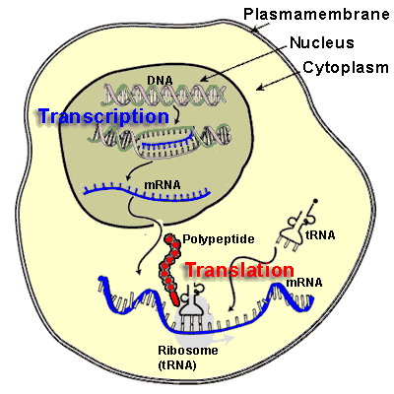
RNA (ribonucleic acid) is a smaller single stranded molecule that is made in the nucleus and can travel to the cytoplasm. It is made of nucleotides. Each nucleotide has a ribose sugar, a phosphate, and one of the 4 RNA nitrogenous bases (Adenine, Uracil, Guanine, and Cytosine). RNA comes in three forms. mRNA (messenger RNA) is made by copying the code of a small section of DNA (a gene) into the RNA nucleotides. This process is called Transcription. The mRNA then leaves the nucleus and travels to the cytoplasm to a ribosome. At the ribosome the mRNA is “read” and the nucleotide code is used as directions for assembling a protein. The process of making a protein is called Translation. rRNA (ribosomal RNA) is made in the nucleus and travels to the cytoplasm. It forms part of the ribosome. tRNA (transfer RNA) is made in the nucleus and travels to the cytoplasm. tRNA are specific. They carry the amino acids to the ribosome to make the protein.
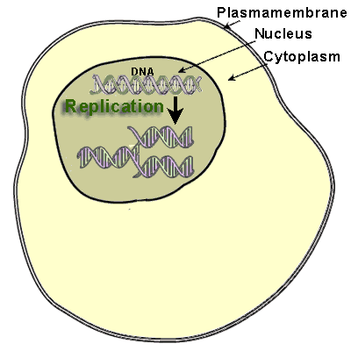
Comparing DNA and RNA Venn Diagram

Word Bank:
Nucleotides Deoxyribose Ribose Single-stranded
Double stranded Nitrogenous Bases Thymine Uracil
Messenger Double Helix Replication Transcription
Exact Copy Found in Nucleus Leaves Nucleus Doesn’t leave nucleus
Template for nucleic acid synthesis

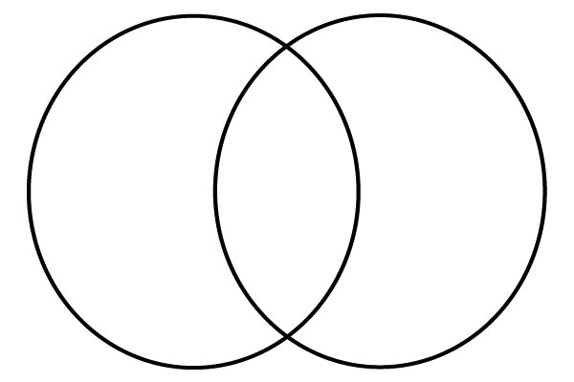
DNA RNA

