Review for quiz (and test)
Name:
Papers to review:
Cells: The building blocks of organisms (know info on 1st page (prokaryote vs. eukaryote) and know cell membrane, mitochondria, nucleus, and cytoplasm for this quiz/test).
Exploring What Cells Are Made Of (Food Labels): Be able to read a food label and identify the amount of carbohydrates, lipids, protein and water in the food
Water, Ethanol and Wood and Energy Capture Sheet: Be able to identify organic molecules vs. inorganic molecules. Identify high energy bonds vs. low energy bonds. Be able to explain why organic molecules can be used for fuel but inorganic molecules such as water and CO₂ do not burn.
Molecules Cells Are Made of: Be able to identify the monomer of carbohydrates and protein. Know the types of atoms in carbohydrates, lipids and proteins. Know examples of carbohydrates. Be able to explain why beef has more calories than celery.
Macromolecules: What are the Building Blocks of Life (Lion and Elephant): Be able to identify a picture of a carbohydrate. Identify which macromolecules are best for energy (based on the number of C-C and C-H bonds).
Modeling Cellular Respiration: Be able to explain the law of conservation of mass in cellular respiration. Be able to explain what happens to the high energy bonds in sugar. Know the formula for cellular respiration
Cellular Respiration Notes: Know the reactants and products of cellular respiration. Know the organelle that cellular respiration takes place in. Know the molecule that is made that holds energy. Be able to identify the 3 stages of cellular respiration and give general explanations of what happens in each stage.

Review Questions:
Cells: The building blocks of organisms
- What types of organisms are prokaryotes?

- What types of organisms are eukaryotes?

- For each of the following cell parts identify if they are found in Prokaryotes, Eukaryotes or Both.

Cell Membrane:
Nucleus:
Cytoplasm:
Mitochondria:

- Which organelle stores genetic information?

- Which organelle breaks down sugar to create ATP in cellular respiration?

Exploring What Cells Are Made Of (Food Labels):
Use the food labels to answer the following questions:
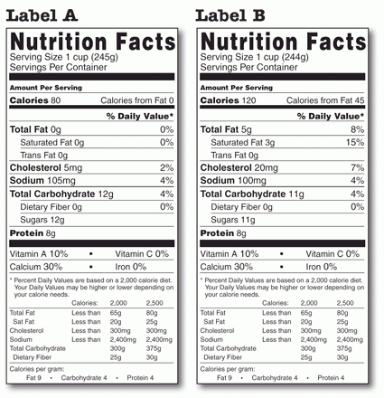

- Which food label is most likely from an animal?

- Which food would you expect to have a higher percentage of water?

- Which food would you expect to have more calories?

Water, Ethanol, and Wood and Energy
- What elements MUST be in a molecule for it to be organic?

- Identify the following molecules as organic or inorganic:
- Glucose (C₆H₁₂O₆) __________________
- Oxygen (O₂) _______________________
- Carbon Dioxide (CO₂) _______________
- Water (H₂O) ________________________
- Fats/Lipids _________________________
- Protein ____________________________

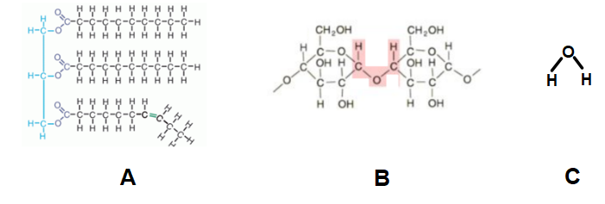

11. What types of bonds in the molecules above have the most energy?

12. Rank the molecules above from most energy to least energy in terms of the energy that is available in their bonds to give off to cells. Explain why.

13. What type of molecule is A? (Carbohydrate, lipid, protein or Nucleic Acid) Is it Organic?

14. What type of molecule is B? (Carbohydrate, lipid, protein or Nucleic Acid) Is it Organic?

15. What type of molecule is C? (You should be able to figure out this one) Is it organic?

Molecules Cells Are Made Of
16. Fill in the chart from your worksheet
Type of Macromolecule | Atoms Present | Types of Bonds | Monomer or Examples | Polymer or Examples
Carbohydrates

Lipids

Protein

Macromolecules: What are the building blocks of life
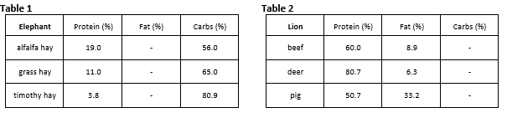
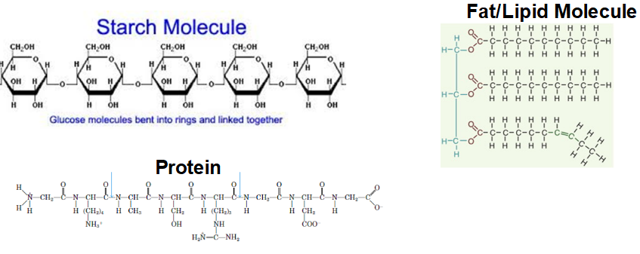

17. Use the charts above about the food that elephants and lions eat. Looking at the bonds found in each type of molecule identify:
-Primary Source of Energy for Elephants:_________________________________
-Primary Source of Energy for Lions:

Modeling Cellular Respiration
18. How is the law of conservation of matter shown in the chemical equation for cellular respiration?

19. What is the law of conservation of energy? How is energy conserved in cellular respiration? (where does the energy from the high energy bonds in the sugar end up in the products?)

Cellular Respiration Notes
20. Write out the balanced formula for cellular respiration.

21. Where does cellular respiration take place in the cell?

22. What are the reactants of cellular respiration?

23. What are the products of cellular respiration?

24. Which molecule has more stored energy- ATP or ADP?

25. What are the 3 stages of cellular respiration?

26. What happens in glycolysis? Where does it take place?

27. What happens in the Kreb’s Cycle? Where does it take place?

28. What happens in the electron transport chain and ATP synthase? Where does it take place?

29. Which stage makes the most ATP?

30. Which molecules are electron transport carriers?

31. How much ATP is produced at the end of Aerobic Cellular Respiration?

