Name:
Learning from Patients: The Science of Medicine (2003)
Lecture One—Research Mechanics: Putting the Brakes on Cancer
Bert Vogelstein, M.D.
Excerpt from Lecture 1 (Adapted)
From the Howard Hughes Medical Institute the 2003 Holiday Lectures on Science. This year's lectures Learning from Patients: The Science of Medicine will be given by Dr. Bert Vogelstein Howard Hughes Medical Institute Investigator at Johns Hopkins University School of Medicine and Dr. Huda Zoghbi Howard Hughes Medical Institute Investigator at Baylor College of Medicine. The first lecture is titled Research Mechanics: Putting the Brakes on Cancer.

Introduction:

*Nature of cancer: Malignancy and metastasis. Let's begin with the nature of cancer. There are lots of different types of tumors and I'll tell you the difference between cancer and tumors in a second but cancers are a form of tumor. Benign tumors are not life-threatening. They're not particularly dangerous.

It's not size that defines the difference between a benign tumor and a malignant tumor. Another name for a malignant tumor is a cancer. If it's not size, what is it? It's something called invasiveness. It will eventually hit a blood or lymphatic vessel and then tumor cells can go inside the blood vessels and travel to other parts of the body. That is called metastasis- when a malignant tumor reaches a blood vessel, travels throughout the bloodstream, reaches other organs like the lungs or the liver and starts to form a new tumor -a kind of colony of the original tumor in the new place and that's why people die, because of metastases. The primary tumors can almost always be removed surgically but if the tumors aren't detected until after they have metastasized then it's too late for this form of treatment to work exclusively. The Greeks recognized this invasiveness of cancer very early on, and that's why they called it "cancer" which means "a crab." They saw the invasive arms of the cancer such as in the melanoma and that reminded them of the claws of a crab.
What is the difference between a benign and malignant tumor?

What is metastasis?

*Tumor growth and metastasis:
How does a tumor grow? First, there are cells which divide abnormally. They keep dividing at the expense of the normal cells that surround them and in three dimensions. Once they divide enough they start to pop out. You can begin to see them with your naked eye -not just under a microscope. Then they need to recruit blood vessels in order to grow to a size that's greater than just a tenth of an inch in diameter. The blood vessels supply oxygen and nutrients. Then a cell may break away and go into the blood vessel. That is the last stage or metastasis stage.
What happens to the area around the tumor when the normal cells divide abnormally?

* Many types of cancer:
There are lots of kinds of cancers. Cancer is often thought of as a single disease in the newspaper but it's really not. It's hundreds of different diseases. For every cell type in the body there's at least one form of cancer and they are different. For example, a breast cancer is different than a melanoma or a colon cancer. A kind of cancer that particularly affects young people is leukemia. Most of the cells in the blood are red cells but there are also a few white cells. Those are normally there and they help prevent infections. In a blood sample from a leukemia patient, however, there are still a few normal-looking white cells but most of the white cells are large and abnormal forms. These represent the leukemia cells. Because these cells are already in the blood (since they're a cancer of blood cells), they spread immediately throughout the body and have to be treated immediately for the patient to survive.
What is leukemia?

*Tumors and ratio of cell birth to death:
What do all tumors have in common?

In normal adult tissue what is the ratio supposed to be between the birth and death rate of cells?

What causes a tumor?

Why does a normal cell divide?

What happens in a tumor?

Despite the fact that all of these tumors are different in some ways, they also have something in common. What they have in common is that there is an abnormal ratio between cell birth and cell death. In a normal adult tissue say, the skin or in the intestines where cells are always dividing, there's always a very specific ratio of cell birth and cell death. It has to be exactly one. For every cell that's born, one cell dies. If too many cells die and more cells die than are born, the tissue will shrink. It will atrophy. On the other hand, if more cells are born than die that is a tumor. That's the definition of a tumor and it doesn't require much of an increase of that ratio in order to get a big tumor over time. It only requires a slight difference in the ratio of cell birth to cell death to develop a very large tumor over time. Most tumors take twenty to thirty years to develop. This is the common underlying theme of tumor development.
When a normal cell divides, it is doing so in response to some kind of signal. That signal might be that a neighboring cell has died, so the cells are reproducing to replace the dead cell. This leaves the net number of cells at the end the same as before the original cell death. A normal cell may also divide due to a hormone message saying the organism needs to grow that tissue, so that will lead to growth, but it should be growth that is needed and is controlled by the endocrine system (an example of this happening is during puberty, when hormones dictate development of new tissues).
But in a tumor, it's quite different. In tumor cells, which are mutated (have damaged DNA), the cell for some reason divides when the body does not need to grow that tissue and when no cells have died. There will keep being more cells, more cells and more cells over time and that starts a benign tumor.

Mutations in specific “cancer” genes cause the disease. Cancer is, in essence, a genetic disease but it's different than most other genetic diseases with which you're familiar.

*Types of genes that are mutated in cancer:
There are only three kinds of genes.

- One kind is called an oncogene. Everybody has
What is the purpose of a proto-oncogene?

What is a proto-oncogene called if it is mutated?

What does an oncogene do?
proto-oncogenes (“proto” means “first” or “before, so proto-onco means “before cancer”). They are any genes that normally stimulate cell growth. They're what you need to grow and to live. But if a proto-oncogene becomes mutated and stops behaving in a controlled way like it should, it becomes an “oncogene”, which is like having an accelerator in a car that's stuck to the floor because there is a heavy weight on the pedal. The car continues to go even if the driver wants to stop it by lifting her foot off the accelerator pedal. That is just what a mutation in a proto-oncogene does in a cell. It makes the cell continue to grow and divide whereas normally, without the mutation, the cell would stop growing because it's being controlled properly.

- This analogy works, too, for the second kind of gene which is called a tumor suppressor gene. These are the cell's brakes. These normally inhibit growth and division. A mutation in a tumor suppressor gene is much like having a dysfunctional brake. Just as cars have more than one brake (they have a foot brake, or a hand brake or emergency brake), cells have multiple brakes, too, and it's only when several brakes plus an accelerator or two all become dysfunctional in an automobile that the car spins out of control. It's the same in a cell. It's only when several of these genes become mutated and don't work properly that the cell spins out of control and becomes a metastatic cancer.
What is the purpose of a tumor suppressor gene?

What happens when there is a mutation in the tumor suppressor gene?
What is the purpose of DNA repair genes?

- There's a third kind of gene which may cause tumors when they are mutated and these are called DNA repair genes. Your DNA is being damaged by the environment all the time. UV light, chemicals, X-rays, mistakes during replication, and just random chemical changes that happen to all organisms. Our cells have lots (over 130) of genes that make special enzymes to fix this damage. Having a faulty repair gene is like having an inept mechanic who can't fix the mistakes that are made and cells are always making mistakes.

Tumor Suppressor Genes:
What does p53 do?

Mutations in tumor suppressor genes are important because they cause many forms of inherited cancers. In the United States this year about 135,000 people will develop colon cancer. In the world, about a million people this year will develop colon cancer. A very important tumor suppressor gene is the p53 gene (named for the protein it codes for that weighs 53,000 daltons). This protein is known as the “guardian angel gene” because it works to prevent mutations and to stop cell with mutations from dividing. It also directs the DNA repair mechanisms sometimes. The p53 gene is activated when there is a problem with DNA replication and a mutation is formed. The p53 protein in turn activates DNA repair proteins as well as slows down the progression of a cell going from G1 to S stages (at the G1/S restriction point). It can also cause a cell to undergo apoptosis, programmed cell death, so that it does not replicate itself and divide into more abnormal cells. A mutation in either the p53 (one that knocks it out) or Ras genes (one that over produces the abnormal cell) will cause rapid cell growth and division leading to cancer. Examples of tumor suppressor genes in common cancers include the BRCA1 and BRCA2 genes which are associated with breast and ovarian cancers and the APC gene (adenomatous polyposis coli) which is associated with 60% of colorectal cancers.

P53 gene is mutated in most cancers. P53 is mutated like all of the others in part because there's some sort of faulty repair. It's hard to be a cancer without getting a p53 mutation. So all of these different tumor types have mutations in p53. It's kind of a common denominator for cancer. How can someone get a mutation to their p53 gene? Sunlight, and the UV radiation in it, could do it, such as you get when you're on the beach. Everybody likes the beach. Unfortunately, at the beach not only will you get a good tan, you may get a mutation in p53, changing a "C" nucleotide to a "T" nucleotide. Now, this is a characteristic mutation caused by sunlight. If you irradiate bacteria, meaning expose them to radiation, they get this kind of mutation (a "C" to a "T") and that mutation occurs in the p53 gene in skin cancers. Skin cancers are, of course, induced by ultraviolet (UV) light. We now know that cigarette smoke causes cancers in part by inducing mutations in p53 in lung tissue. In colon cancers it's a more complex scenario. We know specific mutations in p53 that occur but we don't know exactly what the carcinogen is.
How common are p53 mutations in cancers?

DNA repair genes:
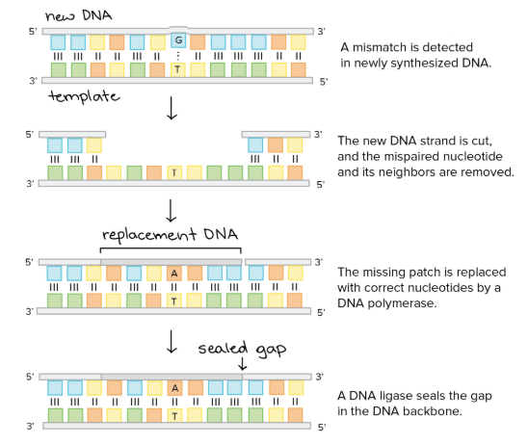
DNA can get damaged in a number of different ways, so our cells have several ways to fix it. One way is using DNA mismatch repair genes. When DNA copies itself, an enzyme called DNA polymerase copies both chains of nucleotides in the DNA (the top strand and the bottom strand). DNA polymerases are really good at this, but sometimes they're not perfect, as we just mentioned. Sometimes they make mistakes and the kind of mistake they might make is to incorporate the wrong nucleotide. Normally, there's going to be an "A" opposite a "T" and a "C" opposite a "G" but suppose it makes a mistake and copies a "T" where a "C" should be? That should be "GC," but now there's a "T." So that's a mistake, a potential mutation. Fortunately, cells have repair systems that can cut out those mutations and replace the nucleotides with what they should be. Those repair systems are made of a bunch of different repair proteins coded for by DNA mismatch repair genes.
What do DNA mismatch repair genes do?

Why are mutations to DNA repair genes so damaging?

Other DNA repair genes are involved in fixing damage that is done to DNA due to damaging chemicals and radiation (like UV rays) in the environment, when several nucleotides are damaged in a big area, or when a piece breaks off of a chromosome.

If there is a mutation in some of these very important DNA repair genes, then the damage doesn’t get fixed and mutations can build up faster, damaging other DNA repair genes, tumor suppressor genes and proto-oncogenes (turning them into oncogenes).
Proto-Oncogenes/Oncogenes:
What signals a cell to divide?

What does the Ras gene do?

Normally, cells get a signal to divide from growth factors. Growth factors are proteins that are released by cells that “tell” other specific target cells to divide. They are important in growth and tissue repair such as wound healing. Proto-oncogenes code for proteins that stimulate normal cell growth and division. They are a group of enzymes and proteins that transmit a signal (or amplify it much as a stereo speaker does). A very important proto-oncogene is the Ras gene (named after “rat sarcoma) which codes for the Ras protein that coordinates transmission of signals received by a growth factor when it binds to a receptor protein on the surface of a cell membrane. This protein activates other proteins that ultimately turn on a gene that stimulates the cell to continue progressing through its cell cycle stages to replication and division.

Signal Transduction Pathway

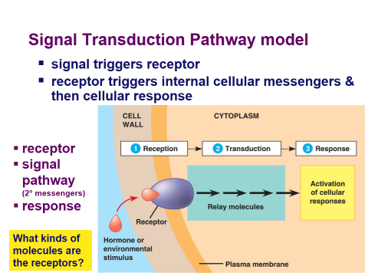
In order for multicellular organisms to coordinate their cellular activity, conserve resources and energy, and know when to grow and divide, the cells must have internal control systems as well as a method to communicate with other cells. Cells “talk to each other” when they are nearby by sending signals and can also talk to each other when they are far apart as, for example, in different organ systems by sending information through the circulatory system (our blood). Signals can also come from external environmental sources such as light and sound. Cells in a healthy multicellular organism have various rates of cell cycles depending on the type of cell. Red blood cells and skin need to divide frequently, muscle cells and neurons do not divide once an animal is mature and liver cells can go from dividing cells to non- dividing cells depending on signals they receive.

Cell membranes have proteins embedded in them. Some proteins have the specific job of “listening” to signals. They are very specific receptor proteins that receive specific signals and then tell the cell what to do. Other proteins are sensitive to “touching” neighboring cells. The information received at the surface of the cell must be passed inside the cell and results in a response.
Here is a picture of a “signal transduction pathway” which is just a fancy name for how cells receive information from external signals and respond to these signals.

The cell cycle is controlled by a mechanism with specific proteins and enzymes that act as “checkpoints” and tell the cell whether it should proceed from one stage to another. Much like a key opens only certain locks; these checkpoints are specific to transition cells from one phase to another.
What is the purpose of a checkpoint?

When cyclins bind to CDKs in the cell what happens in the cell?

List 2 checkpoints in the cell:

What is G₀ and what does it mean if a cell goes into this phase?

A class of proteins called cyclins is produced by the cell as the cell goes through its life cycle. There are a number of different types of cyclins that have specific jobs but we will just look at them as a group. In addition there is a class of enzymes called cyclin dependent kinases (CDKs) which as the name implies are enzymes that work with cyclins. When specific cyclins bind to their respective CDKs, various activities in the cell cycle are initiated. These activities are known as “checkpoints” that tell the cell when to proceed from one stage to another. There is a checkpoint that tells the cell to start growing, one that tells the cell that the DNA has been properly replicated and finally that everything looks good and it can divide into two daughter cells. If the cell detects problems at various checkpoints it will stop going to the next stage. As an example, if a checkpoint detects that there was an error in DNA replication it can stop the cell during synthesis and allow the cell time to repair its DNA or it might tell the cell that it needs to go to G₀. A cell will go into G₀ if, after G1, the cell determines that it does not need to divide again. When a cell goes into G₀, it will just do whatever function it is supposed to do (liver cells will do liver cell functions and etc.). Some cells, like some nerve and muscle cells, will go into G₀ permanently after being formed.

Sometimes the cell cycle does not work and either too many cells die or are produced. The latter is a tumor which may be benign or aggressive.

Poster Design:
Work with students in your group to design a poster that shows the function of these different types of genes and proteins and how mutations in them can cause cancer.

In the sections on the outside list the characteristics of each type of gene and protein. Explain how the gene/protein is supposed to work. Explain how the gene/protein can cause cancer when it is not working properly.

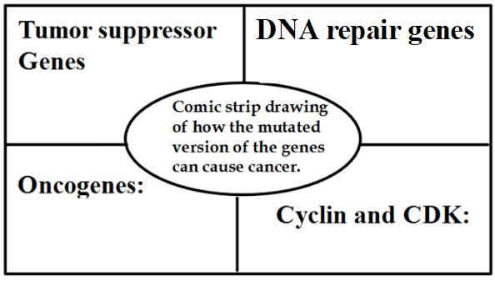
In the inside of the poster, work with the other members of your group to draw a comic strip showing how the mutated version of the gene/protein can cause cancer.

