Growin’ Like a Weed: Quadrat sampling

Name: _______________________ Date: ____________________Pd. _______

Background: When ecologists investigate plant populations, they randomly sample areas using a quadrat, a square frame. They place the quadrat on the ground, and count the numbers of plants of different species inside the quadrat to obtain a sample count or a density estimate. To count larger plants (tress, for example), ecologists perform a line transect, marking a straight line with a long piece of string, and counting any tree within a certain distance of the line.
In this activity, you will estimate the population sizes and densities of lawn weeds using the quadrat method.

Purpose:
To estimate the population densities of the dandelion, ground ivy, Japanese stiltgrass, broadleaf plantain, and white clover
Pre-Lab:
In your lab journals, complete the testable question, hypothesis, variables table, materials, and procedures.
Materials:
- Quadrat
- Colored pencils
Procedure:
1. To randomly choose your sampling site, gently toss the quadrat onto the lawn.
2. Draw any large features that happen to fall within your quadrat like trees, rocks, pavement, etc.
4. Use the guide to common Maryland weeds on the next page, and count the number of each plant species in each rectangle of your quadrat. Record the population size in your data table
5. Using the symbols shown alongside the plant diagrams, also plot the approximate location of the plants in your quadrant drawings.
6. Calculate the average population and density (plants/m²) for each plant species. For density, divide the average number of each plant by the size of the sample area (each area is approximately 0.25 m²).
7. Flip the quadrat left, repeat steps 1-5. Flip the quadrat down, repeat steps 1-5. Flip the quadrat right, repeat steps 1-5.
8. Collect class data and determine the class average population and density.

Don’t forget to answer questions on the back of the last page.

Data Chart:
Quadrat | Dandelion | Japanese Stiltgrass | Ground Ivy | Broadleaf Plantain | White Clover
1
2
3
4
Avg
Density
Class Avg
Class Density
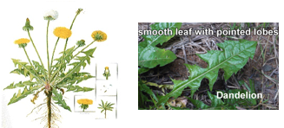
Maryland Weed Identification Guide:

Dandelion: Taraxacum officinale: Dandelions have hairless, toothy, deeply notched leaves. They produce yellow flowers or white, fluffy seed pods. Leaves radiate out from a single root system.
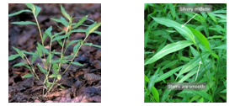
Japanese stiltgrass: Microstegium vimineum: Japanese stiltgrass has several stems coming from a single root system. The leaves are evenly placed along the stem. The leaves have a distinct silver line running up their middle
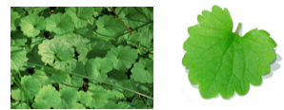
Ground ivy: Glechoma headrace: Ground ivy leaves grow off of a horizontally traveling root system. Their leaves are rounded or kidney shaped with rounded edges. The leaves are dark green with purple tinting in color.
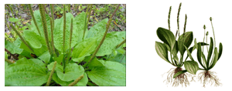
Broadleaf plantain: Plantago major: Broadleaf plantain leaves are broad and smooth edged. There may be flowering stalks rising from the center of the plant. Leaves radiate out from a single root system.
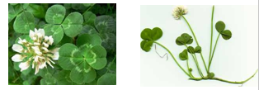
White clover: Trifolium repens: White clover root systems form large clumps of leaved clovers. Each clover stem has a three
leaved arrangement. They produce white flowers.

Quadrat Drawing
- In this space below, draw the approximate locations of major landmarks and the plant in each quadrat section. Be sure to draw any sections of pavement, rocks, or other obstructions in your area.
- Use the following symbols to represent each species of plant:
  - Dandelion
  - Japanese stiltgrass
  - Ground ivy
  - Broadleaf plantain
  - White clover

Conclusion:
1. How did your group data compare to class data?

2. What factors might explain differences between your data and class data?

3. Which plant species had the highest population density? What was the value? (use units)

4. Which plant species had the lowest population density? What was the value? (use units)

5. What are some environmental factors that might affect the population densities of these plants?

6. What type of organisms are best counted using a quadrat method?

7. Why would a scientist use the quadrat method instead of counting all of the individual organisms in a population?

8. What are the disadvantages or limitations of using the quadrat method.

