Cellular Respiration Notes
Name:
Overview of Cellular Respiration
- Definition: Reactants: Sugar and Oxygen.
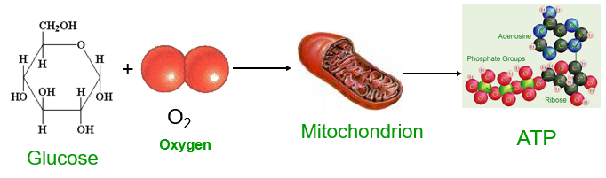
Products: Carbon Dioxide and Water and 36 ATP
- Purpose: Releases energy from sugar
- Occurs in all organisms
- Begins in the cytoplasm and ends in the mitochondria
- Has 3 main stages: Glycolysis, Kreb Cycle, Electron Transport Chain
- ATP is made by cellular respiration and is used by the cells for energy
Cellular Respiration: Glucose + 6 Oxygen 6 Carbon Dioxide + 6 Water + Energy (36 ATP)
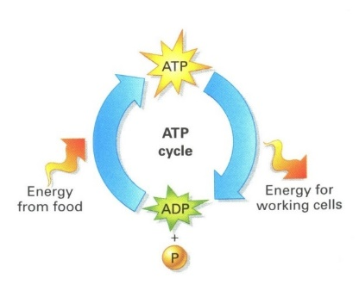
ATP Review:
- ATP provides energy for cellular work
  - Energy is released when ATP is converted to ADP
  - Energy from the organic molecules in food are used to add a phosphate group to ADP so that it can be converted into ATP again.
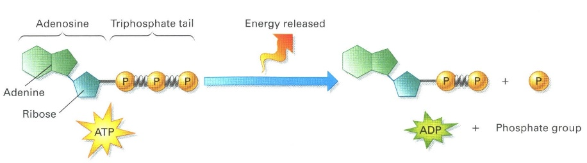
  - ATP is used for energy for movement, heat, biosynthesis and digestion

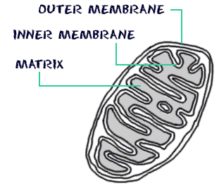

- The mitochondria are the major sites of cellular respiration

Cellular Respiration:
- The controlled breakdown of glucose into CO₂ and H₂O.
- Requires oxygen
- Energy is captured in the form of ATP
- The balanced chemical equation for the reaction of cellular respiration is:
- C₆H₁₂O₆ + 6O₂ → 6CO₂ + 6H₂O + 36–38 molecules of ATP

Cellular respiration takes place in three different stages
  - Stage 1 is Glycolysis
  - Stage 2 Krebs Cycle
  - Stage 3 is the electron transport chain and ATP synthase
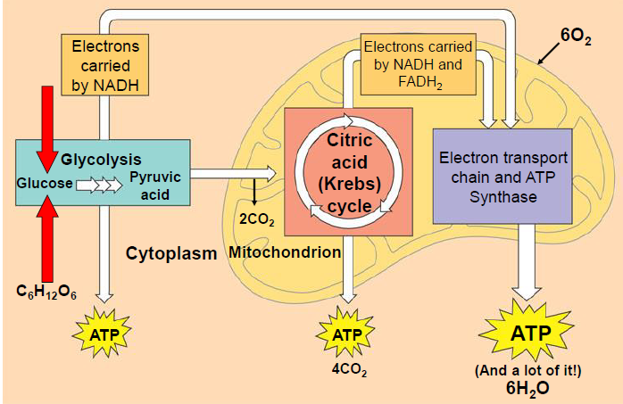
Glycolysis
- Takes place in the cytoplasm outside the mitochondria
- Two ATP’s are used to split one glucose molecule (a 6 carbon sugar) into 2 molecules of pyruvic acid/pyruvate (with 3 carbons)
- Does not require oxygen
END PRODUCTS OF GLYCOLYSIS:
  - 4 molecules of ATP (a net gain of 2 ATP molecules – 2 are used to start the reaction)
  - 2 NADH molecules (each NAD⁺ carries 2 electrons and 1 H ion from each 3 carbon sugar NADH)
  - 2 molecules of pyruvate (used in the Krebs cycle)

The Krebs Cycle
- Occurs in the matrix of the mitochondria
- Requires pyruvic acid from glycolysis
- Requires Oxygen
END PRODUCTS OF the Krebs Cycle:
  - 2 ATP molecules
  - 4 CO₂ molecules
  - 6 NADH molecules and 2 FADH₂ molecules
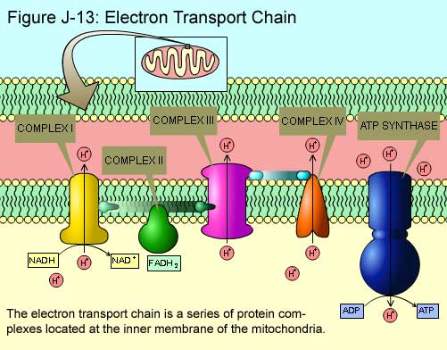
The Electron Transport Chain and ATP Synthase
- Occurs in the inner membrane of the mitochondria
- NADH and FADH₂ carry high-energy electrons to the electron transport chain
- As electrons “fall” down the chain toward oxygen a small amount of energy is released
- This energy is used to generate ATP production (from ADP + P) using a special protein structure called an ATP synthase.
- This process generates up to 36 ATP’s!
