Cellular Respiration Notes
Name:
Overview of Cellular Respiration
- Overall Definition: A chemical process that uses ______________to convert the chemical energy stored in organic molecules (______________) into another form of energy –____________. _____________and ______________are produced in this process.
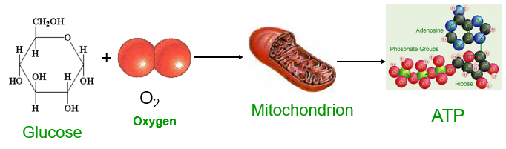
- Occurs in heterotrophs and autotrophs (plants, animals, bacteria, fungus, and protists)
- Is a metabolic pathway (a series of more than two dozen chemical reactions that are accelerated by special proteins called ENZYMES).
- Begins in the cytosol (__________________) and ends in the________________________.
- Has 3 main stages:________________________, the _________________(Citric acid cycle), and the _________________________and ATP synthase
- The end product of cellular respiration, _________, is used by cells as their______________________.
Cellular Respiration: Glucose + 6 Oxygen 6 Carbon Dioxide + 6 Water + Energy (36 ATP)
Photosynthesis: Energy (Sunlight) + 6 Carbon Dioxide + 6 Water Glucose + 6 Oxygen
How does the equation for photosynthesis compare to the equation for cellular respiration?

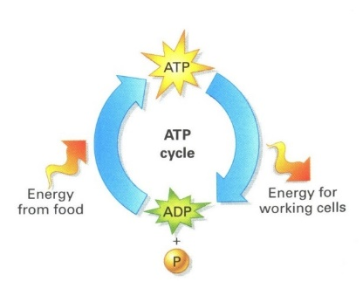
ATP A Review:
- ATP provides energy for cellular work
  - Energy is released when ________is converted to ______
  - Energy from the organic molecules in food are used to add a phosphate group to _________so that it can be converted into __________again.
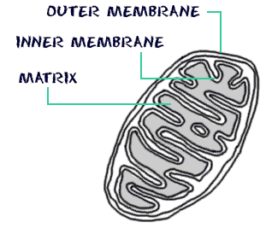
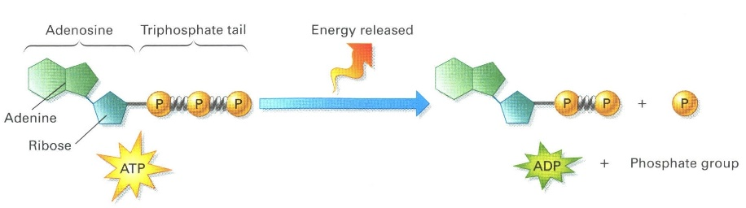
  - ATP is used for chemical work (ex. building proteins from amino acids), mechanical work (ex. contraction of a muscle), and transport work (ex. pumping solutes across a cell membrane

- The ___________________are the major sites of cellular respiration
- The controlled breakdown of ____________________ into CO₂ and H₂O.
- Requires oxygen
- Energy is captured in the form of ______
- The balanced chemical equation for the reaction of cellular respiration is:
- C₆H₁₂O₆ + __O₂ → __CO₂ + __H₂O + 36–38 molecules of ATP

Cellular respiration takes place in three different stages
  - Stage 1 is _____________________________
  - Stage 2 is The Citric Acid Cycle (also called _______________________)
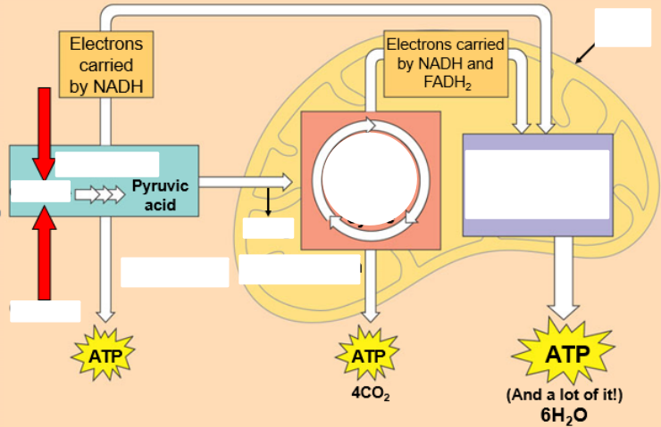
  - Stage 3 is the _________________________________and ATP synthase

Glycolysis
- Takes place in the cytoplasm outside the mitochondria
- Literally means “splitting of sugar” (________________________)
- Two ATP’s are used to split one glucose molecule (a 6 carbon sugar) into 2 molecules of pyruvic acid/pyruvate (with 3 carbons)
Does not require ___________________________
END PRODUCTS OF GLYCOLYSIS:
  - _______ molecules of ATP (a net gain of 2 ATP molecules – 2 are used to start the reaction)
  - 2 NADH molecules (each NAD⁺ carries 2 electrons and 1 H ion from each 3 carbon sugar NADH)
  - 2 molecules of pyruvate (used in the Krebs cycle)
The Krebs Cycle
- Occurs in the matrix of the mitochondria
- Requires pyruvic acid from glycolysis
- Requires ___________________________________
END PRODUCTS OF the Krebs Cycle:
  - 2 ATP molecules
  - 4 CO₂ molecules
  - 6 _________molecules and 2 ________molecules
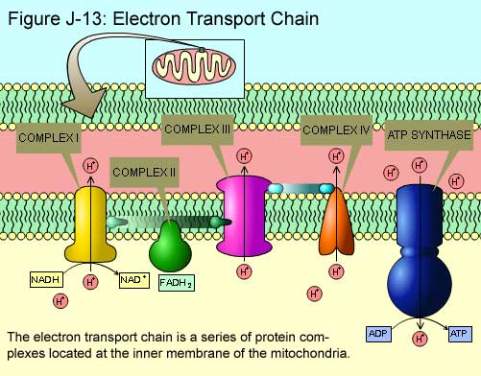
The Electron Transport Chain and ATP Synthase
- Occurs in the inner (cristae) membrane of the mitochondria
- NADH and FADH₂ carry high-energy electrons to the electron transport chain
- As electrons “fall” down the chain toward______________, a small amount of energy is released
- This energy is used to generate _______ production (from ADP + P) using a special protein structure called an ATP synthase.
- This process generates up to ______ ATP’s!
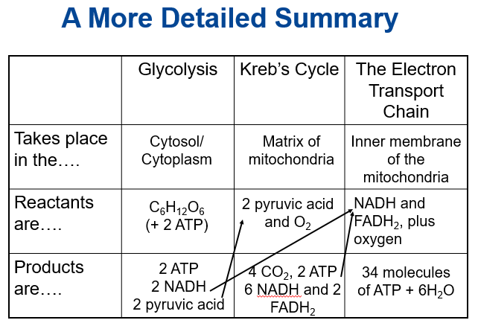

Anaerobic Respiration
- Does _____________require __________________
- Occurs in the ____________________________
- Much less efficient than aerobic (cellular) respiration because only __________molecules of ATP are formed (instead of 38).
- Two main types of Anaerobic Respiration:
  - ______________________Fermentation
  - _______________________Fermentation
Lactic Acid Fermentation
- Used by ________________ cells when oxygen has run out
- Pyruvate (from glycolysis) is converted to lactic acid.
- Occurs in muscle cells, as well as in some bacteria and fungi.
- The liver converts lactic acid back to pyruvate once oxygen is available.
Alcoholic Fermentation
- Used by many _______________________(ex. yeast)
- Pyruvate is converted to _______ and ethyl alcohol

