Name: ____________________________________________________ Date: _______ Period: ____

Describing Populations

A population is: __________________________________________________________________

Population Density:
Definition | Examples
Low Population Density Example:

High Population Density Example:

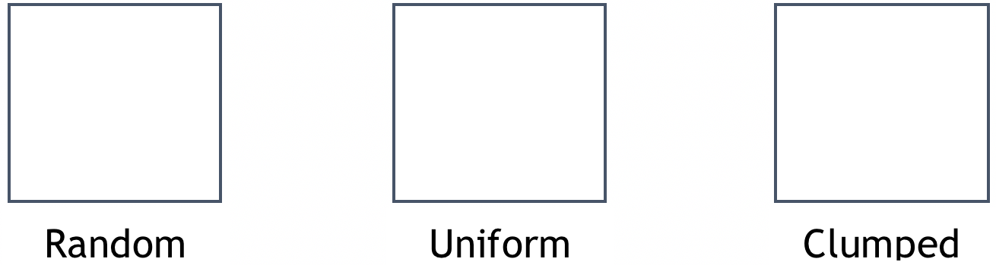
Population Distribution:
(Draw)

Population Demographics - includes the distribution of age and the Sex Ratio (important for reproductive futures.
Sex Ratio: _____________________________________________________________________
Name of Animal 1: ________________________________________________________________
- Population Size: ________________________________________________________________
- Population Density: Pick a spot on the line Low…………………………………………High
  - How do you know? _________________________________________________________
- Population Distribution: (Circle One) Random Uniform Clumped
  - How do you know? _________________________________________________________
- Sex Ratio: (Circle One) Equal Male/Female More Females More Males
  - How do you know? _________________________________________________________
Name of Animal 2: ________________________________________________________________
- Population Size: ________________________________________________________________
- Population Density: (Circle One) Low…………………………………………High
  - How do you know? _________________________________________________________
- Population Distribution: (Circle One) Random Uniform Clumped
  - How do you know? _________________________________________________________
- Sex Ratio: (Circle One) Equal Male/Female More Females More Males
  - How do you know? _________________________________________________________
Name of Animal 3: ________________________________________________________________
- Population Size: ________________________________________________________________
  - Population Density: (Circle One) Low…………………………………………High
  - How do you know? _________________________________________________________
- Population Distribution: (Circle One) Random Uniform Clumped
  - How do you know? _________________________________________________________
- Sex Ratio: (Circle One) Equal Male/Female More Females More Males
  - How do you know? _________________________________________________________
Name of Animal 4: ________________________________________________________________
- Population Size: ________________________________________________________________
- Population Density: (Circle One) Low…………………………………………High
  - How do you know? _________________________________________________________
- Population Distribution: (Circle One) Random Uniform Clumped
  - How do you know? _________________________________________________________
- Sex Ratio: (Circle One) Equal Male/Female More Females More Males
  - How do you know? _________________________________________________________

