Name: ______________________________________________________ Date: _________ Period: ______

Climatogram Activity: Biome Distribution

In this activity you will investigate the relationship between the amount of rainfall and the variance of temperature and the effect on the distribution of biomes globally. Below are nine example climatograms, grids on which averages of precipitation and temperature at a particular location are graphed. Although other factors may greatly affect climate, a climatogram provides enough information to identify a biome from which the data were obtained.
TEMPERATURE readings are measured on the RIGHT side of the climatogram as a LINE graph.
PRECIPITATION measurements are on the LEFT side of the climatogram as a BAR graph.
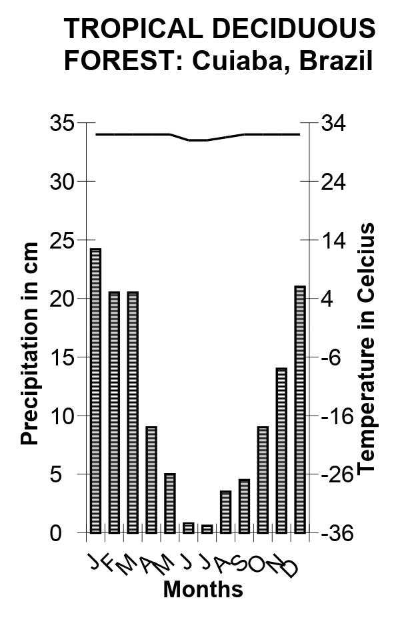 | 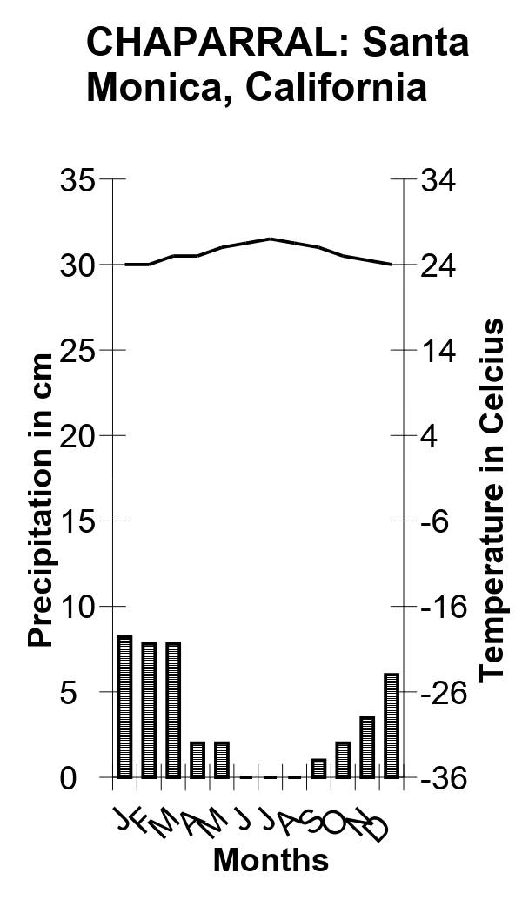 | 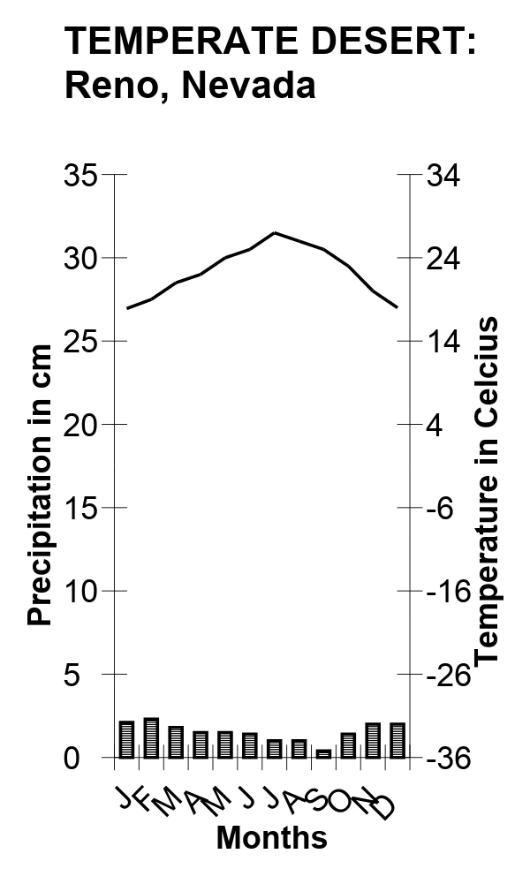
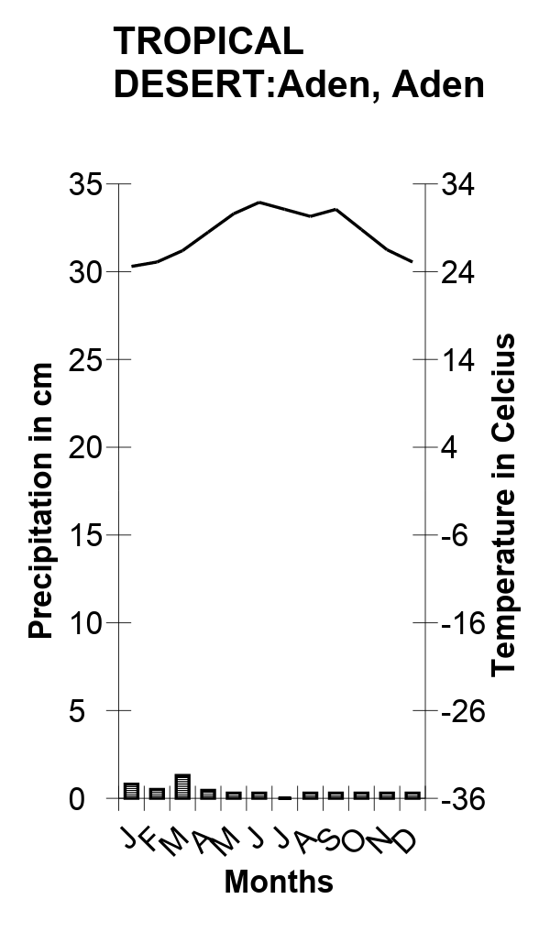 | 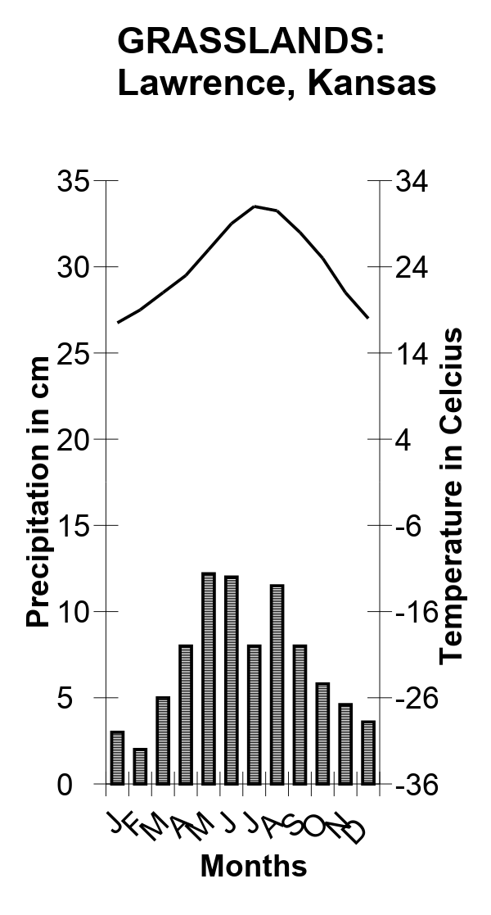 | 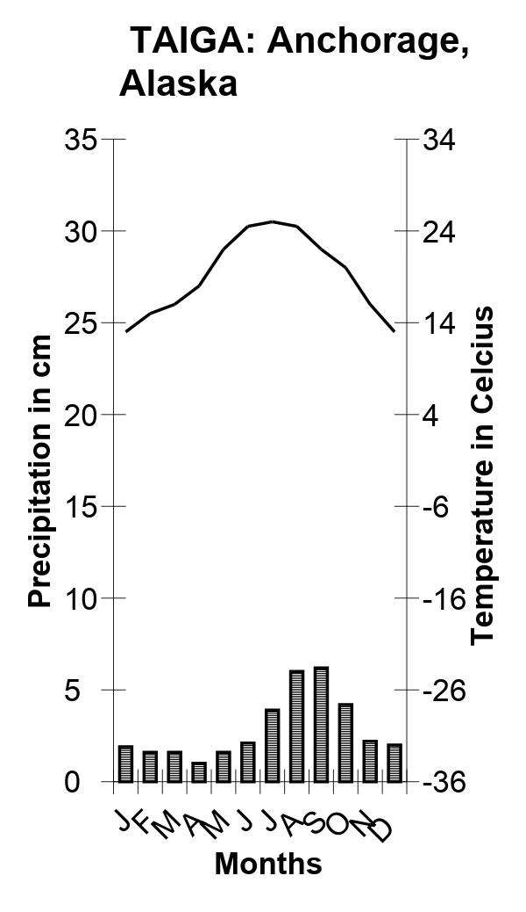
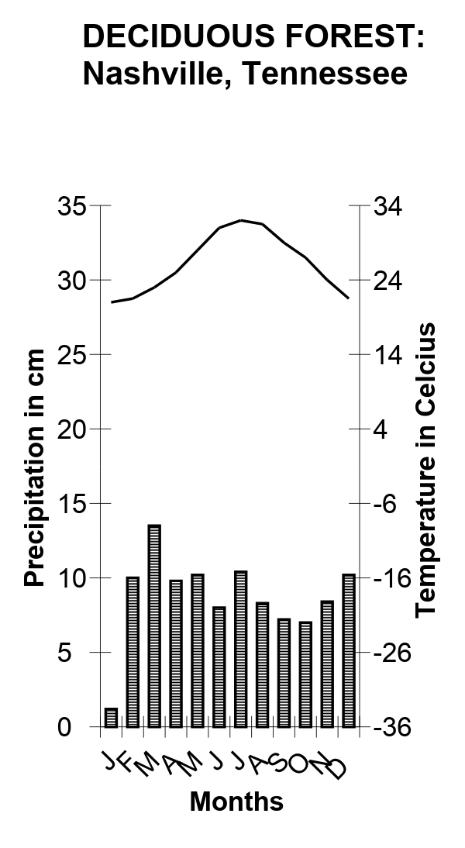 | 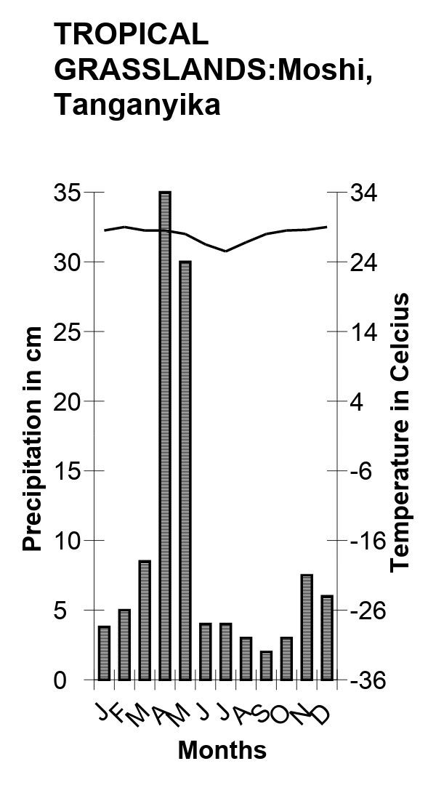 | 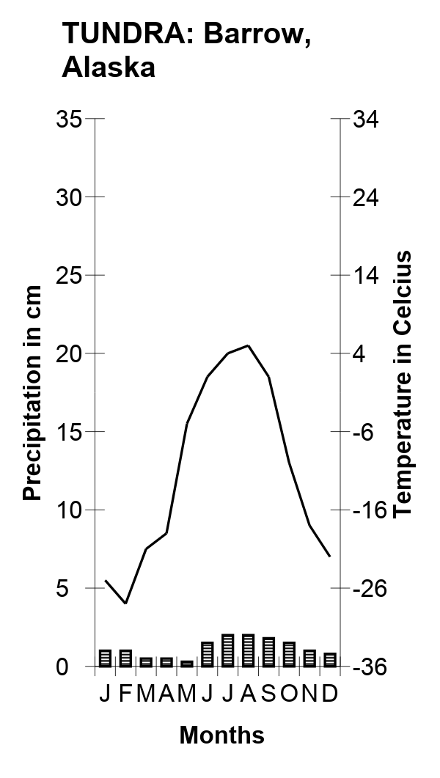

Now create your own climatogram of the following data.
TROPICAL RAIN FOREST: Manokwari, New Guinea

 | J | F | M | A | M | J | J | A | S | O | N | D
Precipitation (in cm): | 27.8 | 27.0 | 31.5 | 28.5 | 19.7 | 21.4 | 15.8 | 13.7 | 12.4 | 11.0 | 16.8 | 27.0
Temperature (in C): | 31.0 | 31.0 | 31.0 | 31.9 | 31.9 | 31.7 | 31.7 | 31.7 | 31.7 | 31.8 | 31.8 | 31.6

Name: ______________________________________________________ Date: _________ Period: ______

Climatogram Analysis Questions: Answer the following analysis questions by examining the climatograms.
- How are the Tundra and Desert similar?

- How are the Tundra and Desert different?

- How are the Tropical Rain and Tropical Deciduous Forests similar?

- How are the Tropical Rain and Tropical Deciduous Forests different?

- Lawrence, Kansas and Nashville, Tennessee occupy similar latitudes. Why is one found in a grassland and the other in a forest biome?

- Which biome has the most rainfall? Why might this be?

- Which biome has the least rainfall? Why might this be?

- Which biome has the highest average temperature? Why might this be?

- Which biome has the lowest average temperature? Why might this be?

- Which biome has the most consistent year-round temperature? Where is it located?

- Which biome has the most variable year-round temperature? Where is it located?

- Considering that the information in your climatograms is presented on a monthly basis, How would you determine which biomes are located in the southern hemisphere?

- Which biomes have 4 seasons? How can you tell?

- Explain 2 patterns you observe in the different biomes.

Name: ______________________________________________________ Date: _________ Period: ______

 | J | F | M | A | M | J | J | A | S | O | N | D
Precipitation (in cm): | 11.4 | 10.4 | 10.4 | 13.7 | 8.6 | 8.1 | 5.58 | 5.0 | 8.6 | 8.9 | 9.6 | 6.7
Temperature (in C): | 26 | 26.5 | 26 | 24.4 | 22.7 | 21.6 | 21.1 | 21.6 | 21.6 | 22.7 | 24.4 | 25
Now graph the information Rio De Janerio, Brazil

- Compare the climatogram for Rio De Janerio with the ten known climatograms. What biome is Rio De Janerio found in? Explain your answer.

- If there was a drought (less rainfall than usual) for an extended period of time, what changes would you expect to see on the climatogram graph?

