A Rapidly Growing Problem

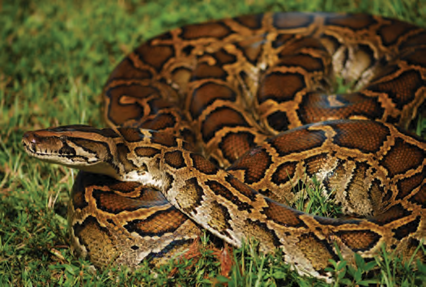
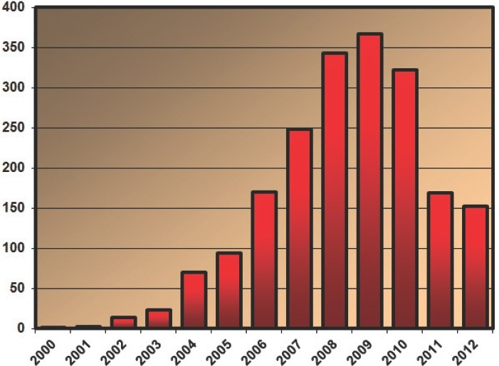
Burmese pythons (Python molurus bivittatus) are light colored snakes, with dark brown blotches bordered in black, and a pale belly. They are popular pets in the United States because of their attractive color pattern, docility (tameness), and the allure (for some) of owning a giant snake. Accor-ding to the U.S. Fish and Wildlife Service, approxim-ately 99,000 Burmese pythons were imported to the US between 1996 and 2006 (compared to only 17,000 between 1970 and 1995). The species is classified by the World Conservation Union as “near threatened” in its native range in Southeast Asia due to exportation (transport) for the pet trade and hunting for skins. Thousands of pythons are also captive bred each year in the U.S. for sale as pets. Burmese pythons sell at reptile trade shows for as little as $20, and at pet stores for $65-80.
Burmese python (Python molurus bivittatus)
Photo: Wellington Guzman, University of Florida
Number of pythons removed from Everglades National Park and surrounding areas over the past decade.
Data provided by Skip Snow, Everglades National Park

The Burmese python is one of the largest snakes in the world: it reaches lengths of up to seven meters (23 feet) and weights of over 90 kilograms (almost 200 pounds). The largest python found so far in the Everglades was 4.9 meters (16 feet) long and weighed 68.9 kilograms (152 pounds). Hatchlings range in length from 50-80 centimeters (19-31 inches), and can more than double in size within the first year. An inexperienced snake keeper who takes home a 50-centimeter (20-inch) hatchling is, within a year, responsible for a brawny 2.4-meter (eight-foot) predator. Unable to handle their giant snakes, and unable to find new homes for them, some owners illegally release them into the wild. Released and escaped Burmese pythons are now breeding in the wild, and their growing numbers may result in dire consequences for native wildlife and ecosystems in South Florida.

A battle
has begun…
Invasion of the Giant Python

Check out the link on the right!

Burmese pythons had been sighted intermittently in Everglades National Park (ENP) since 1980, and were first reported as established in the park in 2000. Since 2000, the number of Burmese pythons captured or found dead in and around ENP has increased dramatically (shown on the graph on the previous page). Although the size of the wild population is not known, it has been estimated to number in the thousands. The rapid and widespread invasion is helped by aspects of the Burmese python’s natural history, including: diverse habitat use, broad dietary (food) preferences, long lifespan (15-25 years), high reproductive output, ability to move long distances, and excellent camouflage. Being semi-aquatic (living in water), Burmese pythons are excellent swimmers and can travel long distances in water. This means that the many creeks and canals separating the areas of the Florida Keys do not inhibit (stop) python movement.

Pythons can easily out-compete many full-grown native snakes, dwarfing them even at a very young age. Large Burmese pythons are known to prey on a wide variety of native wildlife, including rodents, raccoons, rabbits, bobcats, adult deer, birds, and even alligators. This disruption of the natural food chain has potentially serious impacts to the ecosystem and may threaten many additional species in the very near future. Of particular concern is their predation of protected species, like the American alligator, American Wood Stork, and Key Largo wood rat.

In 2006, scientists confirmed their suspicion that pythons were reproducing in the park when they uncovered the first of several nests. This is of considerable concern, as it is believed that ecological impacts are likely to grow in step with continued reproductive success and dispersal (spread). In a sample of eight clutches (nests), the average clutch size was 36 eggs, but pythons have been known to lay as many as 107 eggs (Wall 1921). A recently captured adult female in ENP was found to be carrying 85 developing eggs.
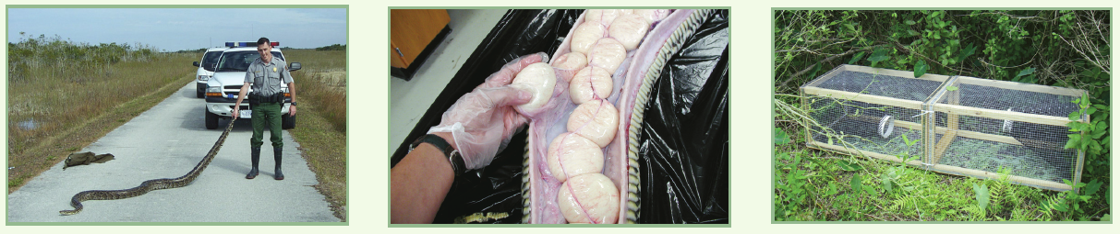
Sources:
Over the past decade, personnel have recovered over 1,900 pythons from the park and surrounding areas. Study of captured specimens gives
us a better understanding of the biology of pythons and their impacts. Burmese Pythons are currently breeding in Florida, and females carry 35 eggs (center photo). Scientists and park managers are investigating new methods of control, including specialized traps (right photo), radio telemetry, capture and removal, diet analysis, and thermal analysis. Photos by Everglades National Park.
- Harvey, R.G., et al. Burmese pythons in south Florida, scientific support for invasive species management. University of Florida, Institute for Agricultural Sciences, IFAS Publication Number WEC-242span, July 2008. Online at http://www.nps.gov/ever/naturescience/upload/IFASPythonFactSheetSecure.pdf
- Burmese Pythons, Natural Resource Management. (South Florida Natural Resources Center, Everglades National Park, April 2013.). Online at http://www.nps.gov/ever/naturescience/upload/2013-Python-Reprint-Hi-Res-2.pdf

The Burmese python is native to southern China, Bangladesh, Burma, Cambodia, Indochina, Thailand, Vietnam, and the Malay Archipelago. It is the largest subspecies of the Indian python, and one of the six largest snakes in the world. Lengths of more than 15 feet (4.6 m) are common, and they may exceed 22 feet (6.7 m) in captivity, however the average is about 16 feet (4.9 m) in length. Females are the larger of the two sexes and often have different coloration and a smaller head relative to the body. They may live about 30 years in the wild.
Size relative to a 6-ft man
Photo provided National Geographic

The body of a Burmese python is longer and thinner than the anaconda’s. Because the body is long, the organs are also long. Snakes usually have only one lung, but the python has two, one of which is considerably smaller than the other. Basic body color may be pale tan, yellowish-brown, or gray. They have large, reddish blotches outlined in cream or gold.

Burmese pythons are nocturnal, ambush predators (at night, they hide to surprise and catch prey). They are constrictors (they squeeze their prey), so they don’t have fangs. They do have back curving teeth that grab prey and don’t let it escape. Burmese pythons prey upon mammals, birds, and reptiles. The presence of domestic fowl and pigs attracts them to agricultural developments. In the wild, snakes do not eat every day. They spend their mornings soaking up the sun’s warmth, enabling them to move around to look for food. If they are successful in their hunt for prey and lucky enough to eat, they spend the next several days or weeks keeping warm enough to digest their meal. The prey is swallowed whole. The jaws separate and allow the snake to take in an animal four to five times as wide as its head.
Alligator vs. Python… Who will win?

Burmese pythons live in rainforests near streams, although they survive in a variety of habitats, such as grasslands, swamps, marshes, and rocky foothills. Populations are dependent upon a permanent source of water.

Burmese pythons reach sexual maturity in four to five years. Males breed at seven to nine feet (2.1 to 2.7 m) and females when they are at least nine feet (2.7 m). The Burmese python breeds in early spring. Unlike in most snakes, the female coils around the clutch (nest) and stays with the eggs until they hatch. She does not feed during this period, which may last two or more months. Burmese pythons actually incubate their eggs by raising the temperature within the coils by as much as seven degrees above the air temperature. This is accomplished by frequent "hiccupping" or muscle spasms. After the snakes hatch, they are on their own and must fend for themselves. They hatch at about 12 to 18 inches (31 to 46 cm) in length.

Source:
- Reptiles and Amphibians Fact Sheets, Burmese Python. (Smithsonian National Zoological Park). Online at http://nationalzoo.si.edu/Animals/ReptilesAmphibians/Facts/FactSheets/Burmeserockpython.cfm [Accessed July 1, 2014]

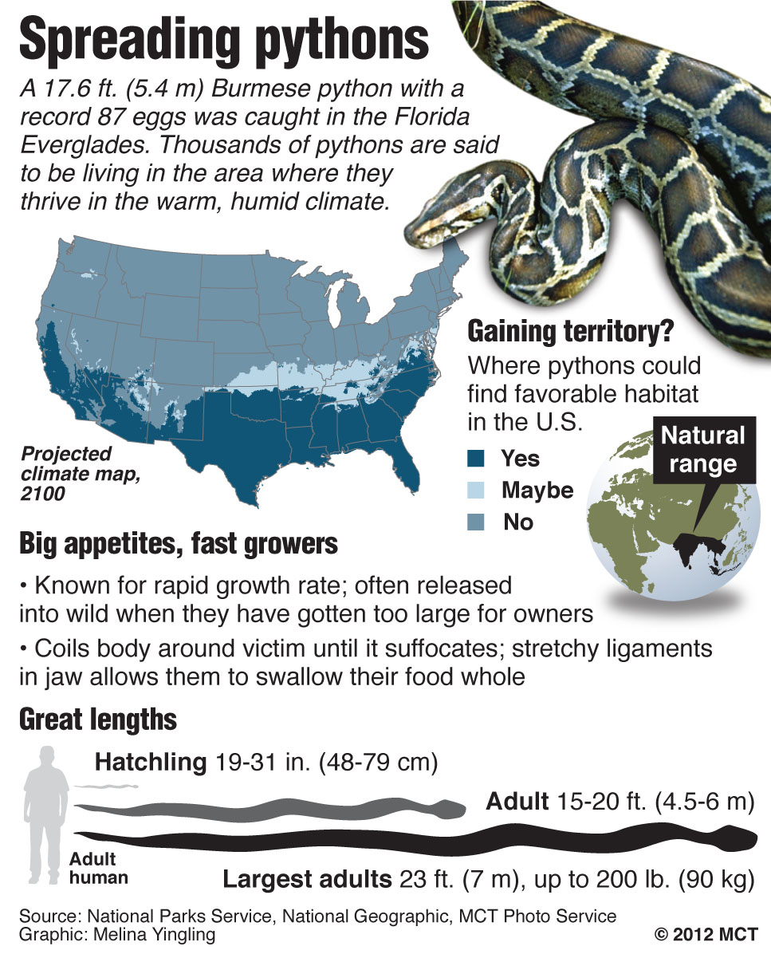

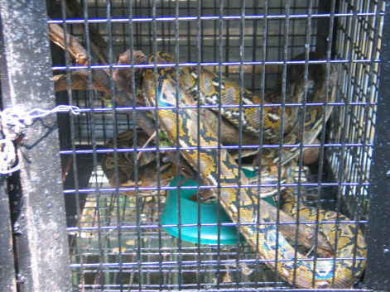
Can I Keep It?
An app for finding ecofriendly exotic pets

September 1, 2011
Conservation Magazine

Bearded dragon or Burmese python? Goldfinch or cockatiel? At www.petwatch.net, potential pet owners can comb through profiles of five dozen wild species, each of which is ranked as a “good,” “fair,” or “poor” choice for a pet. They can also read about how each species stacks up according to criteria such as sustainability of the source population, threat of invasiveness, ability to withstand transport and captivity, and health threats to humans and other species.
Source: http://www.wildlifeinneed.org/projects_wildlifepettrade.php

The wildlife pet trade is “absolutely ginormous,” says Katherine Smith, assistant professor of ecology and evolutionary biology at Brown University in Providence, Rhode Island. “There’s a huge diversity of animals that industry can tap legally to bring in and sell to the country.” According to an analysis of U.S. Fish and Wildlife Service data that Smith and a group of colleagues published two years ago in Science, nearly 1.5 billion live animals representing more than 2,000 species were imported into the U.S. between 2000 and 2006. Over 90 percent were destined for the pet trade. ⁽¹⁾

Smith hatched the idea for PetWatch as a postdoctoral researcher with a Society for Conservation Biology Smith Fellowship. To produce the species rankings, Smith and a team of other postdoctoral fellows combed through the literature on each species, boiled it down to a four-page report, and submitted the report to outside experts for peer review. The process (and the green-yellow-red ranking system that resulted) was inspired in part by Seafood Watch, the Monterey Bay Aquarium’s hugely successful effort to guide restaurant-goers to the most sustainable (environmentally-friendly) types of seafood.

EcoHealth Alliance, a New York–based nonprofit, has recently taken charge of hosting and further developing PetWatch. Sixty species are currently profiled on the website, and another 60 will be added by the end of the year. A mobile phone app was launched over the summer.

As for the question of which reptile makes a better pet? Bearded dragon all the way, says Anthony Ramos, marketing and communications director at EcoHealth Alliance, explaining that the Australian reptile is relatively easy to care for. “It’s a good alternative to a dog.”

Sources:
- DeWeerdt, Sarah. Can I Keep It? An app for finding ecofriendly exotic pets. September 1, 2011. Conservation: University of Washington. Online at http://conservationmagazine.org/2011/09/can-i-keep-it/
- Smith, K.F., et al. 2009. Reducing the risks of the wildlife trade. Science: Vol. 324 no. 5927 pp. 594-595. DOI: 10.1126/science. 1174460

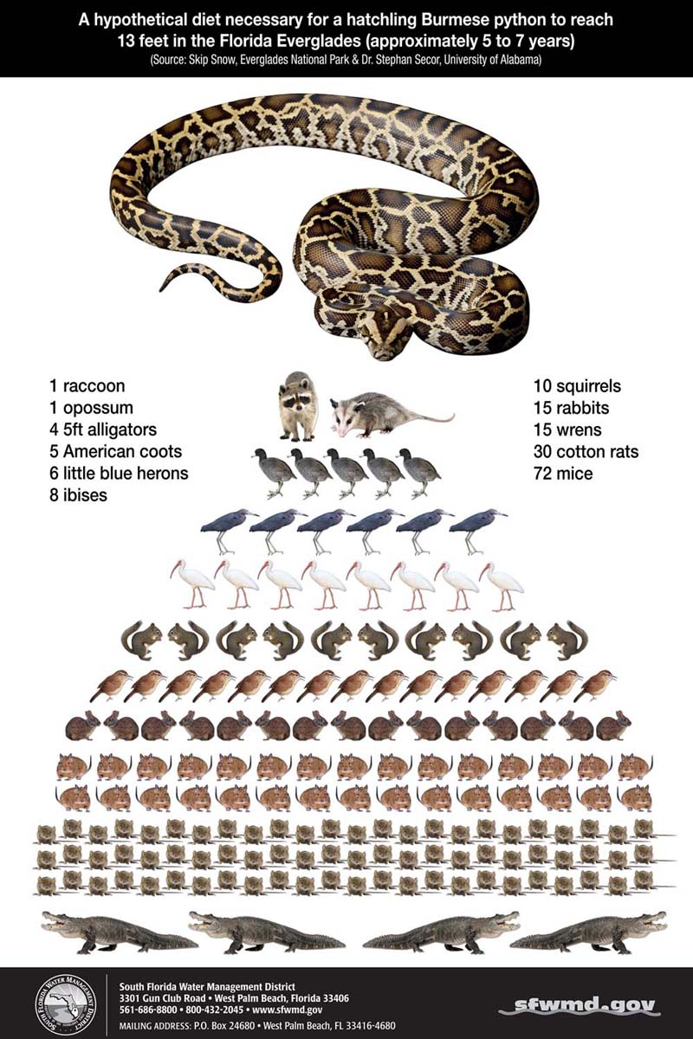

It's a wrap—the 2013 Python Challenge has nabbed 68 invasive Burmese pythons in Florida. Experts are surprised so many of the elusive giants were caught.

To highlight the python problem, the Florida Fish and Wildlife Conservation Commission and its partners launched the 2013 Python Challenge, which encouraged registered participants to catch as many pythons as they could between January 12 and February 10 in state wildlife-management areas within the Everglades. Nearly 1,600 people from 38 states—most of them inexperienced hunters—registered for the chance to track down one of the animals, as well as cash prizes.

Finding 68 snakes is impressive, experts say, since it's so hard to find pythons. For one, it's been unusually warm lately in Florida, which means the reptiles—which normally sun themselves to regulate their body temperature—are staying in the brush, making them harder to detect. On top of that, Burmese pythons are notoriously hard to locate. The animals are so well camouflaged that people can stand right next to one and not notice it. "It's rare that you see them stretched out- most of the time they're blending in," said Cheryl Millett, a biologist at the Nature Conservancy, a Python Challenge partner. What's more, the reptiles are ambush hunters, which means they spend much of their time lying in wait in dense vegetation, not moving, she said.

Ruben Ramirez, founder of Florida Python Hunters, won two prizes in the competition: first place for the most snakes captured (18), and second place for the largest python, which he said was close to 11 feet (3.4 meters) long. All participants were trained to identify the difference between a Burmese python and Florida's native snakes, said Millett. No native snakes were accidentally killed. Hunters were also told to kill the snakes by either putting a bolt or a bullet through their heads, or decapitating them—all humane methods that result "in immediate loss of consciousness and destruction of the brain," according to the Python Challenge website.
Like controversy?
Read an opposing view on the Python Challenge: “Florida's Great Snake Hunt Is a Cheap Stunt”
Completely removing these snakes from the wild isn't easy, and some scientists see the Python Challenge as helping to achieve part of that goal. "You're talking about 68 more animals removed from the population that shouldn't be there—that's 68 more mouths that aren't being fed," said Florida museum's Krysko. "I support any kind of event or program that informs the public about invasive species, and also gets the public involved in removing these nonnative animals that don't belong there”. People who didn't want to hunt or touch the snakes could still help, she said, by reporting sightings of exotic species to a phone number, website or app.
Source:
- Dell'Amore, C. and Andrie, K. 2013. Florida Python Hunt Captures 68 Invasive Snakes. National Geographic News, February 19, 2013. Online at http://news.nationalgeographic.com/news/2013/02/130219-florida-pythons-hunting-animals-snakes-invasive-science/
Burmese pythons are considered ‘apex predators’: predators at the very top of the food chain, with no natural predators of their own. They are able to kill and eat the largest prey animals in their ecosystem,with little fear of falling prey to another predator. (In the ocean, sharks and orcas are apex predators).

Researchers in the Florida Everglades cite several other reasons for why the pythons have become successful invasive species in the park ecosystem. Because the pythons are cold-blooded reptiles, they can use a large proportion of energy for growth and reproduction. (In contrast, warm-blooded organisms must use a large proportion of energy to maintain body temperature). In addition, Everglades National Park does not allow hunting, which means there is a ready supply of wildlife to serve as a food supply for the snakes. Ecologists suggest that the pythons may also have an advantage in that, for at least 16 million years, there have been no snakes in Florida large enough to prey on medium-sized mammals; the mammals have not had opportunity to adapt to avoiding the snakes.

The invasion of the Burmese python has had a dramatic impact on the Everglades ecosystem. In 2011, ecologists estimated a 99.3% decrease in observations of raccoons, a 98.9% decrease in observations of opossums, and an 87.5% reduction in bobcat, compared to 2003.

Biologists at the park have documented that the populations of most medium-sized mammals (including fox, raccoon, bobcats, opossums, rabbits, and deer) showed severe declines after the python invasion. They have supported a causal relationship by observing that (1) the increase in the population of pythons in the Park matches the timing of the decrease in the mammal populations, (2) that the microhabitats of the pythons matches the habitats of the disappearing species (for example, raccoons and opossums often forage near the water’s edge, a microhabitat frequented by ambushing pythons), and (3) that the mammal species are frequently found in the stomachs of captured pythons.

Another ecological observation from the Everglades is that the populations of some rodents, as well as coyotes and panthers, have increased as snakes invaded the park. Scientists hypo-thesize that the snakes may be responsible for these changes, because the snakes have reduced the populations of some of the predators and competitors (bobcats and fox) of these species.

As ecologists capture and remove snakes, they have observed that the pythons are not effective at escape from human predators, since the snakes have a ready supply of quick energy, but little energy reserves. Responders can pull an escaping python back by the tail repeatedly to let the snake expend a lot of energy. When the snake is tired, the capturer firmly grabs at the base of the head and avoids the writhing body getting wrapped around his or her legs.
Sources:
- Python Control: Stopping a Burmese python invasion. (Nature Conservancy). Online at http://www.nature.org/ourinitiatives/regions/northamerica/unitedstates/florida/howwework/stopping-a-burmese-python-invasion.xml [Accessed August 2014]
- Dorcas, M.E., et al. 2012. Severe mammal declines coincide with proliferation of invasive Burmese pythons in Everglades National Park. Proceedings of the National Academies of Sciences, of the United States. Online at
http://www.pnas.org/content/early/2012/01/23/1115226109.full.pdf+html

Check out these links to videos and other media about the Burmese python:

- In the Belly of a Python: [A slide show of] some of the Florida species found in the stomachs of Burmese pythons. (The Nature Conservancy) . Online at
http://www.nature.org/ourinitiatives/regions/northamerica/unitedstates/florida/howwework/in-the-belly-of-a-python.xml [Accessed August, 2014]

- Recent Time magazine article describing efforts to control the Burmese python in Florida
Walsh, B and Protin, C. July 17, 2014. The Volunteer Army Hunting Florida’s Invasive Pythons: Time Magazine. Online at
http://time.com/2970092/volunteer-florida-burmese-python-patrol/

- Time’s Nancy Gibbs joins Morning Joe to discuss the latest cover story, which is on invasive plant and animal species and the billions the government spends in combating them (July 17, 2014). Online at http://www.msnbc.com/morning-joe/watch/the-growing-threat-of-invasive-species-306736195856

