Cell Cycle and Causes of Cancer Quiz Review
Name:
1. Explain the relationship between a gene, DNA, and a chromosome.

2. Where is a gene found?

3. Genes are the “blueprint” or code to make what type of molecule?

4. Where are chromosomes found in the cell during interphase?

5) Put the steps of the cell cycle in order?

6) Before mitosis can begin, what must occur in the S phase?

7) In what phase of the cell cycle does a cell spend most of its time (Interphase or mitosis)?

8) Why do cells undergo mitosis?

9) What happens during the mitosis phase of the cell cycle?

10) What happens in the G1 and G2 phase of interphase?

11) What happens in the S phase of interphase?

12) What types of molecules check to make certain that the cell has grown to its full size, the DNA has replicated correctly, and that the nucleus is ready to divide?

13) If the normal chromosome number is 40. How many chromosomes will be in each of the two cells after the cell undergoes mitosis?

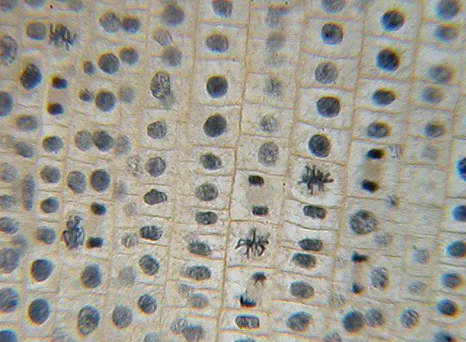
Identify cells in mitosis and in interphase
.

14. What is the definition of cancer?

15. How do tumor suppressor genes affect the cell cycle?

16. How do oncogenes affect the cell cycle?

17. What is the importance of DNA repair genes?

18. A tumor is formed when what type of gene works incorrectly?

19. What is the role of CDK and cyclin in the cell cycle?

20. What happens in each phase of mitosis?
Prophase:

Metaphase:

Anaphase:

Telophase:

