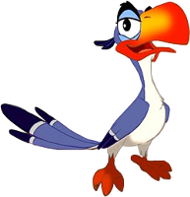
Name: ____________________________________ Period: _____

Biodiversity on Bird Island

1. What is Biodiversity? ________________________________________________________________________

2. What is Species Richness? ________________________________________________________________

3. What is Species Abundance? ______________________________________________________________

Scenario:
A group of scientists recently returned from surveying Bird Island, a remote island in the Atlantic Ocean. This island is inhabited by people. The scientists identified six species of birds living on the island. The map provided was created after surveying the island. Each population of birds is shown as a unique symbol on the map and indicates a sampling site.

PART 1- Graph All of the bird species within your ecoregion and compare your ecoregion to others in your group of 6.

What is your assigned Ecoregion? __________

- For your ECOREGION (GRAPH #1), what was the richness (how many species were present)?

______species

  - Were there any species not present?

  - Compare the species abundance in your ecoregion. Were the population sizes equal or were there more or less of one species?

Compare the ecoregion graphs A-F and answer the following questions:

- Which ecoregions have a similar number of individuals within each species (similar abundance)?

- What ecoregion (A-F) has the highest number of species (high species richness)?

- List the number of different species in each ecoregion?

A- ____ species B- ___ species C- ___ species D- ___ species E- ___ species F- ___ species

PART 2- Graph the ABUNDANCE of ONE Bird species within EVERY Ecoregion
What is your assigned Bird? __________

- For your SPECIES (GRAPH 2):
  - which ecoregion had the highest abundance (population size)? Ecoregion ______
  - Which ecoregion had the lowest abundance? Ecoregion ________

When everyone has completed their graph, answer the questions below.
- Which species has the greatest abundance in the most ecoregions?

- Which species is only found in one ecoregion?

- Which species do you think is at risk of becoming endangered?

- Fill in the blanks using the word box below: High biodiversity helps an ecosystem survive ________________________, such as an invasive species, since the food web is more complex. The greater the ___________________ and __________________ (and the more complex the food web), the more stable the ecosystem is. So….. ________________ richness & abundance = ______________ biodiversity
_________________ richness & abundance = _________________ biodiversityy

Word Box: Higher Lower Lower Higher Changes Richness Abundance

Do you think your ecoregion’s bird populations would survive disturbances to the environment, such as the introduction of an invasive bird species?
Your claim: I (do) or (do not) believe that ecoregion _(A) (B) (C) (D) (E ) (F)_’s bird populations
will survive disturbances to the environment. (Circle an answer in each spot)
Your evidence:
The richness in my ecoregion is _______ species. This richness is high or low compared to other ecoregions.
The abundance in my ecoregion is high for ________________________________________
The abundance in my ecoregion is low for __________________________________________
Your Reasoning:
I believe this because the bird biodiversity in my ecoregion is high or low, because __________________________________________________________________________________________________________________________________________________________________________________________
Biodiversity is important, because ______________________________________________________________
_____________________________________________________________________________________________

Bird Island Graphs

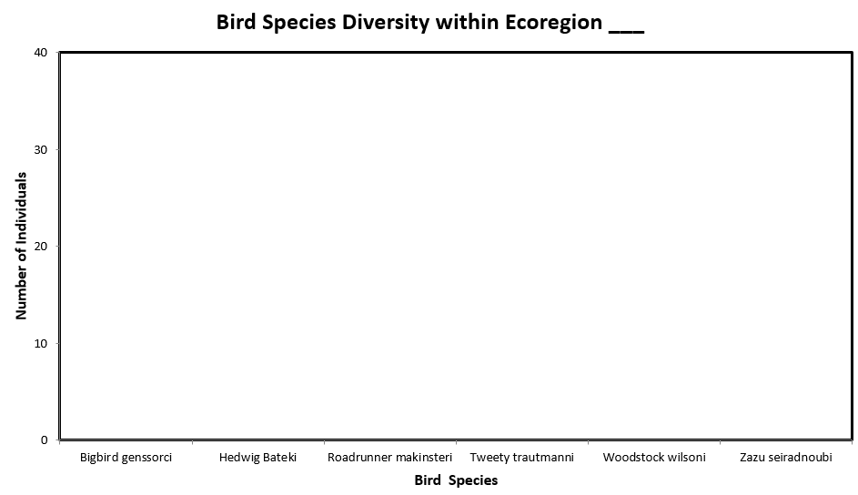

Bird Island Graphs

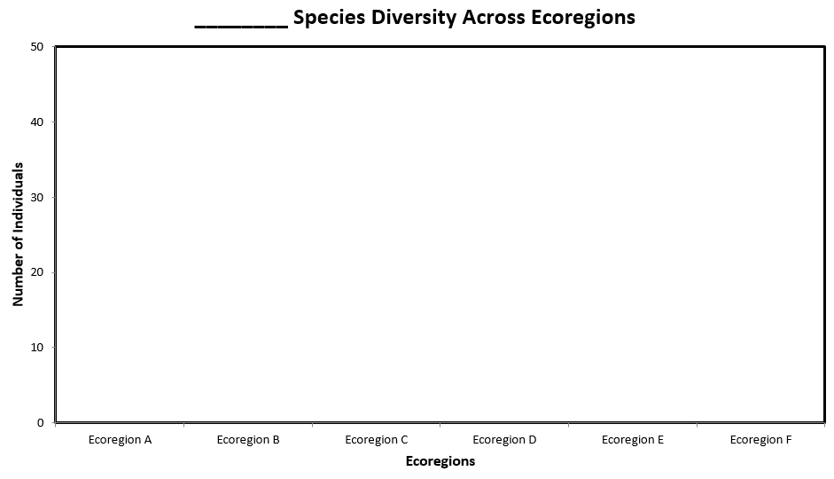

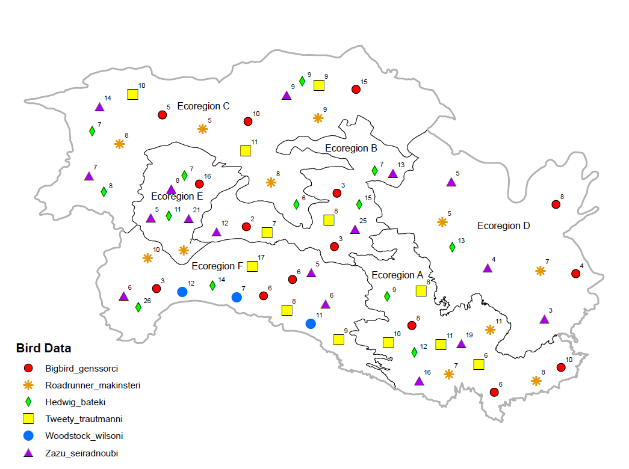
Bird Island Map

