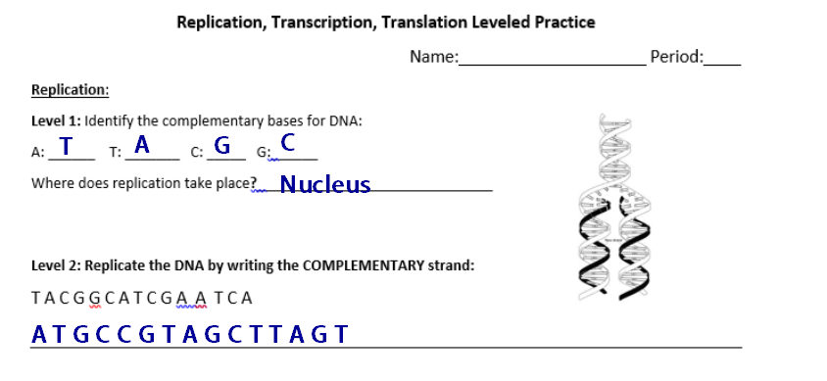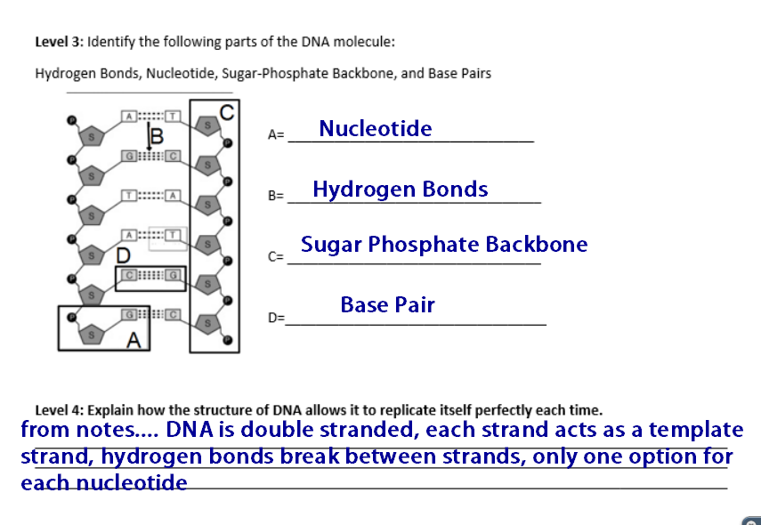

NEXT PAGE IS THE TRANSCRIPTION ANSWER KEY.
ONLY MOVE ON IF YOU HAVE FINISHED THE PROBLEMS!
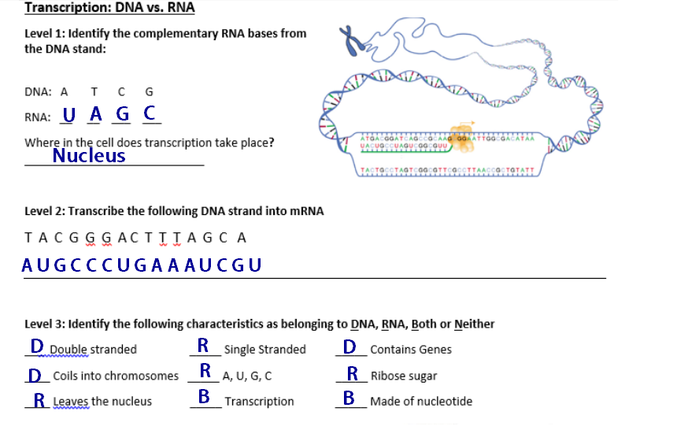

NEXT PAGE IS THE TRANSLATION ANSWER KEY.
ONLY MOVE ON IF YOU HAVE FINISHED THE PROBLEMS!

