**Name: _____________________________________________________ Date: _______________**

**Notes: Introduction to Chemistry**

**What are you made of? Matter!**

**Matter:** anything that occupies space and has mas

* The “stuff” of the universe

**What makes up Matter? Atoms!**

**Atom:** The smallest possible particle of an element that has the properties of that element.

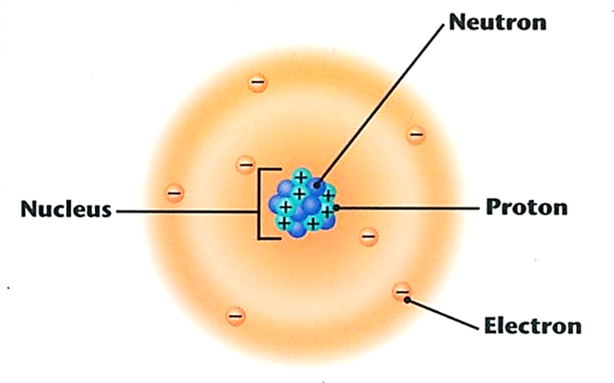

***Made of 3 particles:***

**Proton: A subatomic particle in the nucleus with a single positive charge**

**Neutron: A subatomic particle in the nucleus with single neutral charge**

**Electron: A subatomic particle that quickly moves around the nucleus with a single negative charge and has very little mass.**

**Chemical Terms:**

**Element:** a pure substance made of one type of atom that cannot be broken down into other substances by chemical means.

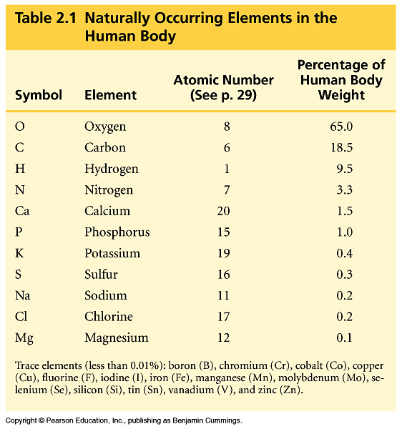

Every element has a symbol containing 1 or 2 letters

Ex: Carbon = C Sodium= Na

Hydrogen= H Chlorine= Cl

Oxygen = O Calcium= Ca

Nitrogen= N Phosphorus= P

**Atomic Number:** the # of protons in the nucleus-- different for each element!

In a regular uncharged atom, # of protons = # of electrons

**ENERGY LEVELS IN ELECTRONS**

Electrons are arranged in **energy levels (also called orbitals or or Electron Shells)**

The number of **Valence Electrons**, electrons in the outer shell determines how reactive an element is.

Atoms are most reactive when the outer shell is partially full.

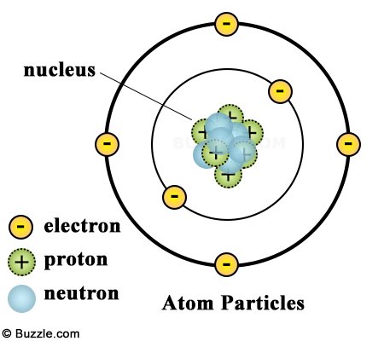(the Atom “wants” to have a full outer shell!)

**# of Electrons each energy level can hold:**

|  |  |
| --- | --- |
| **1st Energy Level:** | **2 Electrons** |
| **2nd Energy Level:** | **8 Electrons** |
| **3rd Energy Level:** | **8 Electrons** |

**Bohr Model shows the organization of the electrons:**

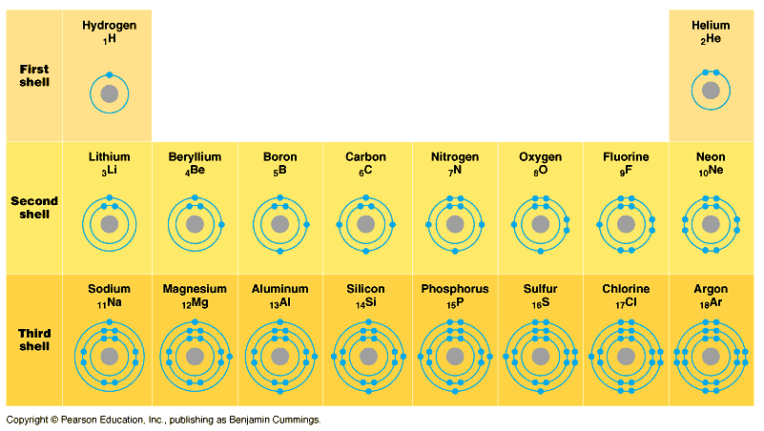

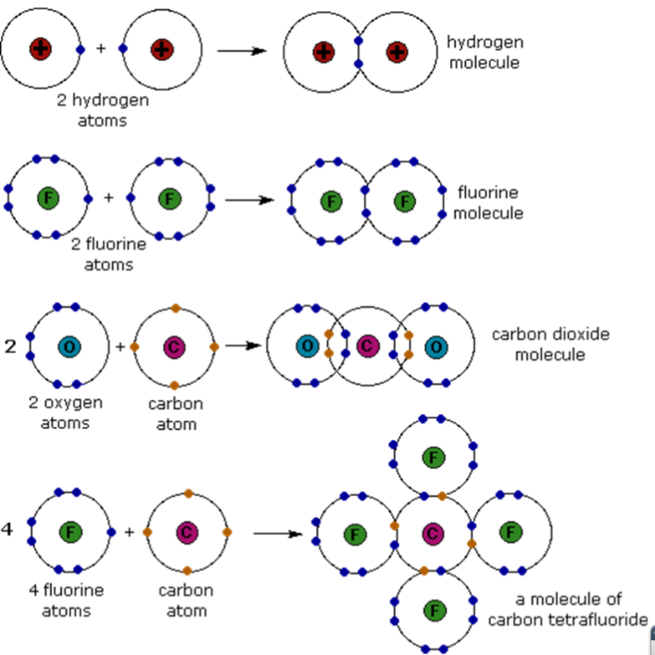

**Chemical Bonding**

Atoms interact such that they all try to have full outermost shells(energy levels).

The attractive forces between atoms in a molecule are **chemical bonds**

**Chemical Bonding Vocab:**

**Molecule:** A particle with 2 or more atoms bonded together.

**Compound**: Molecule with at least 2 different elements. They can have very different properties from the elements that make them up.

**Covalent Bonds:** Two atoms ­­­­­­­­­­­­­­­­­­­­­­­­­share one or more pairs of electrons

* Each ends up with full outermost energy levels (at least part of the time)

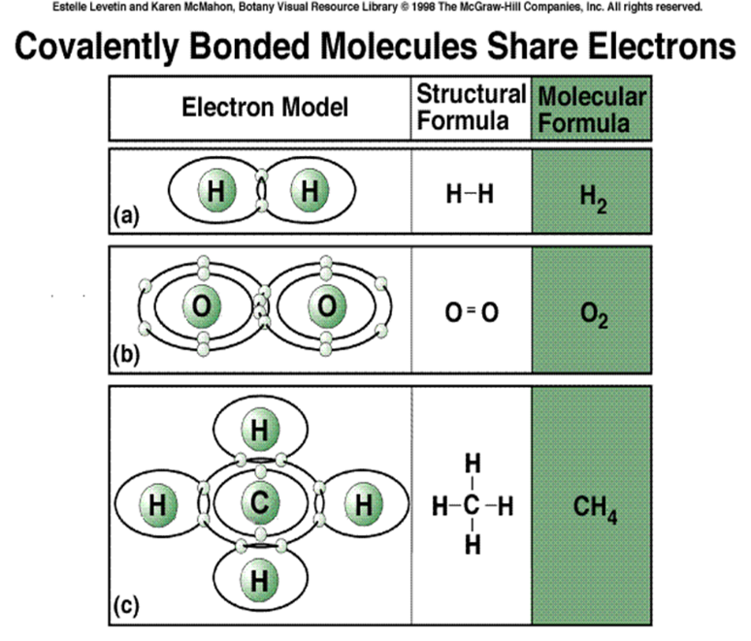

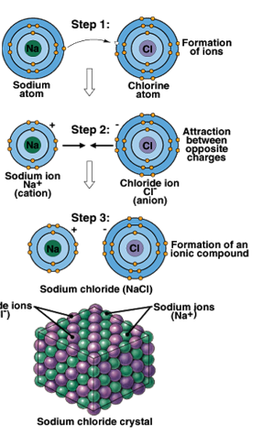**Draw a Covalent Bond:**

|  |
| --- |
| **Hydrogen + Hydrogen** |
|  |

**Ionic Bonds** *-* One atom ***loses*** electrons; the other ***gains*** electrons

**Ion**= any atom/molecule with a charge (positive or negative)

–Atom that loses electrons has a *net positive charge*

–Atom that gains electrons has a *net negative charge*

–**Unlike charges attract**

•An ionic bondis formed from attraction between the positive and negative ion.

