**Name: _____________________________________________________ Date: _______________**

**Notes: Introduction to Chemistry**

**What are you made of? Matter!**

**Matter:** anything that occupies _______________ and has _______________.

* The “stuff” of the universe

**What makes up Matter? Atoms!**

**Atom:** The smallest possible__________________________________ that has the properties of that element.

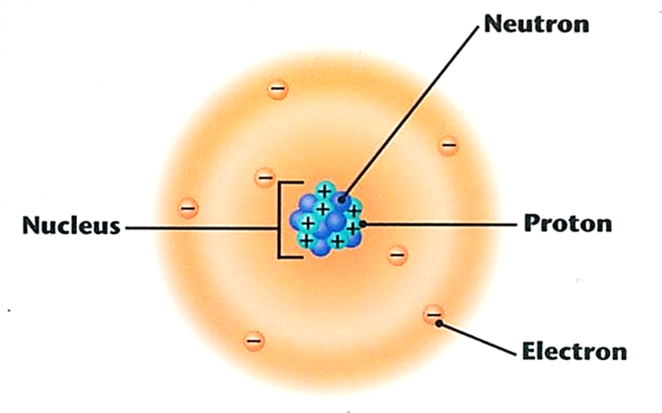

***Made of 3 particles:***

**Proton: A subatomic particle in the ______________ with a single ___________________________**

**Neutron: A subatomic particle in the _______________ with ________________________.**

**Electron: A subatomic particle that quickly moves _________________________________ with a single __________________________ and _________________.**

**Chemical Terms:**

**Element:** a pure substance made of ____________________ ____________ that cannot be_________________________ into other substances by chemical means.

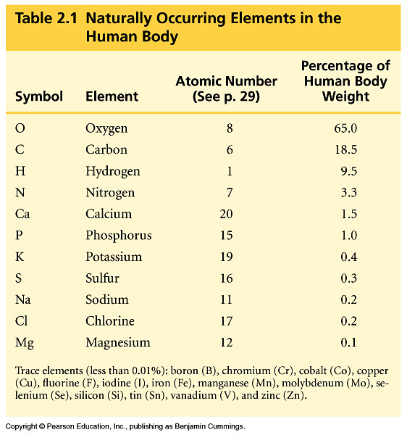

Every element has a symbol containing 1 or 2 letters

Ex: Carbon = _________ Sodium= ________

Hydrogen= _________ Chlorine= _______

Oxygen = ________ Calcium= ________

Nitrogen= _________ Phosphorus= ________

**Atomic Number:** the # of ________________________ in the nucleus-- different for each element!

In a regular uncharged atom, # of protons = # of electrons

**ENERGY LEVELS IN ELECTRONS**

Electrons are arranged in **___________________ (also called _____________________or Electron Shells)**

The number of **Valence Electrons**, electrons in the _________________________, determines how _____________________________________.

Atoms are most reactive when the ______________________________________________________.

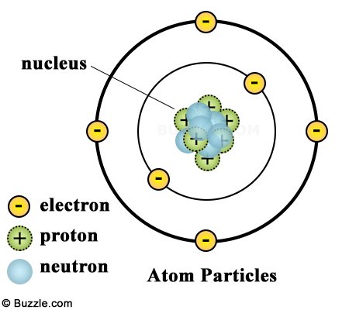(the Atom “wants” to have a full outer shell!)

**# of Electrons each energy level can hold:**

|  |  |
| --- | --- |
| **_____st Energy Level:** | **_____ Electrons** |
| **_____nd Energy Level:** | **_____ Electrons** |
| **_____rd Energy Level:** | **_____ Electrons** |

**Bohr Model shows the organization of the electrons:**

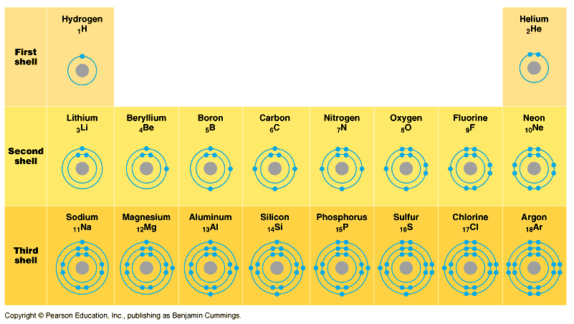

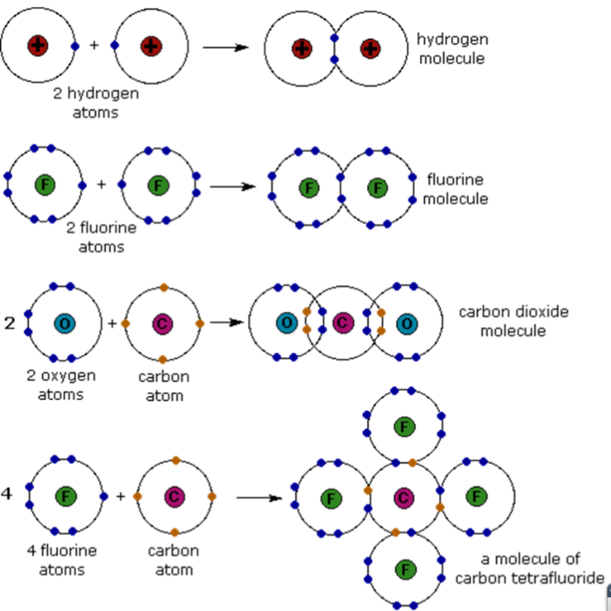

**Chemical Bonding**

Atoms interact such that they all try to have

________________________________________(energy levels).

The attractive forces between atoms in a molecule are **_________________________________.**

**Chemical Bonding Vocab:**

**Molecule:** A particle with _______________________ bonded together.

**Compound**: Molecule with at least ____________________ __________________. They can have very different properties from the elements that make them up.

**Covalent Bonds:** Two atoms ­­­­­­­­­­­­­­­­­­­­­­­­­___________________________ one or more pairs of electrons

* Each ends up with ____________________________________ (at least part of the time)

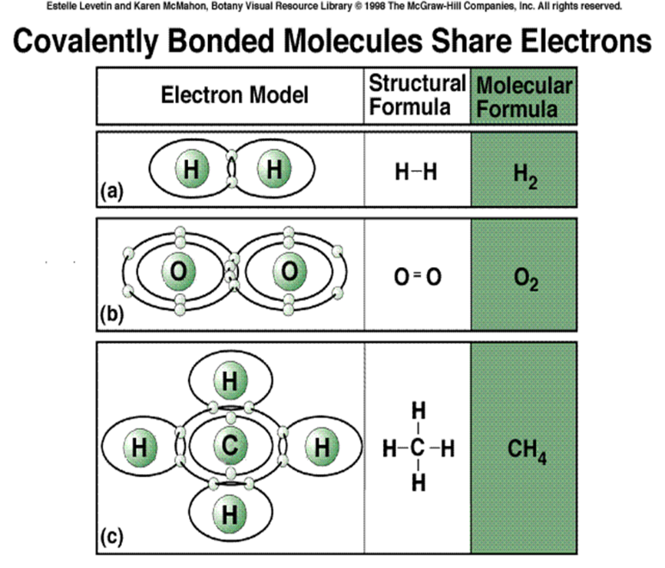

**Draw a Covalent Bond:**

|  |
| --- |
| **Hydrogen + Hydrogen** |
|  |

**Ionic Bonds** *-* One atom ***loses*** electrons; the other ***gains*** electrons

**Ion**= any atom/molecule with a charge (positive or negative)

–Atom that loses electrons has a *net positive charge*

–Atom that gains electrons has a *net negative charge*

–**Unlike charges attract**

•An ionic bondis formed from attraction between the positive and negative ion.

