Exploring What Molecules Cells Are Made Of

The cells of animals, plants, and decomposers are all made mostly of water and large molecules referred to as “organic”: Fats, proteins, and carbohydrates

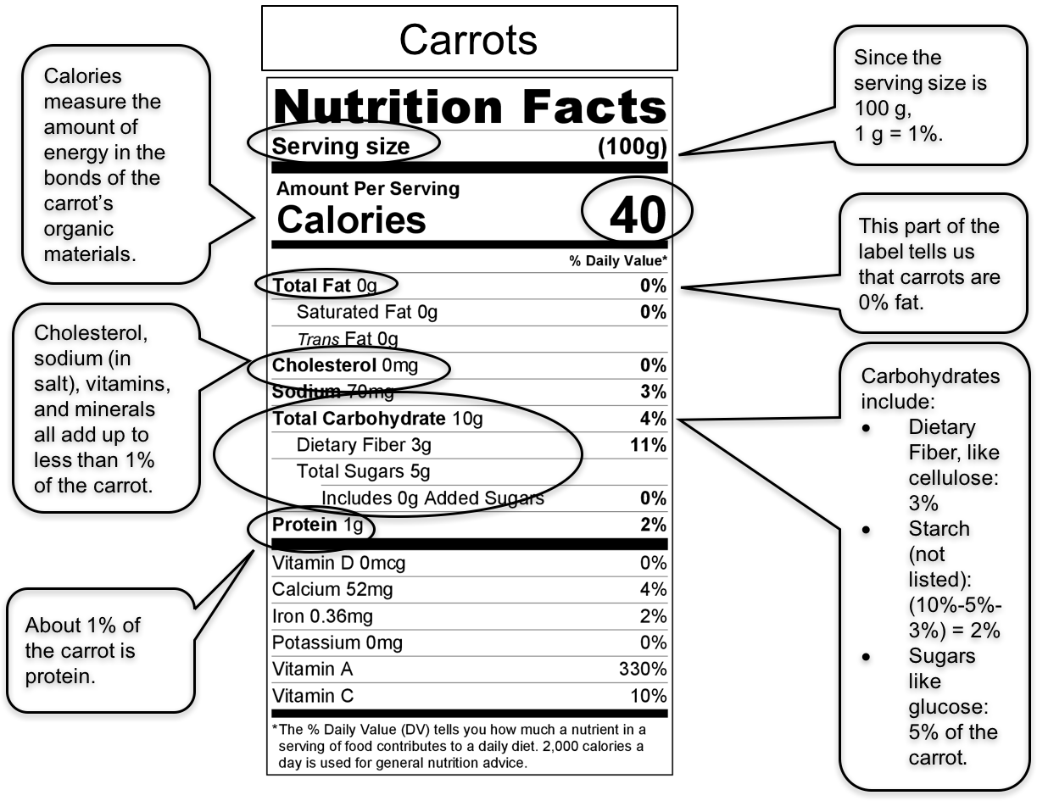
Here’s how to use nutrition labels to find out about different kinds of cells. We’ll use carrots as an example.

The label also includes other materials that cells need in small amounts (less than 1% of the cell’s mass) to do their work. These include vitamins (vitamin A and vitamin C), cholesterol, and minerals (sodium and iron).
Calculating how much water: Subtract the mass of the organic materials from the total mass of the food (100 g for this label).
If you add up all the materials on the carrot label, here is what you get:
Fat: | 0 g | or 0% of the mass
Cholesterol, sodium, vitamins, and minerals: | less than 1 g | or 1% of the mass
Carbohydrates (sugar, starch, fiber): | 10 g | or 10% of the mass
Protein: | 1 g | or 1% of the mass
Total | 12 g | or 12% of the mass

This means that the other 88% of the mass of the carrot is WATER!

Directions:
Food labels can tell us a lot about the molecules in the cells of the organisms that they come from.
You will analyze different kinds of organisms by studying the six foods described on the Food Labels handout.
This handout shows how many grams of different materials are in 100 g of each food.
Follow these steps to fill out the table below:
- Fill in the kind of organism that the food comes from (animal, plant, or decomposer).
- Find the mass in grams of main organic materials in the food: carbohydrates, fats, and proteins.
- Remember that the total mass of vitamins and minerals is less than 1 gram.
- Calculate the amount of water by subtracting the mass of the organic materials from the total mass (100 g).
- Find the amount of chemical energy (calories) in that food.

Table 1: Food Label Summary
 | Food Name | Kind of Organism it comes from (animal, plant, decomposer) | Mass of Organic Materials |  |  | Water  (g)  (100g-total mass of organic materials) | Chemical energy (Calories)
 |  |  | Fat  (g) | Carbohydrates (g) | Protein  (g)
1 | beef
2 | carrots
3 | celery
4 | mushrooms
5 | spinach
6 | peanuts

Analysis:
- Why is it important that the same mass (100 grams) of each food is analyzed in this activity?

- Choose two different types of organisms and make a comparison statement about their cells and what they are made of.

Claim:

Evidence:

Reasoning:

- Honors: Make a claim about the patterns or trends you see in the data.

Claim:

Evidence:

Reasoning:

