Name:____________________________ Period:_______
Biodiversity and Species Richness and Abundance
- What is biodiverstiy?_________________________________________________________
- How do humans affect biodiversity? ____________________________________________
- Why is biodiversity important to an ecosystem? __________________________________

Species richness and relative abundance are the two factors that are considered when measuring species diversity.
Explanation:
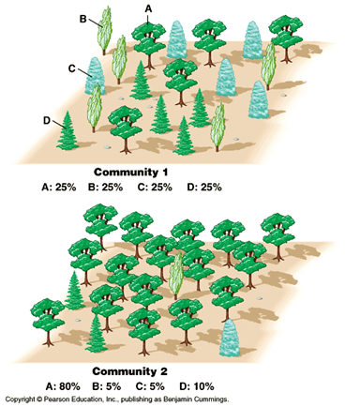
Species richness and relative abundance are the two factors that are considered when measuring species diversity.
- Species richness refers to the number of species in an area.
- Species abundance refers to the number of individuals per species.
- Relative species abundance is how common a species is relative to the other species in a defined location.

For example, in the image below, we can see that these two communities are composed of the same species and are identical in regards to species richness. They have four different species of trees.

However, they differ in regards to relative species abundance: Community 2 is mostly composed of species A. Species A has high relative species abundance compared to species B, C, and D.
If we look at Community 1, each of the four species contributes to 25% of the population. The relative abundance of each species is more evenly distributed than Community 2.

While both communities have the same species richness, Community 1 would have greater diversity due to the relative abundance of each species present.
To conclude, the number of species factors into species diversity but also the number of individuals in each species is also considered. Both affect species diversity.

Define Species Richness: _______________________________________________________

Define Species Abundance: _______________________________________________

Define Relative Species Abundance: ________________________________________

Comprehension Check:
Taylor is a bird watcher. She takes data on the number of birds and their different species for a wildlife refuge. Her most recent data set includes:

Site 1 She counted 294 birds, belonging to 27 species.

Site 2 She counted 288 birds belonging to 33 species.

1. Which site has the most bird richness?

Claim | Evidence

Use the data below to answer Questions 2-4
Evans Parkway in Montgomery County MD  May 28th 2018  Identified 19 species, 6 are listed below (https://ebird.org/view/checklist/S46099804) |  | Aspen Hill in Montgomery County MD  May 19th 2018  Identified 49 species, 6 are listed below  (https://ebird.org/view/checklist/S45832326)
Bird species | Number of individuals counted | Bird species | Number of individuals counted
Mourning Dove | 4 | Mourning Dove | 2
Chimney Swift | 2 | Chimney Swift | 6
Red-bellied Woodpecker | 2 | Red-bellied Woodpecker | 7
Fish Crow | 9 | Fish Crow | 1
American Robin | 6 | American Robin | 10
House Sparrow | 15 | House Sparrow | 0

2. Which species has the most relative abundance?

Claim | Evidence

3. Which location has the most species richness?

Claim | Evidence

