Name:_______________________________ Period: _____

Step 1: Species Selection
Briefly research 3 species that you may be interested in studying in more detail for your endangered species project. Record your research below.
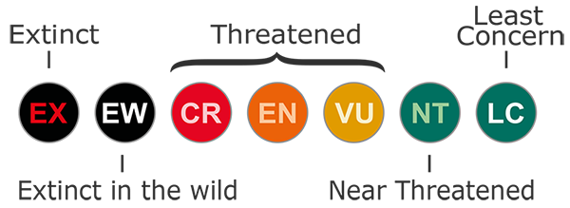
The image above shows the various threat levels as determined by the International Union for Conservation of Nature and Natural Resources (IUCN).

Use the following decision matrix to assist you in selecting one of the species for further exploration.
Name of the Animal | Species 1: | Species 2: | Species 3:
Type of Animal (Reptile, Mammal, or Amphibian)
Threat Level (Conservation Status- either near threatened, vulnerable, endangered, or critically endangered)
What is or could be directly threatening this species population?
Briefly describe the habitat of this organism.
Ex: Warm dry desert of Western United States

