Name: Period:

Cells: The Building Blocks of Organisms (Honors)
Purpose for Reading: As you read this text, work to make sense of why cells are considered the “building blocks” of organisms. Use this reading as a reference guide for your unit on Cells.

Part 1: Background on Cells
Cells are often referred to as the building blocks of living things because all living this are made up of cells. Animals, plants, and decomposers are made up of cells. Some organisms consist of a single cell, like bacteria. Most bacteria are decomposers but some are producers and can do photosynthesis.
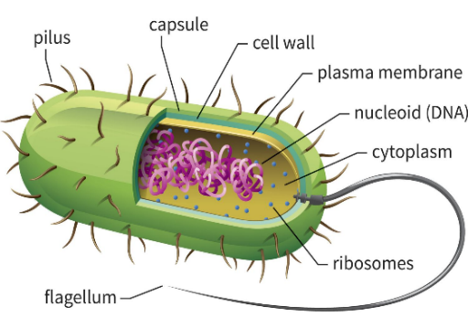
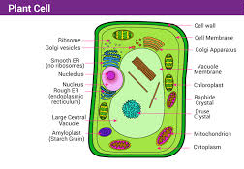
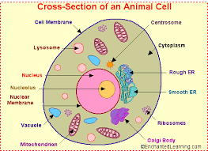

Cells have many parts, each with a different function. Some of these parts, called organelles, are specialized structures that perform certain tasks within the cell.
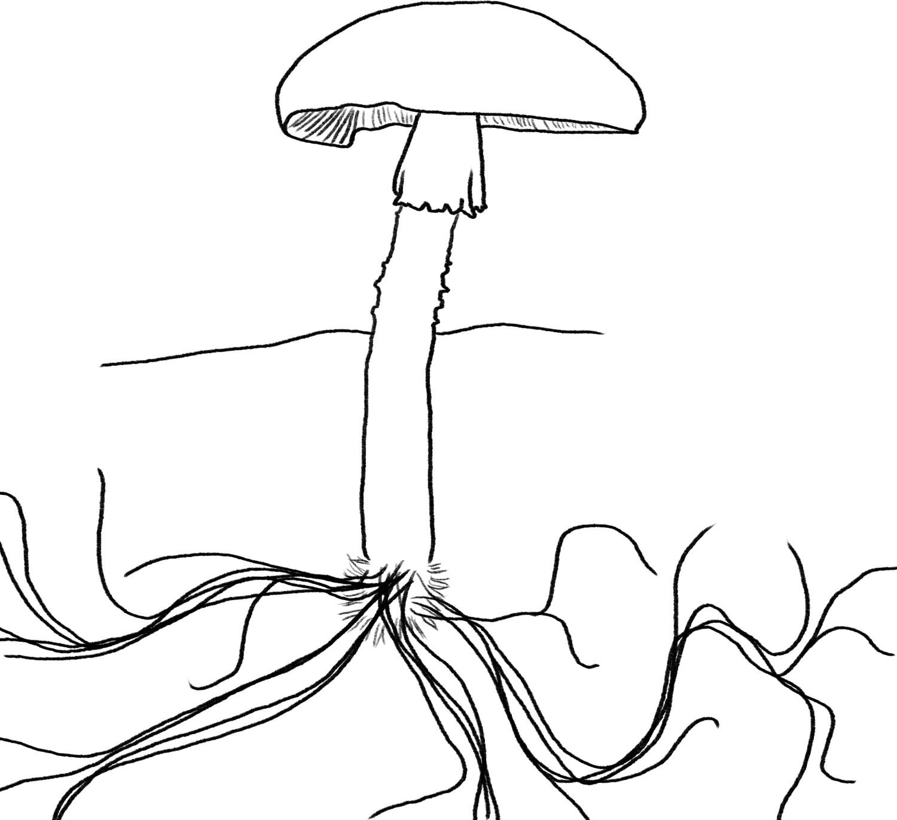
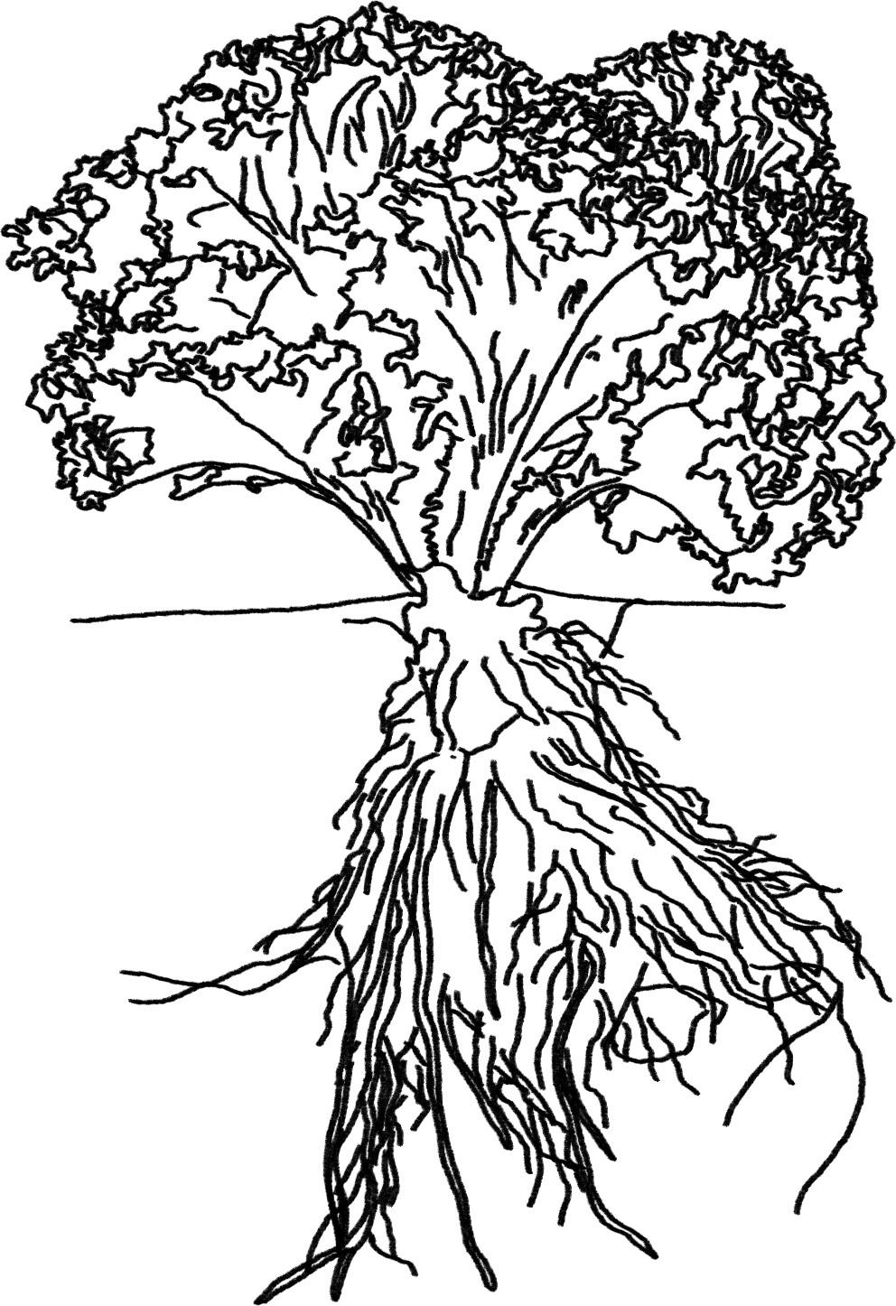
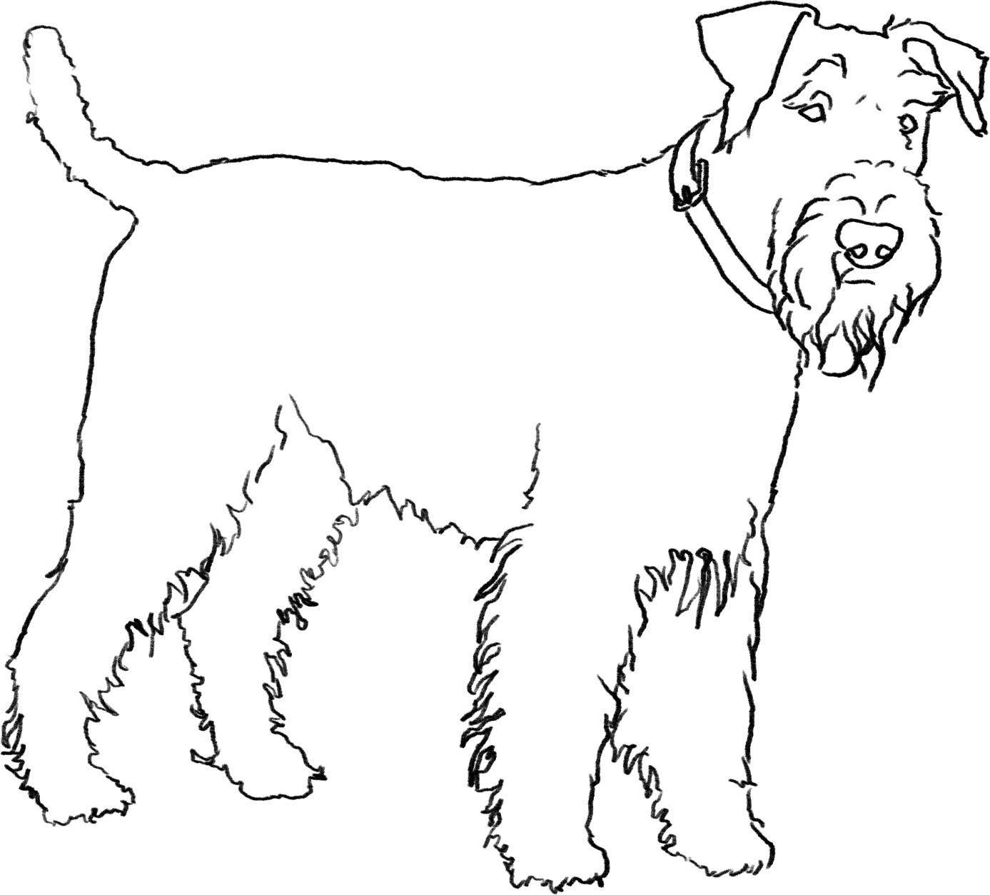

More complex organisms are made up of many different kinds of cells, like dogs, lettuce plants, and mushrooms. Dogs are in the animal kingdom and are consumers. Lettuce is a plant and is a producer. Mushrooms are fungus and are decomposers.

Eukaryotes vs. Prokaryotes:
Organisms are classified as eukaryotes or prokaryotes. Prokaryotes include bacteria and are all singled celled. Prokaryotes do NOT have a nucleus or any organelles that have membranes around them (called membrane-bound organelles). The DNA in prokaryotic cells is in the cytoplasm rather than enclosed within a nuclear membrane. Eukaryotes include animals, plants, fungus and protists. Eukaryotes can be single celled (most protists and some fungus) or multi-cellular (all animals and plants, most fungus and some protists). Eukaryotes have a nucleus to store the DNA as well as many other organelles that are made up of membranes (mitochondria, chloroplast, ER, Golgi, vesicles).

Reading Comprehension Check:

- What are all living things made out of? ________________________________________
- What types of organisms can be single celled? _all___________________, _most______________________, and some _______________________ .
- A. What types of cells are prokaryotic? ________________________________________
B. What types of cells are eukaryotic? _________________________________________
- What is the main difference between a prokaryotic cell and a eukaryotic cell? What do eukaryotic cells have that prokaryotic cells do not? _______________________________
_______________________________________________________________________
- Where is the DNA stored in a prokaryotic cells? __________________________________ ________________________________________________________________________

Part 2: Cell Organelle Chart
Directions:
- Read through the Cell Parts Chart.
- In the “Functions” column, using a highlighter, highlight all of the key verbs that describe the main functions of each organelle.
- Look in the “What Types of Cells?” column. Underline the cell parts that are found in ALL cells.

Cell Organelle Chart
Organelle | Description | Function | What types of cells?
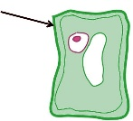  CELL WALL | Rigid, tough, made of cellulose | Protects and supports the cell | NOT in Animals (in plants, fungus, bacteria and some protists)
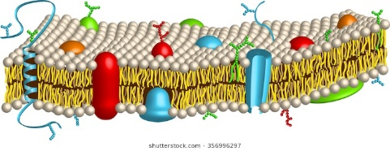  CELL MEMBRANE  (Plasma membrane) | Thin, covering, protects cells. Made up of two layers of phospholipids. Contains proteins embedded throughout. | Protects the cell, performs active transport and passive transport, moves materials in and out of the cell, communication | ALL Cells have Cell Membranes
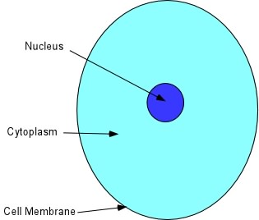  CYTOPLASM | Jelly like substance that contains organelles, made mostly of water | Pads and supports organelles inside the cell. | All Cells have Cytoplasm
NUCLEUS | Dense, ball shaped structure, contains DNA | Controls all of the cell’s activities | Eukaryotic Cells (Plants, Animals, Fungus and Protists)
NUCLEAR MEMBRANE (or nuclear envelope)  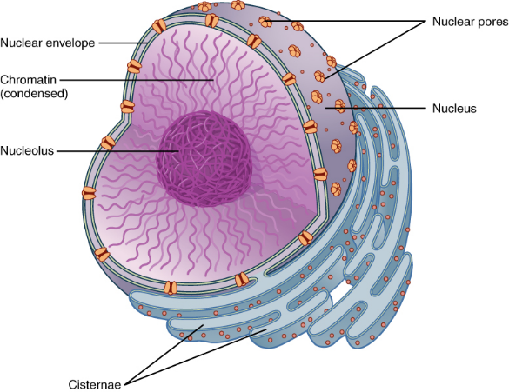 | Thin covering over the nucleus | Covers and protects the nucleus | Eukaryotic Cells (Plants, Animals, Fungus and Protists)
NUCLEOLUS | Small dark area in the nucleus | Produces ribosome’s | Eukaryotic Cells (Plants, Animals, Fungus and Protists)
CHROMATIN | In the nucleus, made of DNA and protein, contains genes | Provides instructions for the cells activities, (growth, reproduction) | All Cells have DNA. DNA that is uncoiled is chromatin.
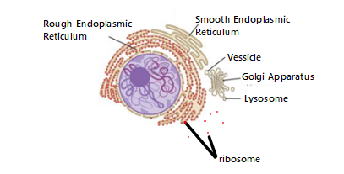

Organelle / Images | Description | Function | What types of cells?
LYSOSOME | Small, round structures, containing enzymes | Digests older cell parts, food or other objects | Eukaryotic Cells (Plants, Animals, Fungus and Protists)
VESICLE | Small bubble or pouch | Stores materials like water, minerals, food and waste | Eukaryotic Cells (Plants, Animals, Fungus and Protists)
GOLGI APPARATUS | Small bags with tubes connecting them | Packages and secretes proteins for use in and out of the cell | Eukaryotic Cells (Plants, Animals, Fungus and Protists)
ROUGH ENDOPLASMIC RETICULUM | Clear, tubular system of tunnels throughout the cell that contains ribosomes on the outside. | Modifies and transports proteins made by the ribosomes. | Eukaryotic Cells (Plants, Animals, Fungus and Protists)
SMOOTH ENDOPLASMIC RETICULUM | Clear, tubular system of tunnels throughout the cell. | Produces and metabolizes fats and steroids. | Eukaryotic Cells (Plants, Animals, Fungus and Protists)
RIBOSOME | Small specks made of RNA. Found in cytoplasm or on the rough ER | Makes proteins | ALL Cells have Ribosomes
Organelle | Description | Function | What types of cells?
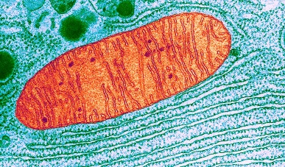  MITOCHONDRIA | Location in the cytoplasm, bean shaped | Supplies energy or ATP for the cell through cell respiration using glucose and oxygen | Eukaryotic Cells (Plants, Animals, Fungus and Protists)
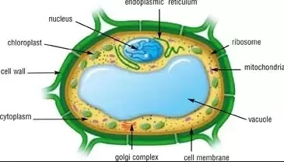  VACUOLE | Large open storage area, smaller in animal cells | Storage tank for food, water, wastes or enzymes | Eukaryotic Cells (Plants, Animals, Fungus and Protists)  Plants have a large central vacuole
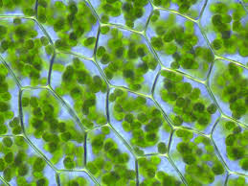  CHLOROPLAST | Green structures that contain chlorophyll | Captures sunlight and uses it to produce food through photosynthesis | Plants only
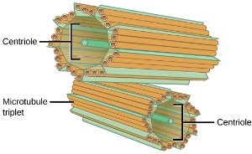  CENTRIOLE | Small cylindrical | Used with the spindle apparatus during mitosis | Animals only
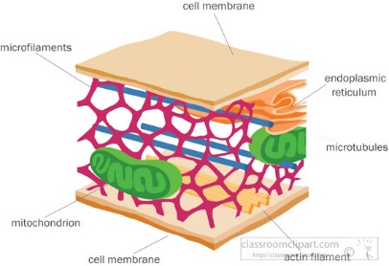  CYTOSKELETON | Protein filaments and tubes within a cell | Helps cells maintain their shape and internal organization. It also provides mechanical support | All cells have a cytoskeleton
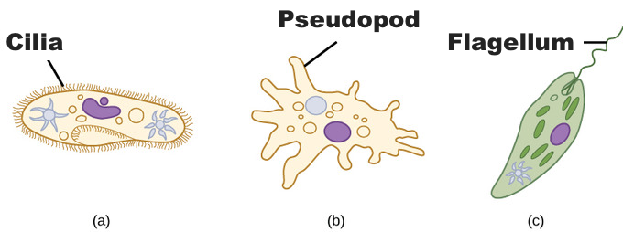  CILIA | Thin hair like protein projections from a cell | Allow the cell to move itself or other materials. Sensory structure. | Some animal, fungus, protist and bacterial cells.
FLAGELLA | Same as cilia. (moves like a whip) | Allow movement. | Some animal, protist and bacterial cells.

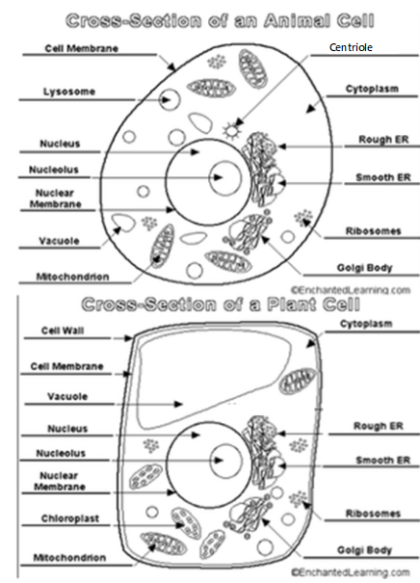

Bacterial Cell: Cell Wall, Cell Membrane, Cytoplasm, Ribosomes, DNA, Cilia, Flagella

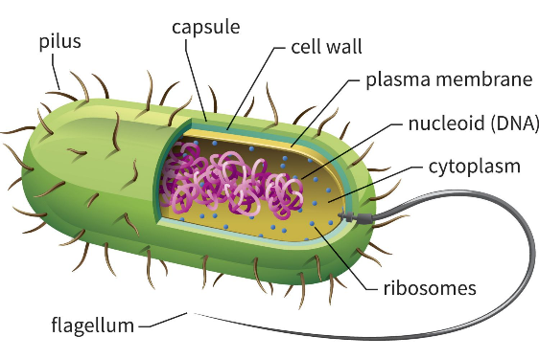

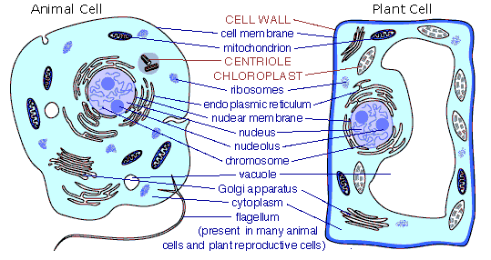

Reading Comprehension Check:
- What cell parts are found in ALL cells? _________________________________________ ________________________________________________________________________
- What cell parts are found in ONLY plant cells? ___________________________________ ________________________________________________________________________
- What cell parts are found in ONLY animal cells? _________________________________
- What cell parts are involved in movement of cells? _______________________________
Part 3: Types of Cells
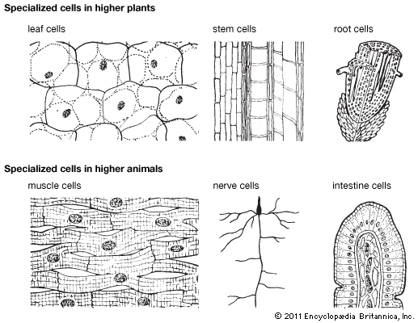
A complex animal, like a dog, has bone cells, muscle cells, nerve cells, and blood cells; just to name a few! Plants and decomposers also have many different types of cells. Different kinds of cells carry out different kinds of work as an organism grows and moves. Cells can connect to build tissues, organs, and body systems. Every cell needs matter and energy to live and grow.
Specialized cells in higher fungus
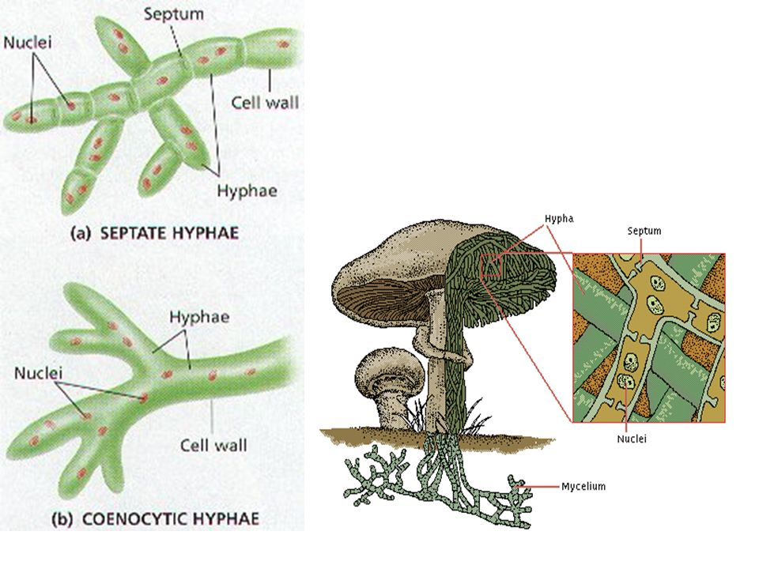

Reading Comprehension Check:
- A. What similarities do you see in the cell types shown above?
_______________________________________________________________________ _______________________________________________________________________
B. What differences do you see in the cell types shown above?
_______________________________________________________________________ _______________________________________________________________________

