Name: ________________________________________ Date: _____________________
Introduction to Populations Capture Sheet
Look at the coral reef ecosystem below. Identify 2 biotic and 2 abiotic factors.
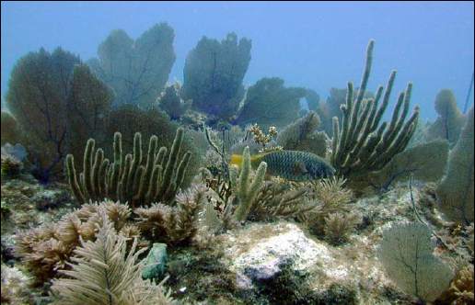
Abiotic Factors
- ___________________
- ___________________

Biotic Factors
- ___________________
- ___________________

Photo courtesy of US EPA, Office of Wetlands, Oceans and Watersheds

All biotic and abiotic factors are interrelated: a change in one factor will affect other factors.
Describe how a change in one abiotic factor that you identified may affect one of the biotic factors.
_______________________________________________________________________________________________________________________________
_____________________________________________________________________________________
How does a population grow?

With a partner, identify factors that increase a population’s growth and factors that decrease a population’s growth, and fit them into the equation format provided below. (You can use the space below the lines also).
What factors increase a population’s growth? - What actors decrease a population’s growth?

Population Change = ________________________________ - _______________________________

Exploring Bacteria Population Growth

The table below contains data for the population growth of a hypothetical bacteria population.
- Identify the trends (pattern) in the population size. You should note two observations.
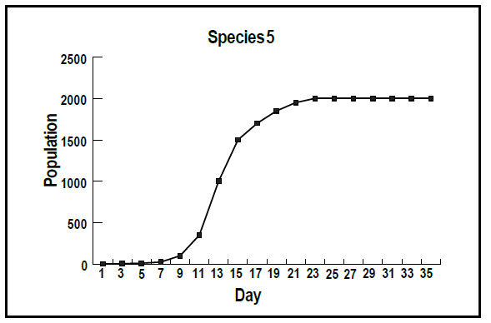

Based on the graph, what do you observe about bacteria growth?

Construct an explanation for why bacteria don’t take over the world.

Name: ____________________________________ Date: ________________

Population Growth and Carrying Capacity Extension-Coronation Island, Alaska
- Work with your group to read and discuss the four cards describing the events on Coronation Island, Alaska. Complete the diagram below.
  - Why were the wolves introduced to Coronation Island?

  - Fill out the diagram sequencing the events on Coronation Island.

  - Predict limiting factors for the deer population.

  - Predict limiting factors for the wolf population.

- Work with your group to read the Scientific Studies on Coronation Island cards, and answer the questions below.
  - What were some limiting factors for the deer population on Coronation Island? Label them abiotic or biotic.

  - What were some limiting factors for the wolf population on Coronation Island? Label them abiotic or biotic.

  - How did these limiting factors affect the carrying capacity of Coronation Island?

  - What would you have done to manage the deer population on Coronation Island?

  - Wolves were native to Coronation Island, but had not had a breeding population on the island for many years. Compare and contrast the re-introduction of the wolves to Coronation Island to the introduction of an invasive species.

  - How do you think humans could impact the carrying capacity of the wolf population?

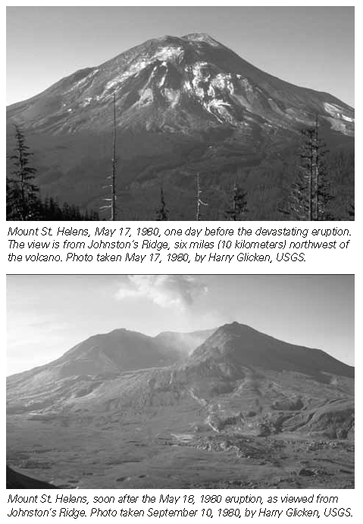
Source: USGS/ Cascades Volcano Observatory
http://nides.bc.ca/Assignments/Rocks/Before.htm

- On May 18th, Mount St. Helens erupted sending a cloud of ash up to 80,000 feet in 15 minutes. The eruption blasted away more than 230 square miles of forests, lakes, meadows, and streams. (See pictures to the right).
  - Some seeds are able to withstand fires. Sketch a graph showing the population growth of these seeds after the fire.

  - Do you think the eruption changed the carrying capacity of the region?

Coronation Island Cards

Before 1960-  In 1960, the US Department of Fish and Wildlife introduced four wolves to control the overpopulation of black-tailed deer on Coronation Island, a small island in southeast Alaska. | 1960-  At first, the large deer population was decreased by the wolves, and overgrazing of the ecosystem was controlled.
1964-  By 1964, the deer population crashed, and the wolf population had grown to 13 wolves. | 1983-  The wolves had run out of food (the deer), and began consuming each other. By 1983, there were no wolves on the island, and the deer were once again plentiful.

Scientific Study on Coronation Island Card

Scientific Studies on Coronation Island
Scientists investigating the events believe several factors influenced the population changes on Coronation Island. First, they think that the island was too small to support both deer and wolf populations. Because the deer couldn’t find shelter from the wolves, they were quickly hunted by the wolves. Second, the deer reproduced less than usual due to the low quality food available on the island from overgrazing. Third, the deer were the only food source for the wolves.

Information source: http://www.pinedaleonline.com/wolf/pdf/Wolves-NationalParks.pdf

