Notes on DNA, Genes, Chromosomes and Traits
Name:

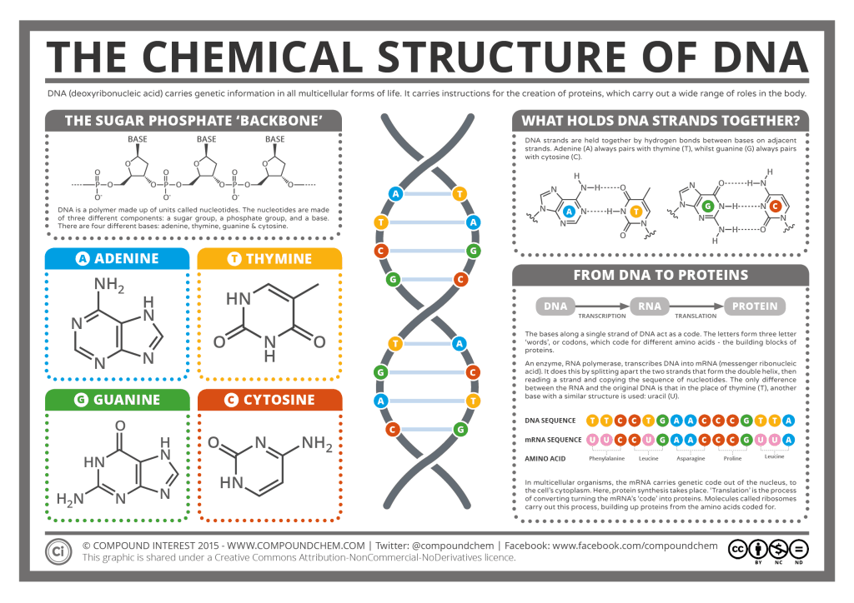

DNA is an enormous molecule found in the nucleus in a eukaryote. It is double stranded and made up of nucleotides. Each nucleotide contains a phosphate, sugar and base. The genetic code for an organism is found in the order of the bases of the DNA. There are 4 bases A, T, C and G. A always pairs with T and T always pairs with A. C always pairs with G and G always pairs with C. If one strand of DNA had the code ACTGAGTCAAAA the opposite strand would be TGACTCAGTTTT. It would look like
A C T G A G T C A A A A
T G A C T C A G T T T T

DNA is the code to make proteins that the cells use to do work. DNA is the code and protein is the expression of the code. A molecule of DNA will hold the code to make many different proteins. Not all of the DNA is read to make a protein. A section of the DNA that is the code to make a protein is called a gene.
The proteins that are made in the cell are used for many different purposes. They can be enzymes that make specific reactions take place, or used in the cell membrane to allow certain substances to pass through, or they can be part of the structure of the cell. The proteins that are active in a cell give that cell many of its characteristics. A trait (such as hair color, eye color, height, ability to digest certain foods..etc) is caused by the proteins that are made in a cell. Traits are genetic because the information to make them is in the code of the DNA. A trait is a visible expression of DNA that has been read to make a protein. Not all genes in the DNA are turned on in every cell. Most cells only read and make proteins from certain sections of the DNA.
All cells in an organism will have the same number of chromosomes. A chromosomes is a molecule of DNA that is wound up around proteins. When the DNA is unwound it is called chromatin. Humans have 46 chromosomes in every cell.
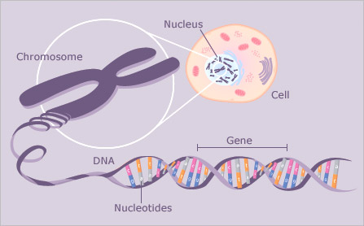

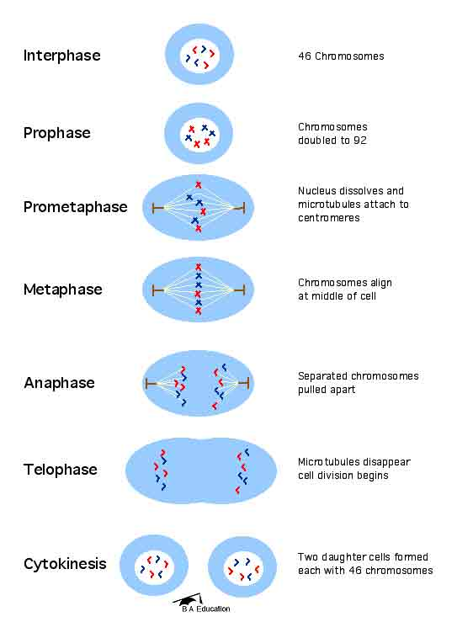
Cells need to make identical copies of themselves. In a single celled organism this is how the organism reproduces (asexual reproduction).
In a multicellular organism this is how the organism grows or creates new cells to take the place of worn out cells. Cells make copies of themselves by replicating their DNA (DNA Replication) so that they have two copies of every chromosome. Then the cell organizes the DNA so that when the cell splits into two each cell gets one copy of every chromosome. The cell replicates its DNA during Interphase and divides up the DNA during mitosis. The cell splits during cytokinesis. Mitosis is divided into 4 stages: Prophase, Metaphase, Anaphase and Telophase.
Because these cells have identical DNA they will produce identical protein. This means that they will have identical traits.

Animals reproduce by sexual reproduction. This means that females create an egg and males create a sperm through the process of meiosis. The egg and the sperm combine through the process of fertilization. The fertilized egg (zygote) has DNA from both parents but it is not an exact copy of either parent.
Sexual Reproduction increases genetic variation in a population because the offspring are unique.

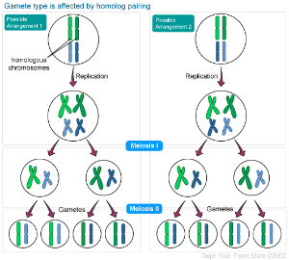
Questions:
Define:
Gene:
DNA:
Chromosome:
Trait:
What is the relationship between DNA, Genes, Chromosomes and Traits?

What molecule is the code for our traits?
What molecule is responsible for the expression of our traits?
How do cells make sure that new cells in the same organism have identical DNA?
How do animals produce offspring that have similar traits as their parents but are unique?
What is cancer?
Cancer is the general name for a group of more than 100 diseases. Although there are many kinds of cancer, all cancers start because abnormal cells grow out of control.
The human body is made up of trillions of living cells. Normal body cells grow, divide, and die in well-organized, controlled process. During the early years of a person’s life, normal cells divide faster to allow the person to grow. After the person becomes an adult, most cells divide only to replace worn-out or dying cells, or to repair injuries.
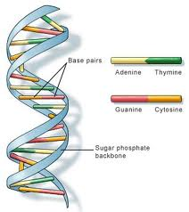
Cancer starts when cells in a part of the body start to grow out of control. Cancer cell growth is different from normal cell growth. Instead of dying, cancer cells continue to grow and form new, abnormal cells. Cancer cells can also invade (grow into) other tissues, something that normal cells cannot do. Growing out of control and invading other tissues are what makes a cell a cancer cell.
Cells become cancer cells when DNA (deoxyribonucleic acid) is damaged. DNA is in every cell, and directs all the cell’s actions. In a normal cell, when DNA gets damaged, the cell either repairs the damage or the cell dies. In cancer cells, the damaged DNA is not repaired, and the cell doesn’t die. Instead, the cell goes on making new cells that the body doesn’t need. These new cells all have the same abnormal DNA as the first cell does. People can inherit abnormal DNA, but most DNA damage is caused by mistakes that happen while the normal cell is reproducing or by something in the environment.

With the completion of the Human Genome Project in 2001, scientists have been able to study the connection between DNA and cancer, and create new tests and treatments that are available today. This has encouraged an increase in the number of specialized centers that focus on cancer detection and treatment.

- What causes cancer?

- What do normal body cells do over the lifetime of a person?

- What is the purpose of cell division in a healthy person?

- How is cancer cell growth different than normal cell growth?

- How do cells become cancer cells?

- What happens in a normal cell when DNA is damaged?

- What happens in a cancer cell when DNA is damaged?

- What are the two ways that people can get abnormal DNA?

