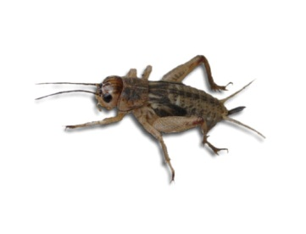
Name: Date: Period:
It’s Alive!!
There are specific characteristics that all organisms (“living things”) share. In groups, you will observe the activities of the cricket, plant and fire on your desk. Not everything you observe today is a living thing. Your job is to determine what it is that makes a living organism alive.
QUESTION: What are some characteristics common to all living organisms?
MATERIALS: Hand lens Cricket
Erlenmeyer flask Piece of carrot
Germinating Seeds Candle
Safety Goggles

Part 1: Observations
DIRECTIONS: Observe the cricket, germinating seeds, and fire. Work with your group to determine the six characteristics of life that all living things share. Write the characteristics of life in their corresponding category below.

Characteristics of Life
Found in All Living Organisms BUT NEVER found in a nonliving thing | Found in All Living Organisms BUT ALSO in some nonliving things.

The 6 Characteristics of Life:
List the 6 characteristics of life below as given on the board.
1. All organisms are .
Single Celled organisms are made up of only 1 cell.
Multicellular organisms are made of many cells that work together in the organism.
Hierarchy: __________ _________ ___________ ___________ ____________
2. Organisms to pass on their . The two types are .
3. Organisms and .
4. Use ____. Ex: Producer/Autotroph
Consumer/Heterotroph
5. to their .
External example: .
Internal Example:
Homeostasis:
6. Populations of organisms ___________________________________.
Organisms must possess the characteristics of life.

Homework Assignment due date/deadline Thursday:
Observing Living Organisms Lab
-You are to bring in a living organism in a container that can be observed by your peers in class. Use the following guidelines to choose your organism:
- The organism can be an animal, plant, fungus, protist, or bacteria.
- If you are bringing an animal, it MUST be in an escape proof container
  - The container should not be any larger than a 10 gallon aquarium or a small cage.
- You may bring in a sample of a substance that would contain living organisms…ex: Pond water. We will have microscopes available if needed.
- If you are bringing a plant, it MUST be the entire organism, not just a leaf

You must take your organism home with you at the end of class (or end of the day) on Thursday.

