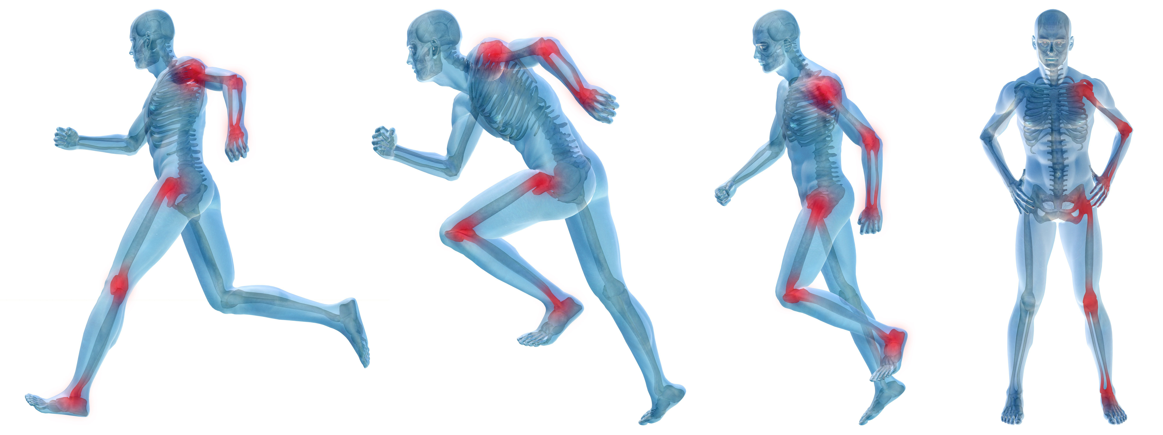
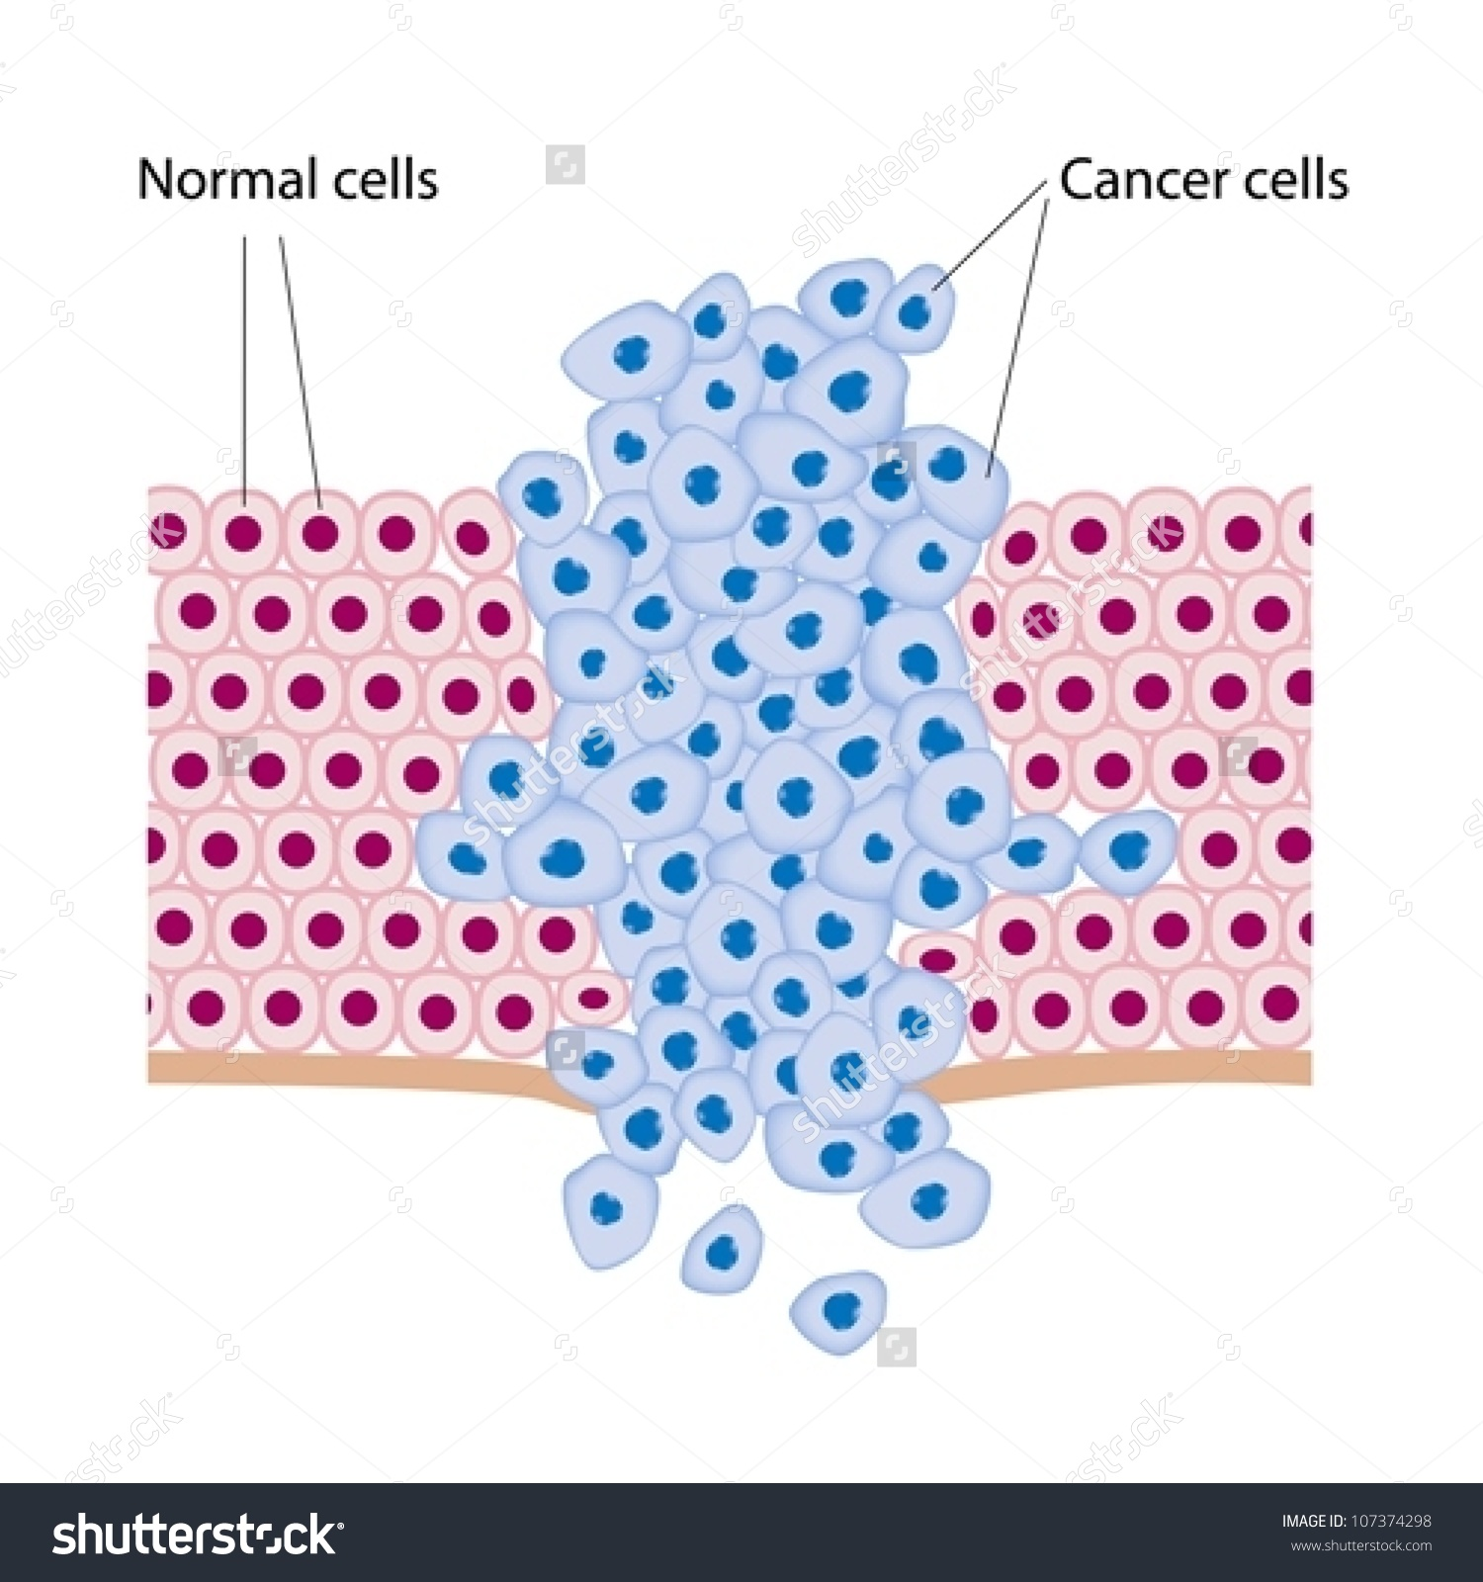
Honors/On Level Biology
Criteria for Success

Teachers:
Rebecca McGaffin Rebecca_A_McGaffin@mcpsmd.org
David McGaffin David_E_McGaffin@mcpsmd.org
Deanna Jennings Deanna_L_Jennings@mcpsmd.org
Talia Turner Talia_D_Turner@mcpsmd.org
Patricia Mitchell Patricia_R_Mitchell@mcpsmd.org

Science Office Phone #: 240-207-2361

Overview: Welcome to Honors Biology!
The goal of this class is for students to become effective science learners by developing skills in scientific inquiry and creating and analyzing data. We will also be laying the foundation in biology to ultimately support application of this knowledge to topics within physics, chemistry, and environmental science, as well as to set students up to take AP biology and other advanced science classes.

Supplies:
- 3-Ring binder with loose leaf paper –A binder (not a spiral or a folder) is a necessity. If organization is typically a challenge, I would suggest a separate 1”-2” binder for Honors Biology rather than a section in a larger binder.
- Pens (dark blue or black, please!) and Pencils
- Highlighter (optional- we have a set in class)

Curriculum for Honors Biology- Semester A
- Characteristics of Life/Safety/Experimental Design
- Endangered Species: Ecology
- Urban Farming: Photosynthesis/Cellular Respiration /Cycles / Biochemistry
- Sports Injury: Structure and Function

Grading Policy:
All MCPS and DHS Standards-based Grading and Reporting Policies for High School 2018-2019 apply.

Grades will be comprised of a variety of assignments/assessments and will be broken into the following categories:
All Tasks/Assessments: 90%
- Tests and Quizzes ~50%
- Classwork, Labs and Projects ~40%
Homework/Completion: 10%

Honors/On Level Differentiation:
All students will start the year enrolled in Honors Biology. The belief is that many more students can be successful in the Honors Biology curriculum than typically sign up for honors classes. The other core belief is that all students will benefit from being exposed to higher level curriculum and all students will benefit from differentiation strategies that allow them to see and hear the materials in multiple ways. Students who are not being successful in the honors curriculum, despite having met with the teacher for opportunities to re-teach and relearn, will be able to move to “on level” Biology. They will stay in the same class and will be provided with the same opportunities to experience higher level material, but they will be given different questions, reading assignments, quizzes and tests. Their report card will list them as being in Biology. This change will be made before Oct 4, 2018. Students who did poorly in the honors curriculum before moving to on level will have the opportunity to bring up any low grades so that their on level grade is not affected.

Late and Missing Work:
- Each assignment will have a due date. This is the date by which you are expected to submit the assignment. All assignments are due at the beginning of the class period.
- Incomplete or missing homework (not due to absences) that is gone over in class will not be able to be made up for credit.
- The deadline is generally 2 days following the due date (and will be announced along with the due date). Your grade will drop one letter grade (10%) if it is turned in by the deadline date. After the deadline, the assignment will be a zero.
- Some work that is not gone over in class can be completed with me after the deadline by appointment only and must be done by the unit test for partial credit.
- Academic Honesty- If you are caught cheating (including copying HW/allowing others to copy), it will result in a zero and you will not be able to make up that grade.

Cell Phone/Electronic Device Policy
- Cell phones and other electronic devices are not to be used unless given direct permission from the teacher.
- You are responsible for your own electronic devices. Do not leave them lying around the room.
- Cell phones may NOT be out or on your person (in pockets, on lap, on desk…etc) during quizzes and tests. If your cell phone is out or on you (especially during tests) you will receive a zero.
- Students are expected to comply with teachers directions. Failure to do so will result in confiscation of your device.

Reassessment:
- Your teacher will tell you whether or not you may reassess each quiz. All mini quizzes and exit card quizzes are able to be reassessed. Most quizzes may be reassessed if done before the unit test.
- Labs and Tests are not re-assessable.

Extra Help:
- If you need to make something up, or if you are confused about anything from class, please come see me! Extra help is available during lunch and after school most days. If you would like to come in for extra help, please discuss this with your teacher in advance.

Absence Policy:
- Absences are the #1 reason that students do poorly in biology. If you are here, I will help you to learn the material. If you are not in class, I can’t help you!!
- Students are to be in class, on time, every day.
- Students are responsible for making up missed assignments due to absences. You have the number of days you were absent PLUS 1 day to make up missed work. For example, if you were absent 3 days, you have 4 days to make up all missed work. If this is not sufficient, please tell me right away so we can work something out.
- Unexcused absences will affect your grade. Work due on the date of an unexcused absence will lose 10% and the work cannot be reassessed. If work is not turned in and you are unexcused absent on the deadline date the work will receive a 0%. Make sure you turn in your note to the attendance office within 3 days of your absence.
- Missing the deadline for daily quizzes, labs, or classwork due to an unexcused absence from class will result in a 0% for that grade.

Classroom Rules: An atmosphere of mutual respect is required. You are also expected to abide by the classroom rules posted in the room.
- No put downs, name calling, or inappropriate comments in class.
- Respect all school property—lab equipment, sinks, furniture, textbooks, etc.
- Keep all work! If there is a question about grades, you must produce the graded paper.

